**Team SIX Member:**

* Ananta Arora (SID: 100421624)
* Jinghao Chen (SID: 100406201)
* Roxanne Alvarez (SID: 100405742)
* Teshani Jayasinghe (SID: 100422405)

**Report on**

**mimic-iii Data Set**

Contents

Summary 4

Data Exploration 6

General characteristics of the dataset 6

How many records do we have? How many variables? 6

What are the variable names? Are they meaningful? 6

What type is each variable? 7

How many unique values does each variable have? 8

What value occurs most frequently, and how often does it occur? 10

Are there missing observations (vertically and horizontally)? If so, how frequently does this occur? 12

Examine descriptive statistics for each variable 18

Categorical Variables 18

Numerical Variable 22

Normalization 24

Normality check 24

Histograms and QQ Plots 24

Shapiro Wilk test 36

Normalization 37

Method 1 – Log Transformation Method 37

Method 2 – L2 Normalization 38

Method 3 – BoxCox Method 40

Method 4 – Min-Max Method 41

Statistical Tests 42

Ordinal Variables 42

Mann-Whitney U test 42

Spearman Correlation 43

Visualization of Ordinal Variables 44

Categorical Variables 46

Chi-Square test 46

Visualization of Categorical Variables 47

Continuous Variables 72

Levene Test for homogeneity 72

Parametric Tests 74

Welch’s t-test 74

Non-Parametric Test 75

Mann-Whitney U Test 75

Comparison of Mann Whitney & Welch T test 77

Spearman Correlation 78

Visualization of Continuous Variables 79

Results Summary Table 80

Literature Review 82

Feature Explanations in Recurrent Neural Networks for Predicting Risk of Mortality in Intensive Care Patients 82

Prognosis of Mechanically Ventilated Patients 82

Machine Learning Prediction Models for Mechanically Ventilated Patients: Analyses of the MIMIC-III Database 83

References 84

Appendix 85

Normalization 85

Before normalization 85

After normalization 95

Method 1 – Log Transformation Method 95

Visualization of Categorical Variables 105

Bar Graphs 105

Box Plots 116

Visualization of Continuous Variable 135

Density plots 135

# Summary

Our team conducted an exploratory data analysis on the Medical Information Mart for Intensive Care (MIMIC-III) dataset. MIMIC-III is a comprehensive health-related dataset that primarily focuses on patients admitted to the Intensive Care Unit at the Beth Israel Deaconess Medical Center (BIDMC) in Boston, Massachusetts, USA.

In this content, we will explore the dataset on mechanically ventilated ICU patients, examine each variable, and apply appropriate statistical tests to identify associations and differences between patient survival outcomes.

Our dataset consists of 18,883 observations and 70 variables. We dropped the variables 'RRT' and 'ventilation duration' because these variables are not obtained on the first day of ICU admission. Based on our observations, missing values predominantly occur in the vital signs and laboratory results groups. The team has decided to drop observations with at least one missing value row-wise, resulting in 12,799 remaining rows. Additionally, we removed 310 rows containing at least one value that falls outside the valid range. Consequently, the resulting cleaned dataset comprises 12,489 rows and 68 variables.

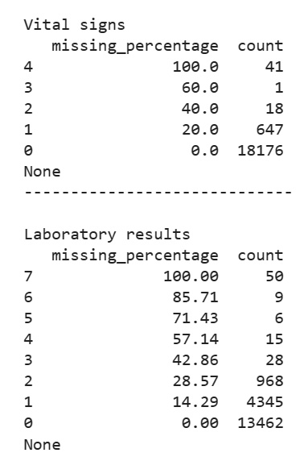

We conducted a Chi-Square test for the categorical variables, and Mann-Whitney U test and Spearman correlation for the ordinal variables.

Regarding the continuous variables, we first conducted a Shapiro-Wilk test to check for normality, and the result was "significantly different from normal" for all variables. To confirm the result of the Shapiro-Wilk test, we created histograms and QQ plots for visual inspection. As part of the analysis, we performed Levene’s Test to assess the equality of variances between the two groups, survivors and non-survivors, and discovered that all continuous variables violated the assumption of equal variances.

Although some distributions appeared to be roughly normal, the presence of outliers caused the distribution shapes to be skewed. Therefore, we conducted a log transformation on the continuous variables and found that some of the variables became normally distributed after the transformation. For these variables, we performed a Welch T-Test using the normalized data. For the remaining continuous variables where the distribution remained non-normal, we conducted a non-parametric test called the Mann-Whitney U test using the values before transformation.

Additionally, for the variables that we were able to normalize the distribution through log transformation, we conducted a comparative analysis between Welch T-test and Mann-Whitney U test results.

Spearman correlation was also conducted for the continuous variables using the dataset before transformation. We present the pairs of variables exhibiting a moderate to strong correlation, based on the correlation coefficient.

For visualizations, we used bar graphs for categorical variables, density plots and scatter plot for ordinal variables, and box plots, scatter plot and density plots for continuous variables.

It is important to note that we attempted to normalize the continuous variables using log transformation, L2 normalization, BoxCox method, and min-max method. Although log transformation performed best, the distributions did not become normal for all the variables.

Finally, we created a table to illustrate the summary of all variables, data types, tests conducted, and the resulting p-value.

# Data Exploration

## General characteristics of the dataset

### How many records do we have? How many variables?

# number of records and variables

df.shape

There are 18,883 records and 70 variables in the dataset.

### What are the variable names? Are they meaningful?

# variable names

df.columns

Below is the list of variable names in our dataset. We will learn later that by conducting the statistical tests, we are able to determine which variables give us meaningful insight into predicting the target variable.

Variables names:

Index(['Hospital Mortality', 'Age', 'Gender', 'Uncomplicated Hypertension',

'Complicated Hypertension', 'Uncomplicated Diabetes',

'Complicated Diabetes', 'Malignancy', 'Hematologic Disease',

'Metastasis', 'Peripheral Vascular Disease', 'Hypothyroidism',

'Chronic Heart Failure', 'Stroke', 'Liver Disease', 'SAPS II', 'SOFA',

'OASIS', 'Sepsis', 'Any Organ Failure', 'Severe Respiratory Failure',

'Severe Coagulation Failure', 'Severe Liver Failure',

'Severe Cardiovascular Failure',

'Severe Central Nervous System Failure', 'Severe Renal Failure',

'Respiratory Dysfunction', 'Cardiovascular Dysfunction',

'Renal Dysfunction', 'Hematologic Dysfunction', 'Metabolic Dysfunction',

'Neurologic Dysfunction', 'Max Heart Rate', 'Min Heart Rate',

'Mean Heart Rate', 'Max MAP', 'Min MAP', 'Mean MAP',

'Max Systolic Pressure', 'Min Systolic Pressure',

'Mean Systolic Pressure', 'Max Diastolic Pressure',

'Min Diastolic Pressure', 'Mean Diastolic Pressure', 'Max Temperature',

'Min Temperature', 'Mean Temperature', 'Max Lactate', 'Min Lactate',

'Mean Lactate', 'Max pH', 'Min pH', 'Mean pH', 'Max Glucose',

'Min Glucose', 'Mean Glucose', 'Max WBC', 'Min WBC', 'Mean WBC',

'Max BUN', 'Min BUN', 'Mean BUN', 'Max Creatinine', 'Min Creatinine',

'Mean Creatinine', 'Max Hemoglobin', 'Min Hemoglobin',

'Mean Hemoglobin', 'Ventilation Duration (h)', 'RRT'],

dtype='object')

### What type is each variable?

|  |  |  |
| --- | --- | --- |
| Category | Count | Data Type |
| Demographic | 2 | 1 continuous  1 binary |
| Diagnosis | 14 | 14 binary |
| Disease severity | 3 | 3 ordinal |
| Laboratory results | 21 | 21 continuous |
| Medical history | 12 | 12 binary |
| Vital signs | 15 | 15 continuous |
| Hospital Mortality | 1 | 1 binary |
| Total | 1 target variable  67 predictors | 27 binary  37 continuous  3 ordinal |

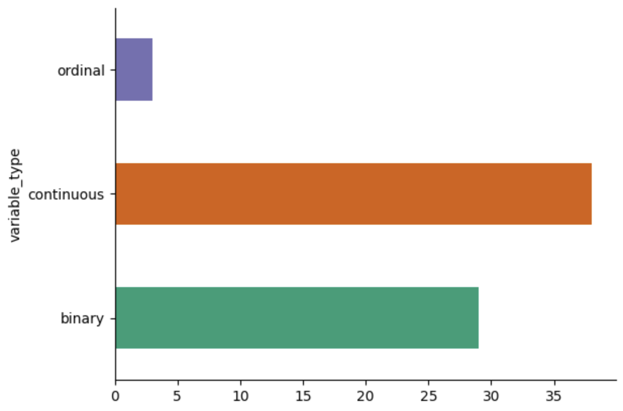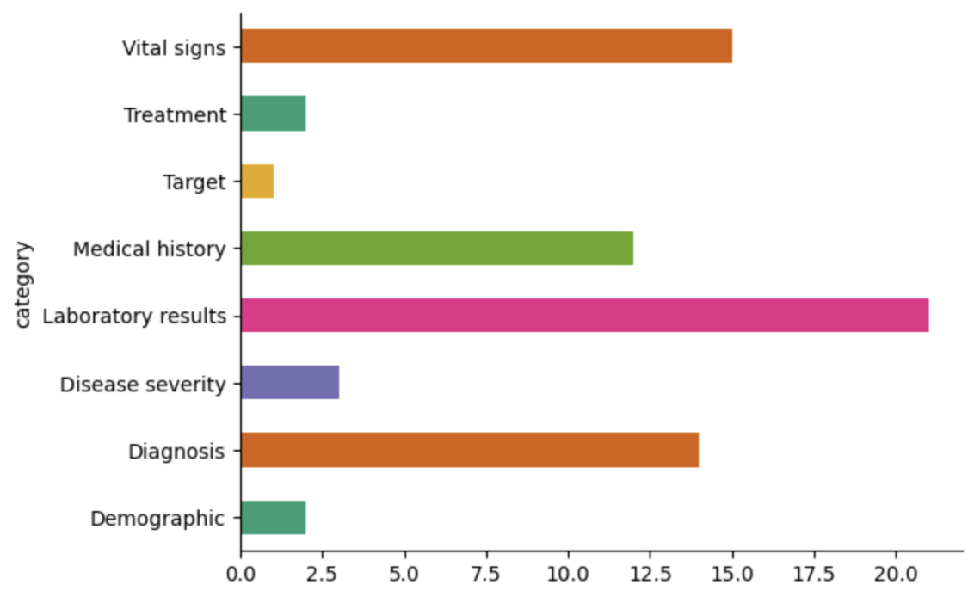

### How many unique values does each variable have?

# number of unique values per variable

df.nunique()

|  |  |
| --- | --- |
| Hospital Mortality | 2 |
| Age | 72 |
| Gender | 2 |
| Uncomplicated Hypertension | 2 |
| Complicated Hypertension | 2 |
| Uncomplicated Diabetes | 2 |
| Complicated Diabetes | 2 |
| Malignancy | 2 |
| Hematologic Disease | 2 |
| Metastasis | 2 |
| Peripheral Vascular Disease | 2 |
| Hypothyroidism | 2 |
| Chronic Heart Failure | 2 |
| Stroke | 2 |
| Liver Disease | 2 |
| SAPS II | 107 |
| SOFA | 23 |
| OASIS | 64 |
| Sepsis | 2 |
| Any Organ Failure | 2 |
| Severe Respiratory Failure | 2 |
| Severe Coagulation Failure | 2 |
| Severe Liver Failure | 2 |
| Severe Cardiovascular Failure | 2 |
| Severe Central Nervous System Failure | 2 |
| Severe Renal Failure | 2 |
| Respiratory Dysfunction | 2 |
| Cardiovascular Dysfunction | 2 |
| Renal Dysfunction | 2 |
| Hematologic Dysfunction | 2 |
| Metabolic Dysfunction | 2 |
| Neurologic Dysfunction | 2 |
| Max Heart Rate | 162 |
| Min Heart Rate | 132 |
| Mean Heart Rate | 12730 |
| Max MAP | 426 |
| Min MAP | 258 |
| Mean MAP | 14561 |
| Max Systolic Pressure | 205 |
| Min Systolic Pressure | 167 |
| Mean Systolic Pressure | 13300 |
| Max Diastolic Pressure | 179 |
| Min Diastolic Pressure | 92 |
| Mean Diastolic Pressure | 11778 |
| Max Temperature | 334 |
| Min Temperature | 369 |
| Mean Temperature | 11507 |
| Max Lactate | 239 |
| Min Lactate | 182 |
| Mean Lactate | 946 |
| Max pH | 89 |
| Min pH | 95 |
| Mean pH | 78 |
| Max Glucose | 573 |
| Min Glucose | 332 |
| Mean Glucose | 4984 |
| Max WBC | 553 |
| Min WBC | 445 |
| Mean WBC | 1974 |
| Max BUN | 167 |
| Min BUN | 151 |
| Mean BUN | 1077 |
| Max Creatinine | 144 |
| Min Creatinine | 123 |
| Mean Creatinine | 606 |
| Max Hemoglobin | 143 |
| Min Hemoglobin | 159 |
| Mean Hemoglobin | 934 |
| Ventilation Duration (h) | 5895 |
| RRT | 2 |
|  |  |

### What value occurs most frequently, and how often does it occur?

# most frequently occuring value and the count

most_frequent_values = {}

for column in df.columns:

    most_common = df[column].value_counts().idxmax()

    count = df[column].value_counts().max()

    most_frequent_values[column] = {'value': most_common, 'count': count}

# DataFrame from the dictionary

result_df = pd.DataFrame(most_frequent_values).T

print(result_df)

|  |  |  |
| --- | --- | --- |
|  | value | count |
| Hospital Mortality | 0 | 15866 |
| Age | 77 | 504 |
| Gender | M | 11457 |
| Uncomplicated Hypertension | 0 | 10123 |
| Complicated Hypertension | 0 | 17418 |
| Uncomplicated Diabetes | 0 | 14980 |
| Complicated Diabetes | 0 | 17924 |
| Malignancy | 0 | 16871 |
| Hematologic Disease | 0 | 16070 |
| Metastasis | 0 | 18055 |
| Peripheral Vascular Disease | 0 | 17244 |
| Hypothyroidism | 0 | 17307 |
| Chronic Heart Failure | 0 | 14348 |
| Stroke | 0 | 17825 |
| Liver Disease | 0 | 17085 |
| SAPS II | 34 | 692 |
| SOFA | 4 | 2872 |
| OASIS | 35 | 972 |
| Sepsis | 0 | 16063 |
| Any Organ Failure | 1 | 9574 |
| Severe Respiratory Failure | 0 | 17663 |
| Severe Coagulation Failure | 0 | 18783 |
| Severe Liver Failure | 0 | 18663 |
| Severe Cardiovascular Failure | 0 | 16581 |
| Severe Central Nervous System Failure | 0 | 17784 |
| Severe Renal Failure | 0 | 17965 |
| Respiratory Dysfunction | 0 | 14003 |
| Cardiovascular Dysfunction | 0 | 16329 |
| Renal Dysfunction | 0 | 14244 |
| Hematologic Dysfunction | 0 | 16858 |
| Metabolic Dysfunction | 0 | 17010 |
| Neurologic Dysfunction | 0 | 17190 |
| Max Heart Rate | 88 | 534 |
| Min Heart Rate | 70 | 647 |
| Mean Heart Rate | 87 | 26 |
| Max MAP | 93 | 484 |
| Min MAP | 58 | 773 |
| Mean MAP | 74 | 26 |
| Max Systolic Pressure | 150 | 396 |
| Min Systolic Pressure | 85 | 601 |
| Mean Systolic Pressure | 108 | 26 |
| Max Diastolic Pressure | 80 | 572 |
| Min Diastolic Pressure | 45 | 863 |
| Mean Diastolic Pressure | 60 | 37 |
| Max Temperature | 37.5 | 645 |
| Min Temperature | 36.11111 | 607 |
| Mean Temperature | 36.94444 | 51 |
| Max Lactate | 2 | 461 |
| Min Lactate | 1 | 976 |
| Mean Lactate | 1.4 | 366 |
| Max pH | 7.44 | 1224 |
| Min pH | 7.32 | 963 |
| Mean pH | 7.38 | 1421 |
| Max Glucose | 165 | 177 |
| Min Glucose | 99 | 343 |
| Mean Glucose | 130 | 76 |
| Max WBC | 12.3 | 162 |
| Min WBC | 10.2 | 193 |
| Mean WBC | 9.7 | 94 |
| Max BUN | 15 | 1041 |
| Min BUN | 13 | 1128 |
| Mean BUN | 14 | 544 |
| Max Creatinine | 0.8 | 2237 |
| Min Creatinine | 0.7 | 2678 |
| Mean Creatinine | 0.8 | 1211 |
| Max Hemoglobin | 12.7 | 403 |
| Min Hemoglobin | 9.4 | 369 |
| Mean Hemoglobin | 9.7 | 138 |
| Ventilation Duration (h) | 4 | 354 |
| RRT | 0 | 18328 |

### Are there missing observations (vertically and horizontally)? If so, how frequently does this occur?

# missing values column-wise

na_count = df.isnull().sum() # total count

na_pct = (na_count/len(df))*100 # percentage

na_df = pd.DataFrame({'Count': na_count.values,

                      'Percentage (%)': na_pct}).reset_index().rename(columns = {'index': 'Feature'})

na_df

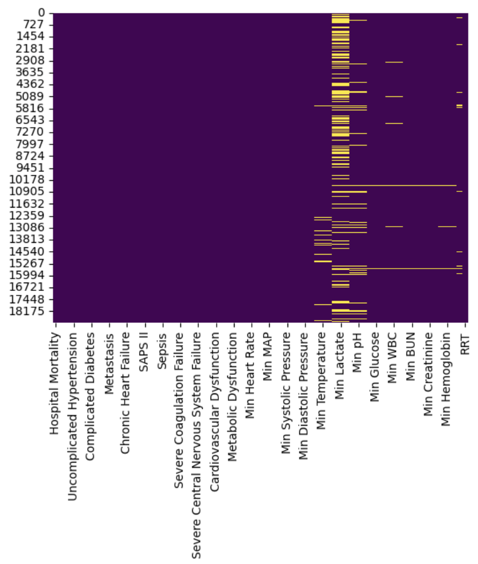The result below shows which variables have missing values and their corresponding count. We have also produced a heatmap to determine the pattern of missing values for all variables.

|  |  |  |
| --- | --- | --- |
| Feature | Count | Percentage (%) Missing |
| Max Heart Rate | 41 | 0.22 |
| Min Heart Rate | 41 | 0.22 |
| Mean Heart Rate | 41 | 0.22 |
| Max MAP | 42 | 0.22 |
| Min MAP | 42 | 0.22 |
| Mean MAP | 42 | 0.22 |
| Max Systolic Pressure | 60 | 0.32 |
| Min Systolic Pressure | 60 | 0.32 |
| Mean Systolic Pressure | 60 | 0.32 |
| Max Diastolic Pressure | 61 | 0.32 |
| Min Diastolic Pressure | 61 | 0.32 |
| Mean Diastolic Pressure | 61 | 0.32 |
| Max Temperature | 687 | 3.64 |
| Min Temperature | 687 | 3.64 |
| Mean Temperature | 687 | 3.64 |
| Max Lactate | 5101 | 27.01 |
| Min Lactate | 5101 | 27.01 |
| Mean Lactate | 5101 | 27.01 |
| Max pH | 1173 | 6.21 |
| Min pH | 1173 | 6.21 |
| Mean pH | 1173 | 6.21 |
| Max Glucose | 75 | 0.40 |
| Min Glucose | 75 | 0.40 |
| Mean Glucose | 75 | 0.40 |
| Max WBC | 229 | 1.21 |
| Min WBC | 229 | 1.21 |
| Mean WBC | 229 | 1.21 |
| Max BUN | 95 | 0.50 |
| Min BUN | 95 | 0.50 |
| Mean BUN | 95 | 0.50 |
| Max Creatinine | 95 | 0.50 |
| Min Creatinine | 95 | 0.50 |
| Mean Creatinine | 95 | 0.50 |
| Max Hemoglobin | 91 | 0.48 |
| Min Hemoglobin | 91 | 0.48 |
| Mean Hemoglobin | 91 | 0.48 |
| Ventilation Duration (h) | 497 | 2.63 |

**Vertical**

The above table shows that Min Lactate, Max Lactate and Mean Lactate columns are missing 27% of their data.

**Horizontal**

The following table reveals that missing values predominantly occur in the vital signs and laboratory results groups. Notably, we found that 41 patients have completely missing vital signs data, and 50 patients have entirely missing laboratory results. We decided to remove 6,084 rows which have at least one missing value across all features.

Additionally, we found a [literature](https://www.ncbi.nlm.nih.gov/pmc/articles/PMC8465577/)[1] from the National Library of Medicine which contains the information about valid ranges for vital signs and laboratory results. Based on this, we have removed additional 310 observations where at least one of its values falls outside of the valid range.

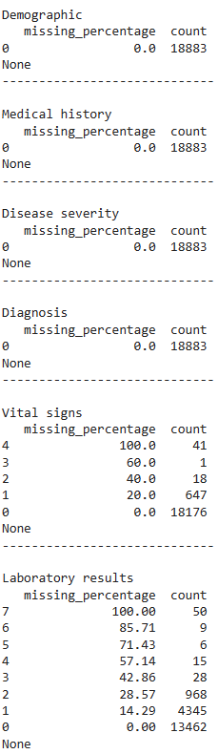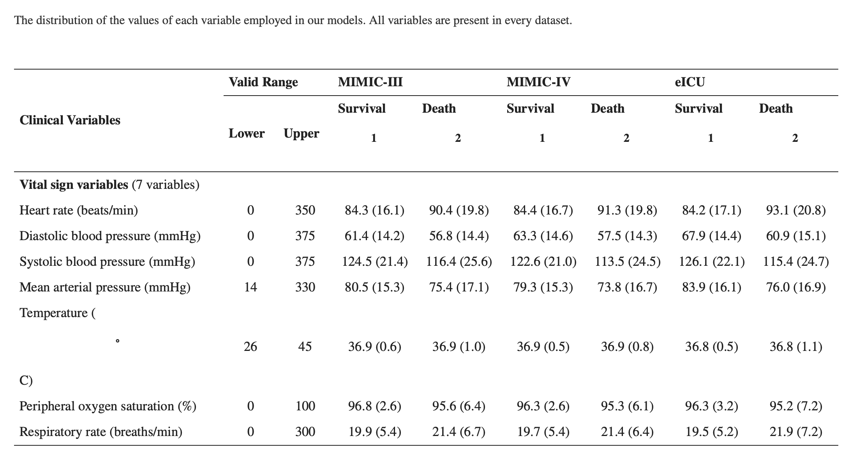

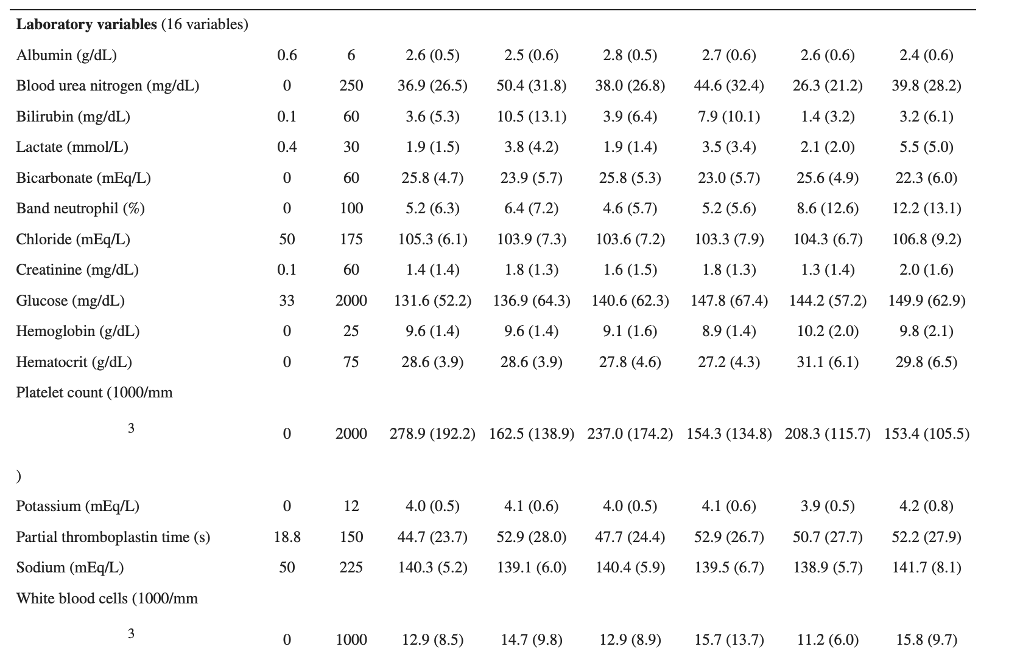

Source: https://www.ncbi.nlm.nih.gov/pmc/articles/PMC8465577/

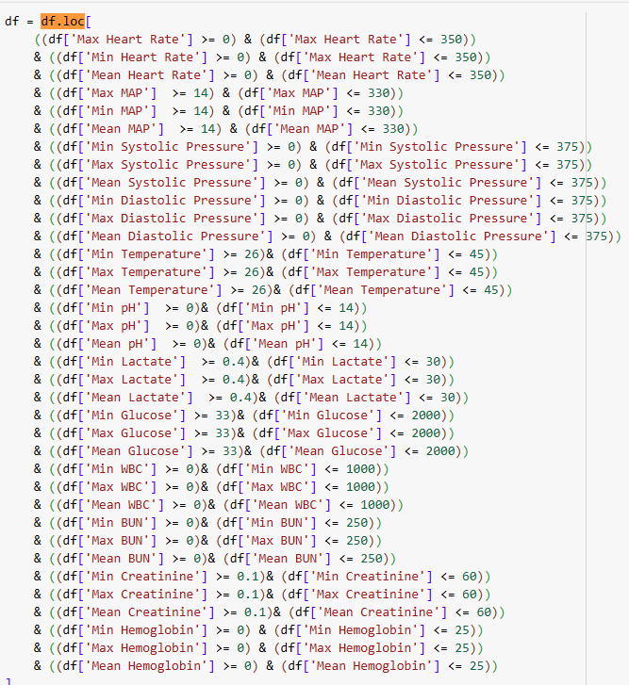

## Examine descriptive statistics for each variable

### Categorical Variables

#### How many distinct values or “levels” does the variable exhibit

There are ~30 categorical values with two levels/ distinct values: 0 or 1

|  |  |
| --- | --- |
| Variable | 0 |
| Hospital Mortality | 2 |
| Gender | 2 |
| Uncomplicated Hypertension | 2 |
| Complicated Hypertension | 2 |
| Uncomplicated Diabetes | 2 |
| Complicated Diabetes | 2 |
| Malignancy | 2 |
| Hematologic Disease | 2 |
| Metastasis | 2 |
| Peripheral Vascular Disease | 2 |
| Hypothyroidism | 2 |
| Chronic Heart Failure | 2 |
| Stroke | 2 |
| Liver Disease | 2 |
| Sepsis | 2 |
| Any Organ Failure | 2 |
| Severe Respiratory Failure | 2 |
| Severe Coagulation Failure | 2 |
| Severe Liver Failure | 2 |
| Severe Cardiovascular Failure | 2 |
| Severe Central Nervous System Failure | 2 |
| Severe Renal Failure | 2 |
| Respiratory Dysfunction | 2 |
| Cardiovascular Dysfunction | 2 |
| Renal Dysfunction | 2 |
| Hematologic Dysfunction | 2 |
| Metabolic Dysfunction | 2 |
| Neurologic Dysfunction | 2 |
| RRT | 2 |

|  |  |  |
| --- | --- | --- |
|  | 0% | 1% |
| Hospital Mortality | 84.02267 | 15.97733 |
| Gender | 0 | 0 |
| Uncomplicated Hypertension | 53.60907 | 46.39093 |
| Complicated Hypertension | 92.2417 | 7.758301 |
| Uncomplicated Diabetes | 79.33061 | 20.66939 |
| Complicated Diabetes | 94.92136 | 5.078642 |
| Malignancy | 89.34491 | 10.65509 |
| Hematologic Disease | 85.103 | 14.897 |
| Metastasis | 95.6151 | 4.384896 |
| Peripheral Vascular Disease | 91.32024 | 8.679765 |
| Hypothyroidism | 91.65387 | 8.346131 |
| Chronic Heart Failure | 75.98369 | 24.01631 |
| Stroke | 94.39708 | 5.602923 |
| Liver Disease | 90.47821 | 9.521792 |
| Sepsis | 85.06593 | 14.93407 |
| Any Organ Failure | 49.29831 | 50.70169 |
| Severe Respiratory Failure | 93.53916 | 6.460838 |
| Severe Coagulation Failure | 99.47042 | 0.529577 |
| Severe Liver Failure | 98.83493 | 1.165069 |
| Severe Cardiovascular Failure | 87.80914 | 12.19086 |
| Severe Central Nervous System Failure | 94.17995 | 5.82005 |
| Severe Renal Failure | 95.13848 | 4.861516 |
| Respiratory Dysfunction | 74.15665 | 25.84335 |
| Cardiovascular Dysfunction | 86.47461 | 13.52539 |
| Renal Dysfunction | 75.43293 | 24.56707 |
| Hematologic Dysfunction | 89.27607 | 10.72393 |
| Metabolic Dysfunction | 90.08103 | 9.918975 |
| Neurologic Dysfunction | 91.03426 | 8.965736 |
| RRT | 97.06085 | 2.939152 |

#### How often does each of these levels occur in the dataset?

* Most of the categorical features have a higher percentage of class 0 than class 1
* Features like Uncomplicated_Hypertension and Any organ failure have a balance between the classes with ~50% distribution for each class.

#### How does the behaviour of another variable, X, vary over the levels of C?

These are the three variables that have significant differences.

##### Age

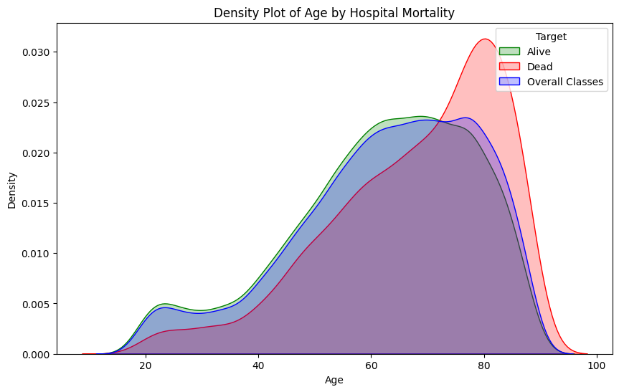

The density plot reveals that the probability of hospital mortality increases with age, particularly after 60. The density drops significantly after the peak. Additionally, we observed a higher density of non-surviving patients after the age of 70. On the other hand, before the age of 60, individuals who are admitted to the hospital and survived have a higher density rate. This could be attributed to the fact that patients before the age of 60 are still physically strong, while those over 60 are often retired and dealing with chronic illnesses, which are more challenging to cure.

##### Heart Rate

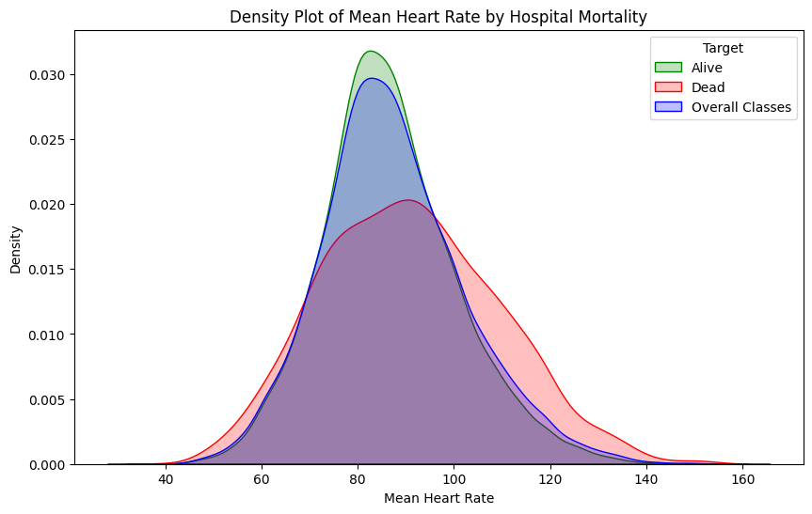

The density plot reveals that most patients who survived had lower heart rates than those without. The heart rate of the surviving patients peaked around 80, while that of those who passed away peaked around 90.

##### Glucose

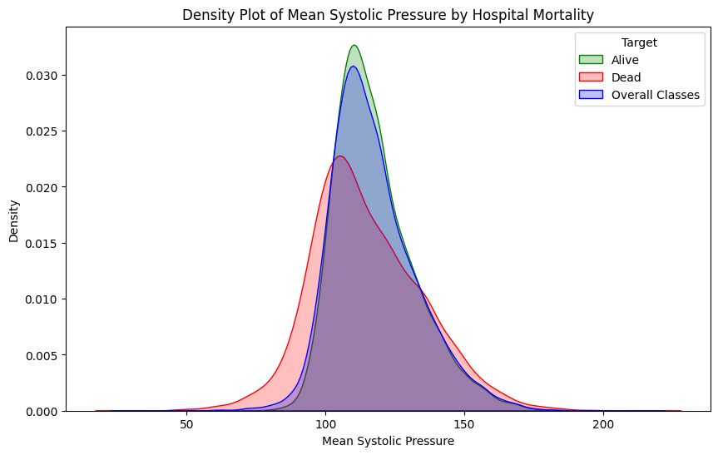

According to the density plot of mean systolic pressure, there is a clear association between systolic pressure and mortality. Patients with higher systolic pressure are more likely to survive, and the density between the alive and dead is significant.

### Numerical Variable

#### What is the mean, median, standard deviation?

* The mean and median are similar for most of the variables, which means most of them follow a symmetric distribution.
* The variables like ventilation duration, WBC, Glucose, Systolic Pressure and Diastolic pressure do not seem to have a bell curve, which means they are affected by other factors.

|  |  |  |  |
| --- | --- | --- | --- |
|  | Mean | Median | Standard Deviation |
| Max Heart Rate | 106.3032 | 104 | 20.20465 |
| Min Heart Rate | 71.28757 | 70 | 15.10189 |
| Mean Heart Rate | 87.3072 | 86 | 14.95483 |
| Max MAP | 108.467 | 102 | 28.96581 |
| Min MAP | 56.98575 | 58 | 13.49352 |
| Mean MAP | 78.04275 | 76.5067 | 10.28279 |
| Max Systolic Pressure | 152.2893 | 149 | 24.06168 |
| Min Systolic Pressure | 87.81793 | 87 | 17.48621 |
| Mean Systolic Pressure | 117.3882 | 114.8611 | 15.61045 |
| Max Diastolic Pressure | 82.91058 | 80 | 17.99794 |
| Min Diastolic Pressure | 43.40686 | 44 | 10.78942 |
| Mean Diastolic Pressure | 60.14084 | 59.13841 | 9.790386 |
| Max Temperature | 37.71966 | 37.7 | 0.826505 |
| Min Temperature | 36.02669 | 36.11111 | 0.971659 |
| Mean Temperature | 36.94948 | 36.95024 | 0.701227 |
| Max Lactate | 3.414678 | 2.5 | 2.865615 |
| Min Lactate | 1.834647 | 1.4 | 1.462907 |
| Mean Lactate | 2.569431 | 2 | 1.954506 |
| Max pH | 7.435479 | 7.44 | 0.071786 |
| Min pH | 7.297606 | 7.31 | 0.104431 |
| Mean pH | 7.370085 | 7.38 | 0.068992 |
| Max Glucose | 189.3344 | 173 | 86.83328 |
| Min Glucose | 109.1762 | 102 | 37.4836 |
| Mean Glucose | 145.9804 | 135.9 | 46.27097 |
| Max WBC | 15.0611 | 13.7 | 10.262 |
| Min WBC | 10.94903 | 10 | 7.456914 |
| Mean WBC | 12.94895 | 11.9 | 8.551809 |
| Max BUN | 24.74585 | 18 | 19.45151 |
| Min BUN | 20.76075 | 16 | 16.87047 |
| Mean BUN | 22.71265 | 17 | 17.98949 |
| Max Creatinine | 1.360863 | 1 | 1.334245 |
| Min Creatinine | 1.122919 | 0.8 | 1.093559 |
| Mean Creatinine | 1.23829 | 0.9 | 1.200874 |
| Max Hemoglobin | 12.39754 | 12.3 | 1.927305 |
| Min Hemoglobin | 9.758317 | 9.6 | 2.217876 |
| Mean Hemoglobin | 10.95254 | 10.7 | 1.847817 |
| Ventilation Duration (h) | 81.15984 | 19 | 154.8556 |
| SAPS II | 37.99121 | 36 | 14.81331 |
| SOFA | 5.04226 | 4 | 3.286905 |
| OASIS | 35.41169 | 35 | 8.258749 |

# Normalization

## Normality check

### Histograms and QQ Plots

When assessing the normality of continuous variables, we created both histograms and quantile-quantile (Q-Q) plots.

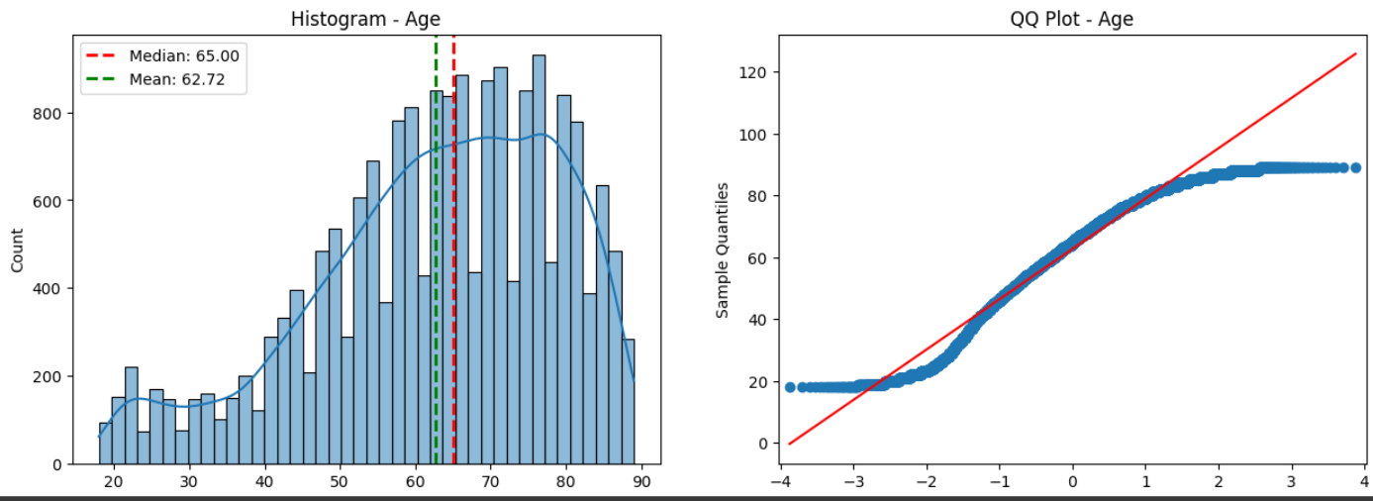

The histogram representing the age variables exhibited a bimodal distribution, indicating that there were two distinct peaks in the data. The Q-Q plot indicated that the age variable deviates from a normal distribution. This can be seen in the graph where points are departing from red line.

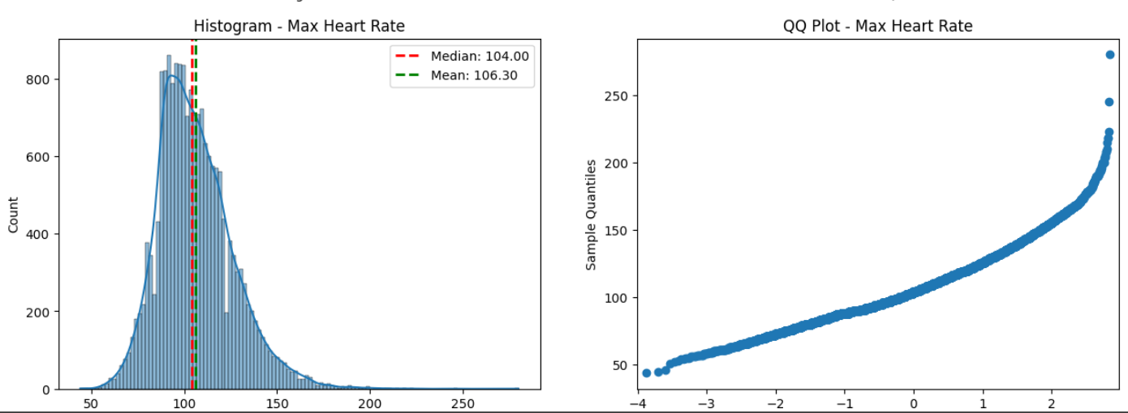

The histogram for the Max Heart Rate is a right skewed curve, which can be confirmed by the QQ plot where the data departs from the straight line at the right side.

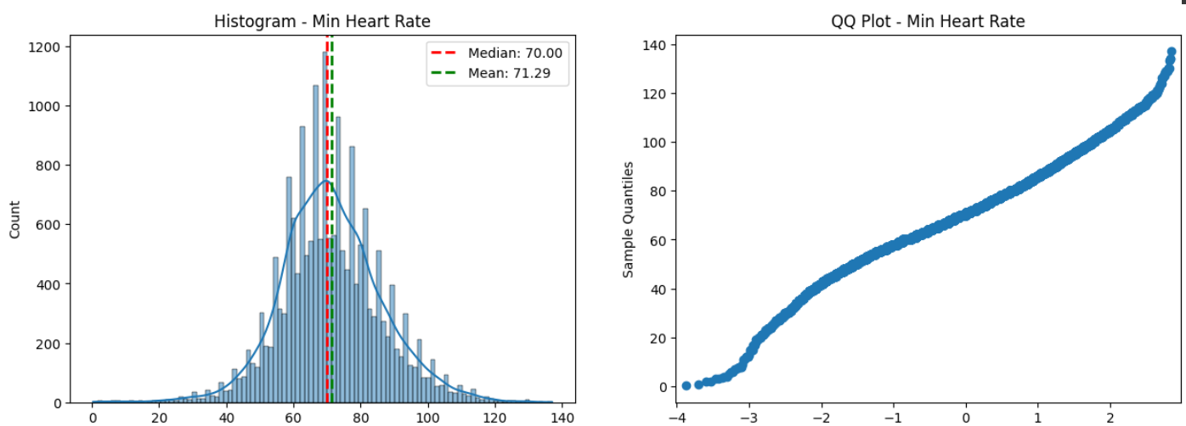

The histogram of the Min Heart Rate follows a normal distribution approximately. This can also be seen in the QQ Plot where the points are falling to a straight line.

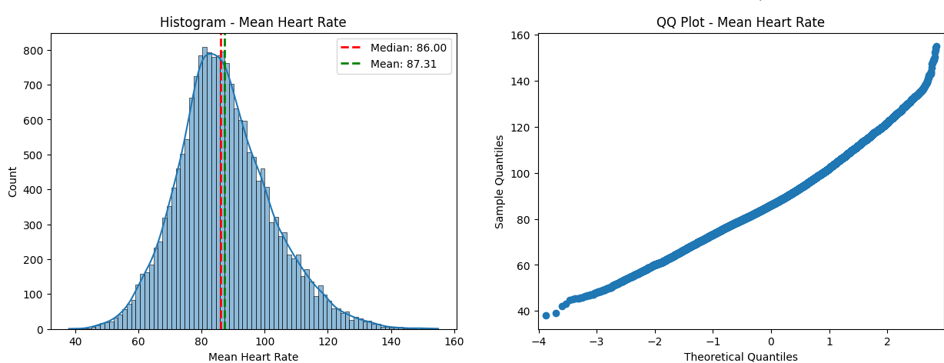

The histogram of the Mean Heart Rate follows a normal distribution approximately. This can also be seen in the QQ Plot where the points are falling to a straight line.

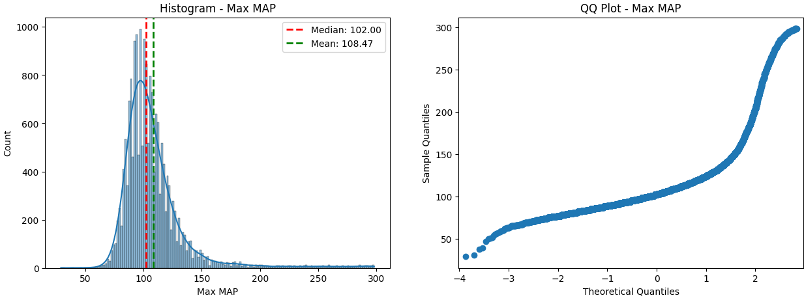

The histogram for the Max MAP is a right skewed curve, which can be confirmed by the QQ plot where the points form a dip on the right side of the plot.

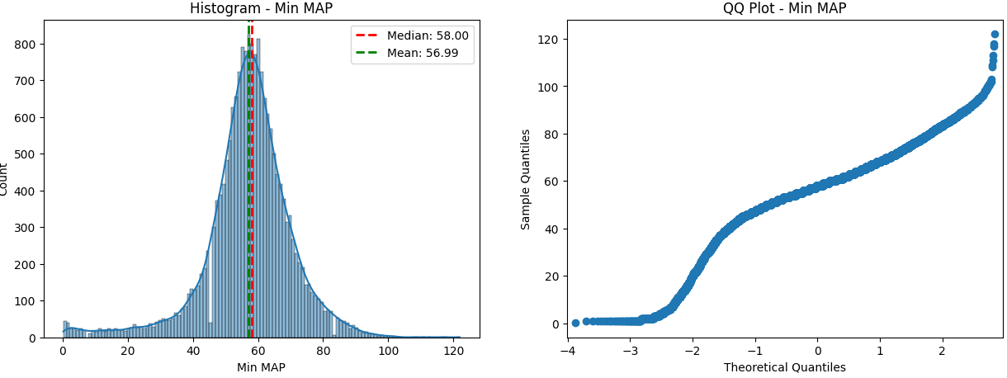

The histogram for the Min MAP is a left skewed curve, which can be confirmed by the QQ plot where the points form a dip on the left side of the plot.

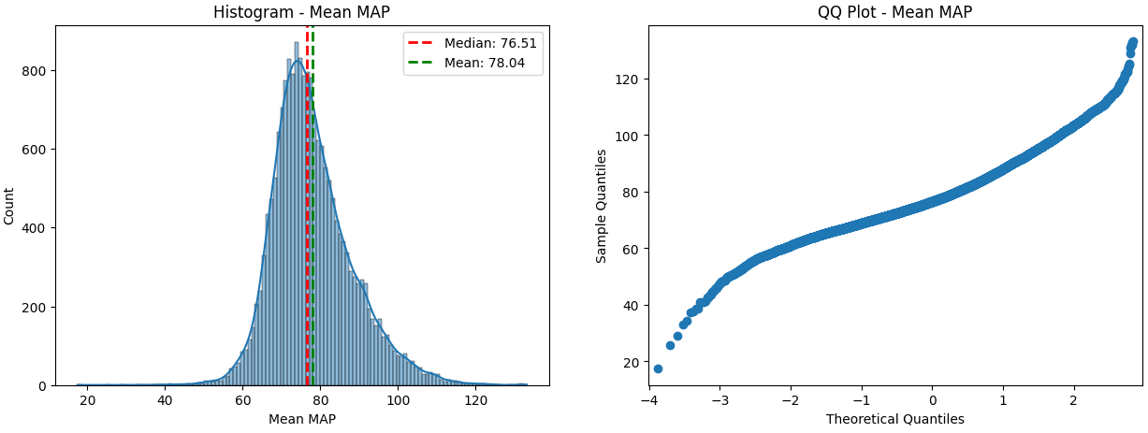

The histogram of the Mean MAP has a longer tail on the left side and shorter tail on the right side, which is clear in the QQ plot where the points from larger dip on the left side and a smaller dip in the right side.

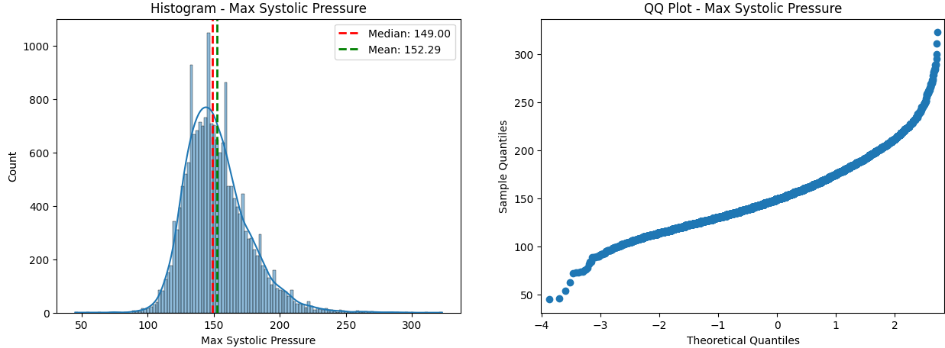

The Max Systolic Pressure has a longer tail on the right side which is confirmed in the QQ plot where there is a larger dip formed in the right side.

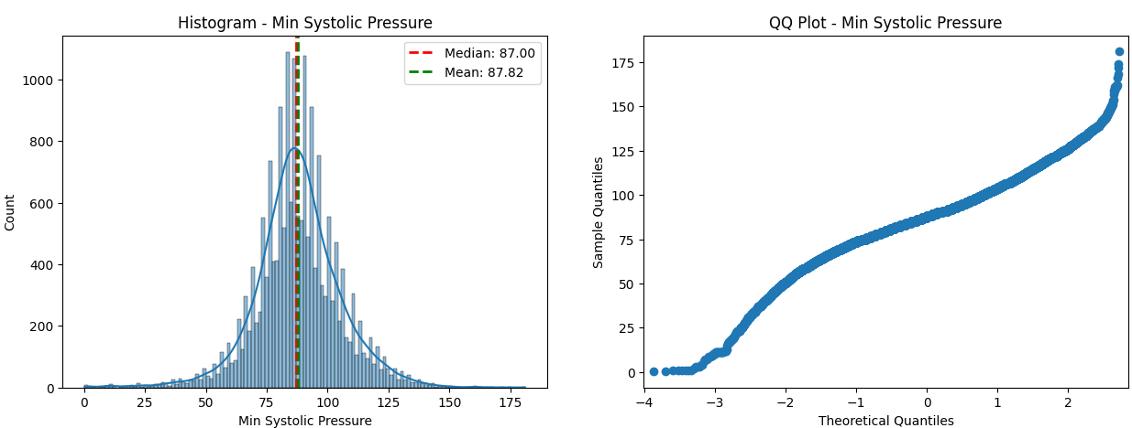

The Min Systolic pressure forms a normal distribution approximately.

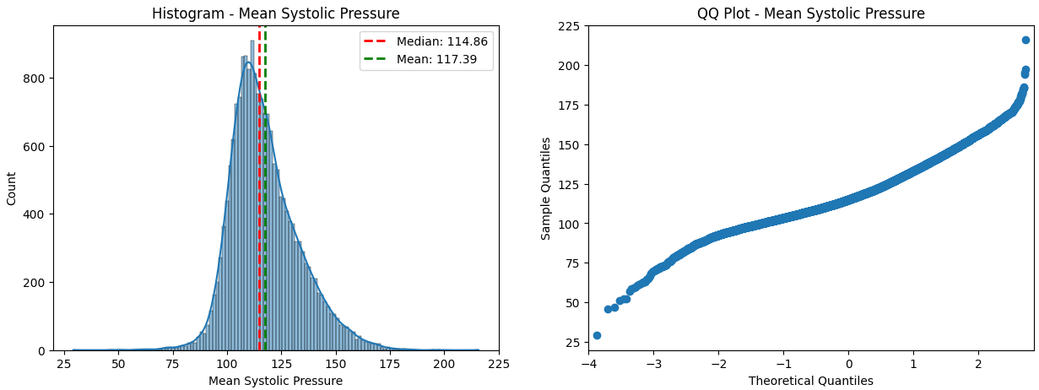

The Mean Systolic pressure forms a normal distribution approximately.

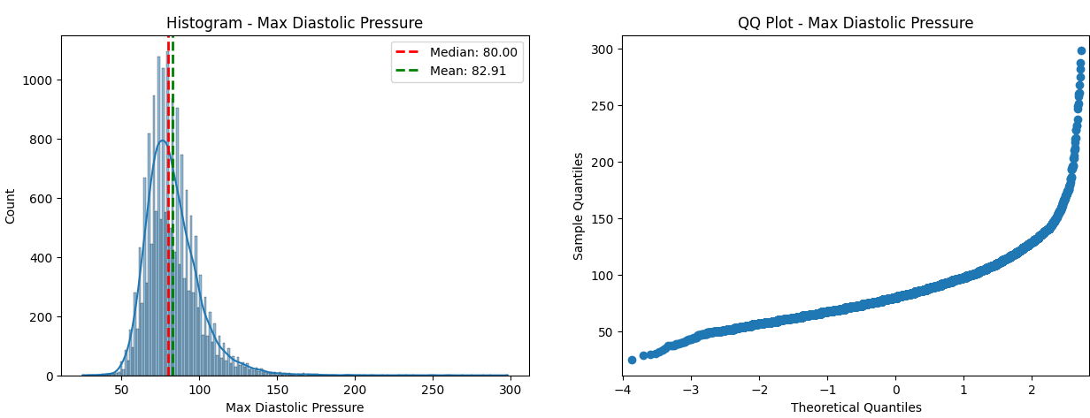

The max Diastolic pressure forms right skewed curve, which can also be seen in the QQ plot where the points form a dip in the right end.

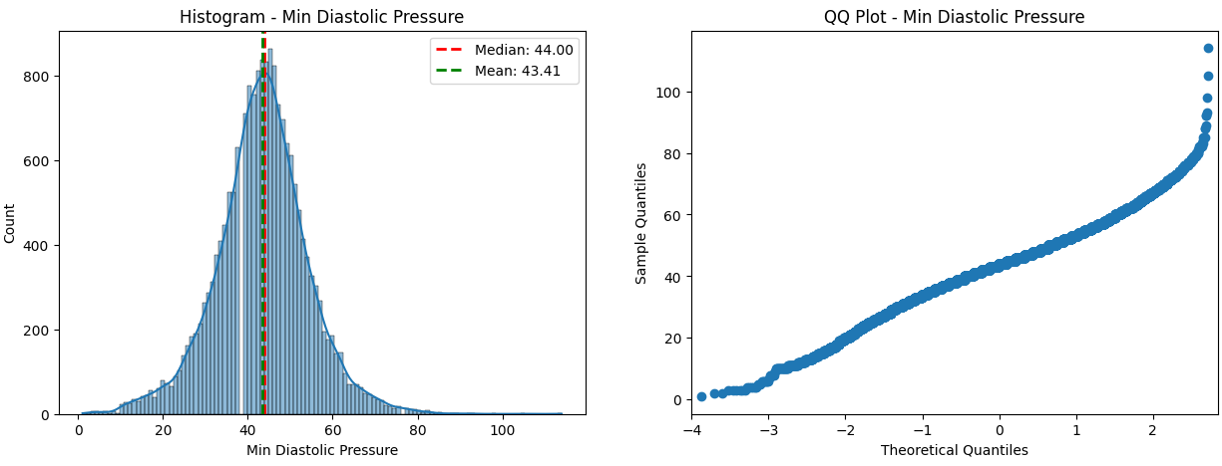

The Min Diastolic pressure forms a normal curve approximately, although there is slight dip in the QQ plot in the right end.

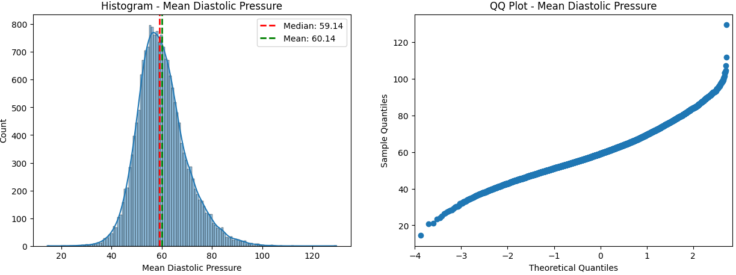

The Mean Diastolic pressure forms a normal curve approximately, although there is slight dip in the QQ plot in the right end.

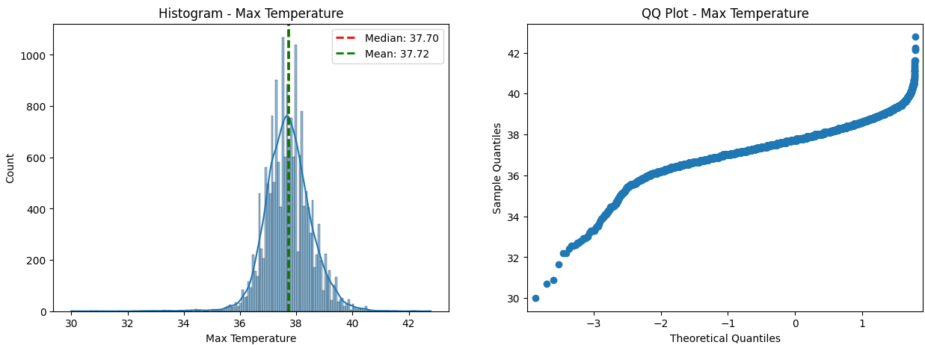

The Max Temperature follows a normal distribution approximately.

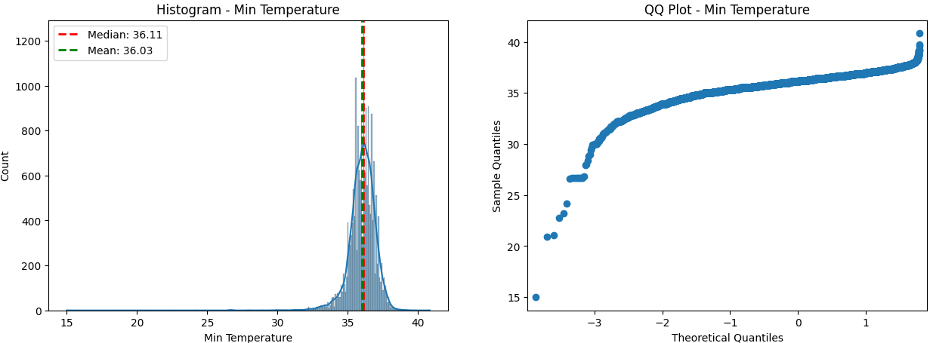

The Min Temperature forms a normal distribution approximately.

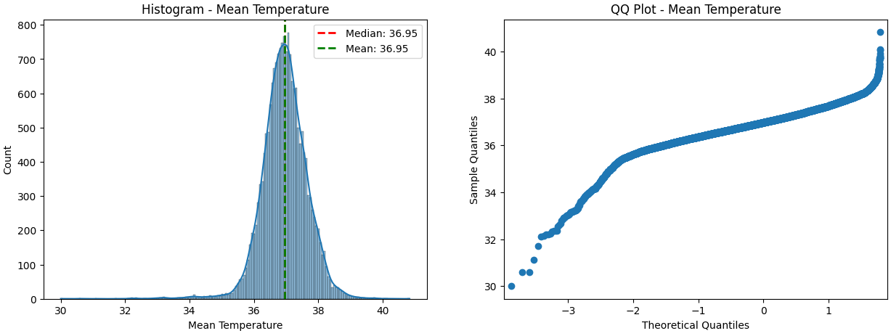

The Mean Temperature follows a normal distribution approximately.

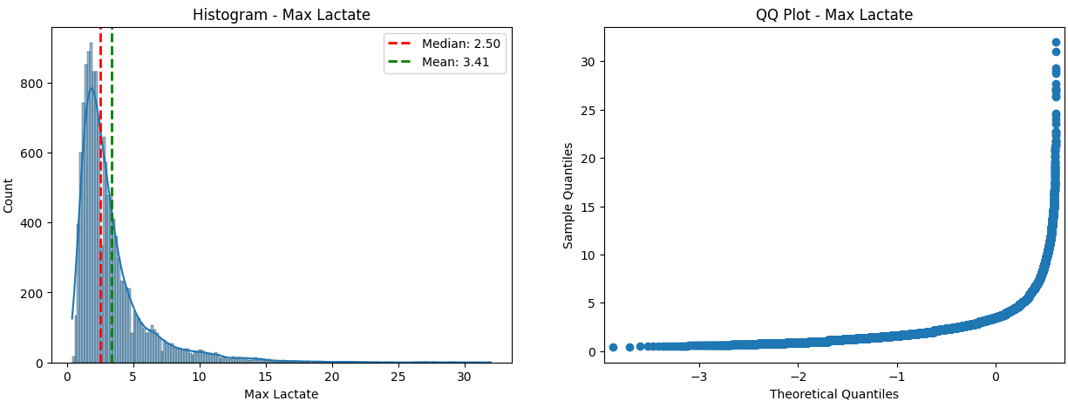

The Max Lactate is extremely right skewed, which is the reason the points form a larger dip in the right end of the QQ plot.

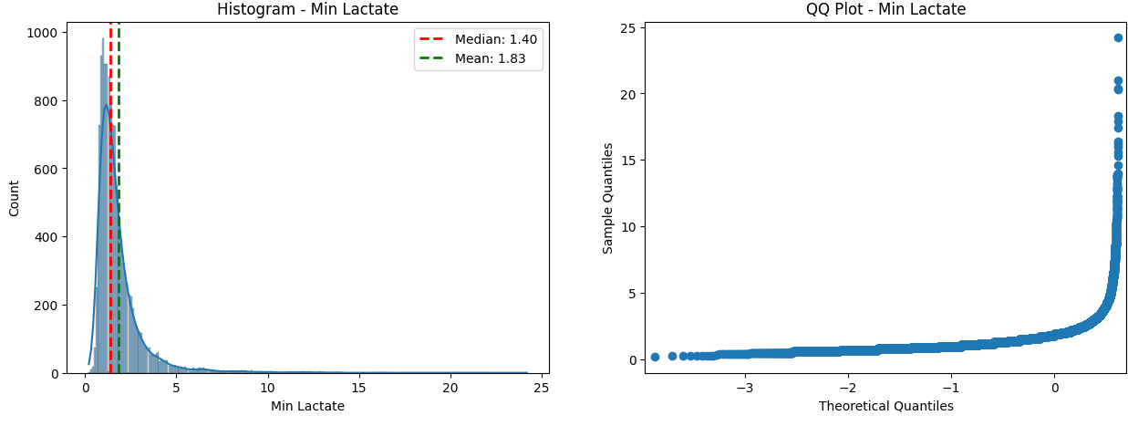

The Min Lactate is extremely right skewed, which is the reason the points form a larger dip in the right end of the QQ plot.

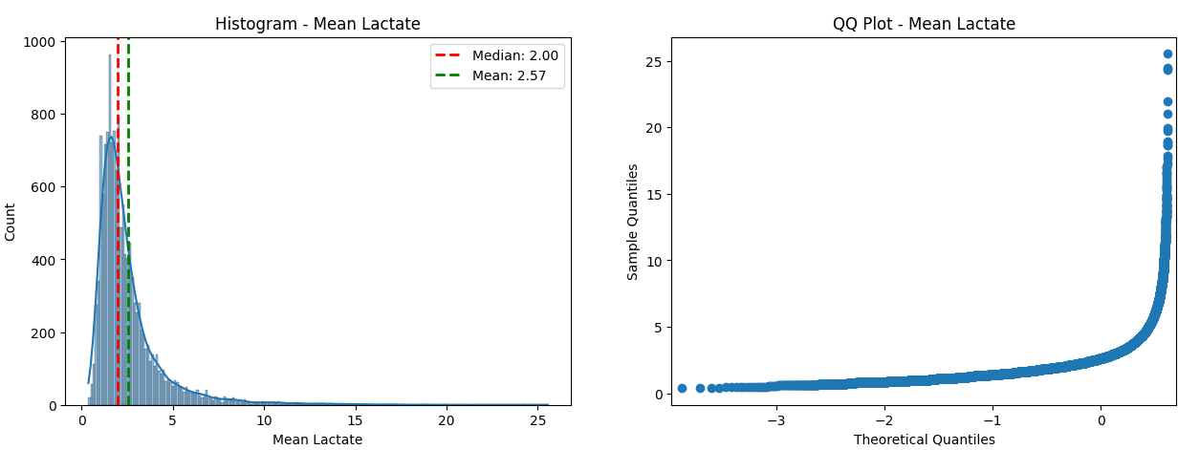

The Mean Lactate is extremely right skewed, which is the reason the points form a larger dip in the right end of the QQ plot.

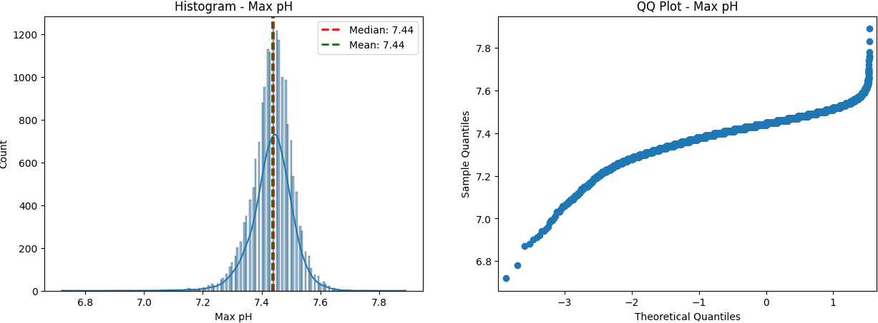

The Max pH follows a normal distribution approximately.

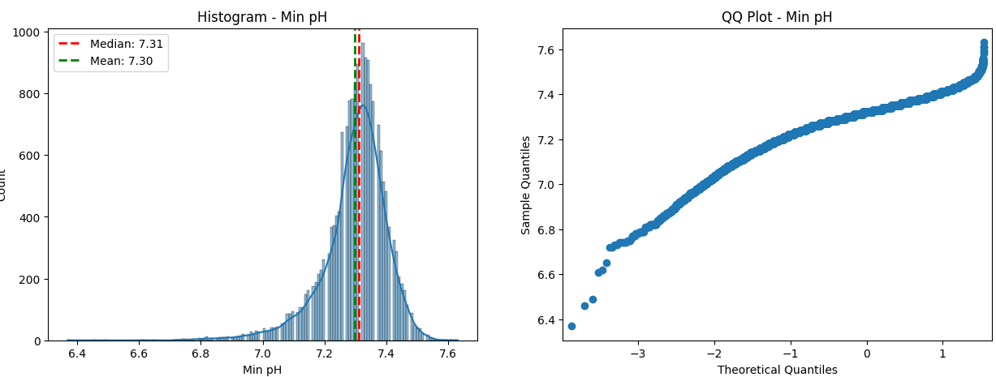

The Min pH follows a normal distribution approximately.

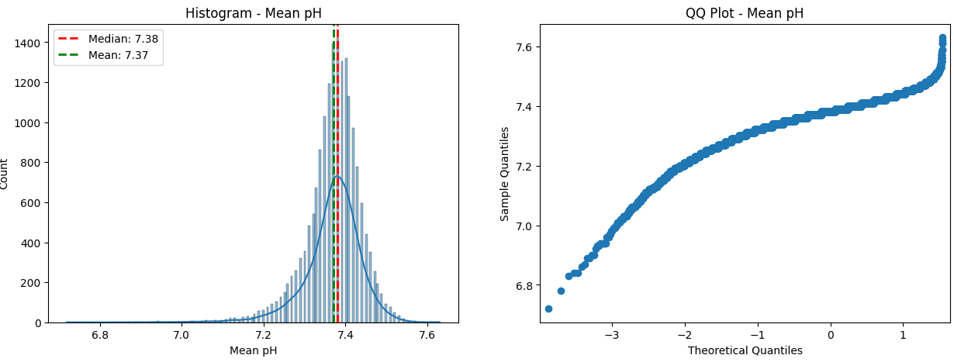

The Mean pH follows a normal distribution approximately.

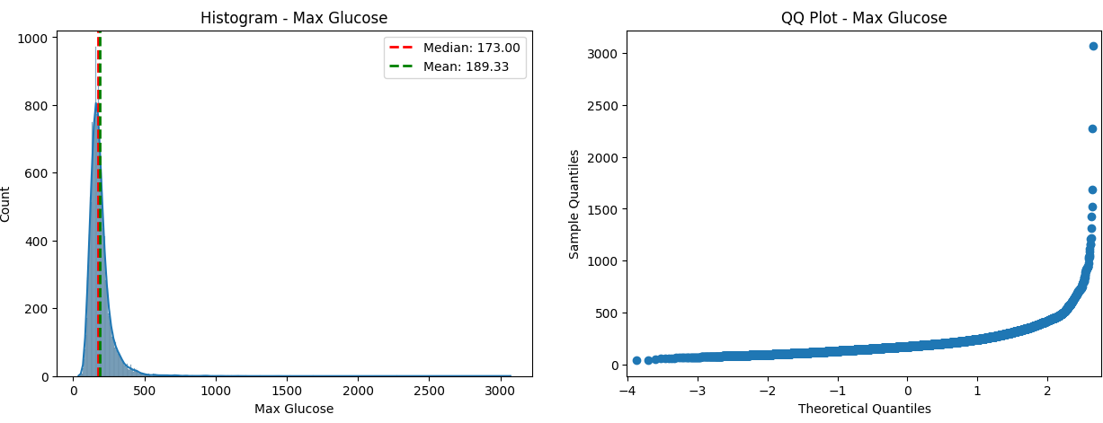

The Max Glucose follows a right skewed distribution.

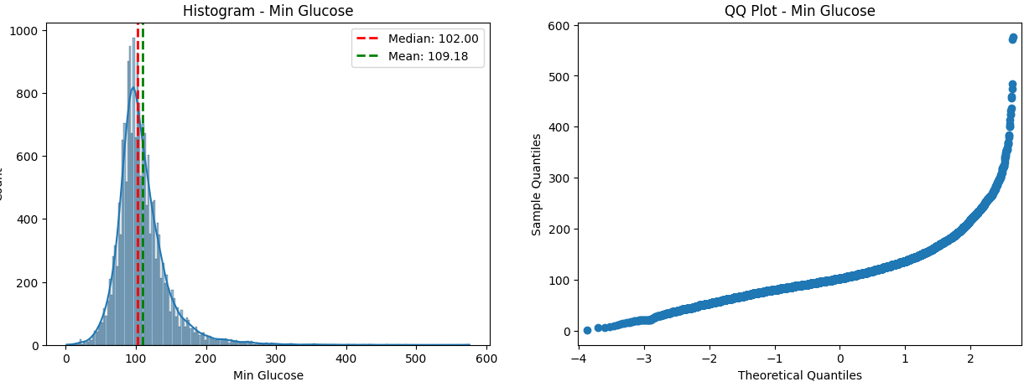

The Min Glucose follows a right skewed distribution.

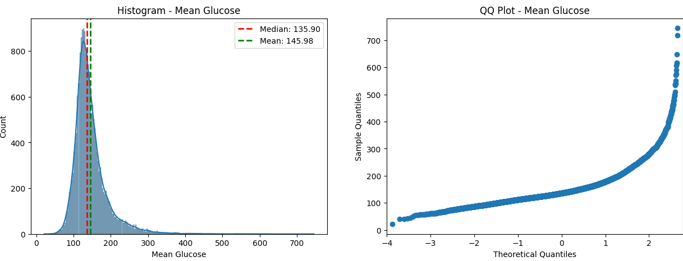

The Mean Glucose follows a right skewed distribution.

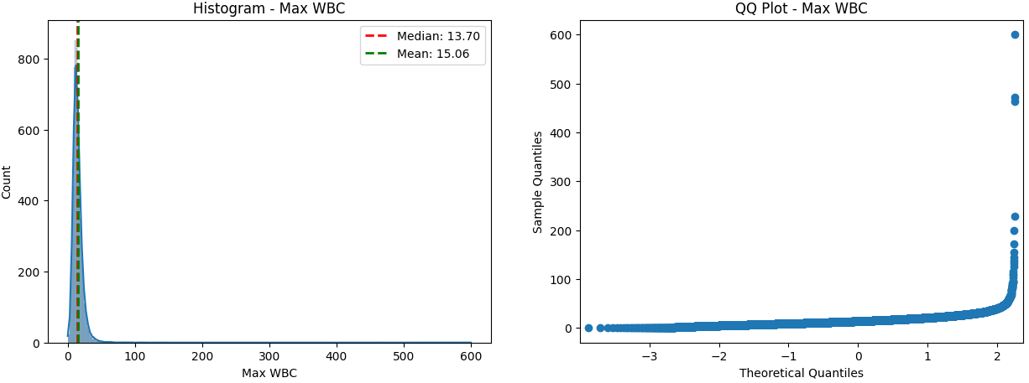

The Max WBC follows right skewed distribution.

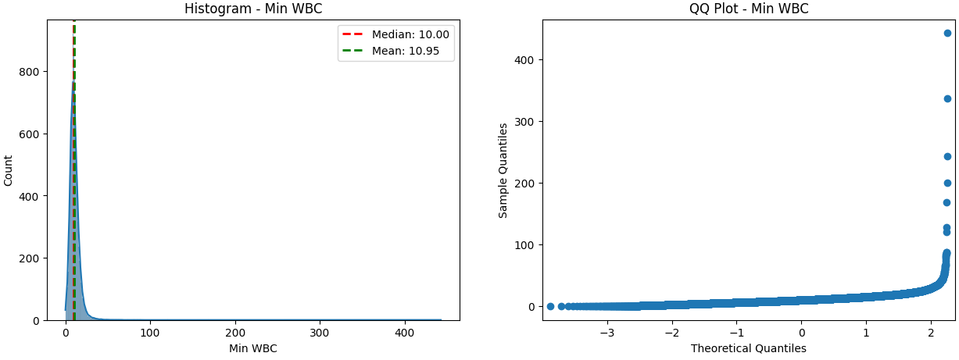

The Min WBC follows right skewed distribution.

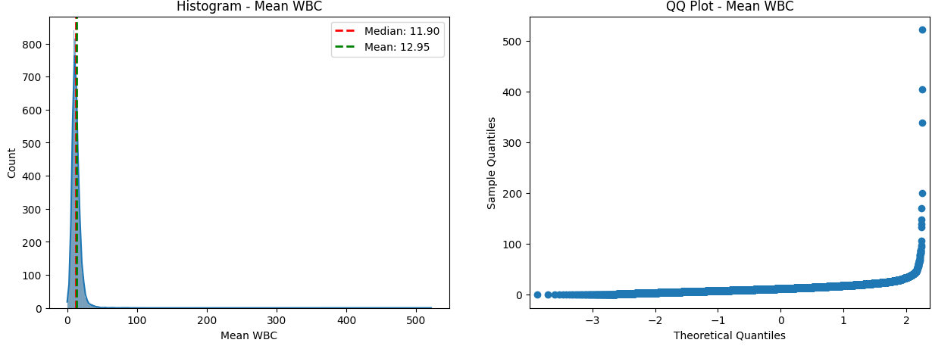

The Mean WBC follows right skewed distribution.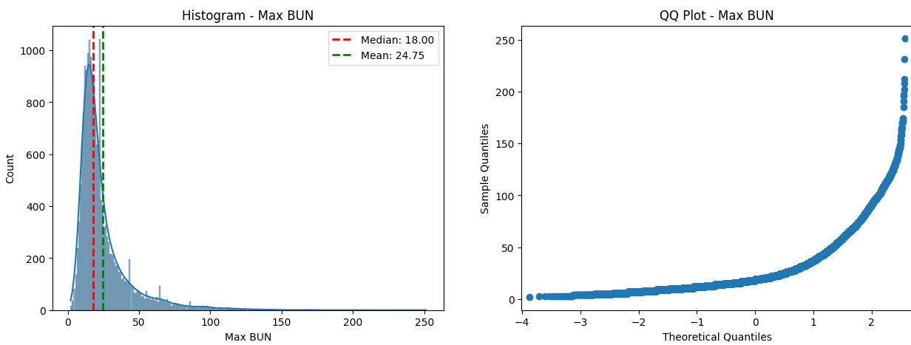

The Max BUN follows a right-skewed distribution.

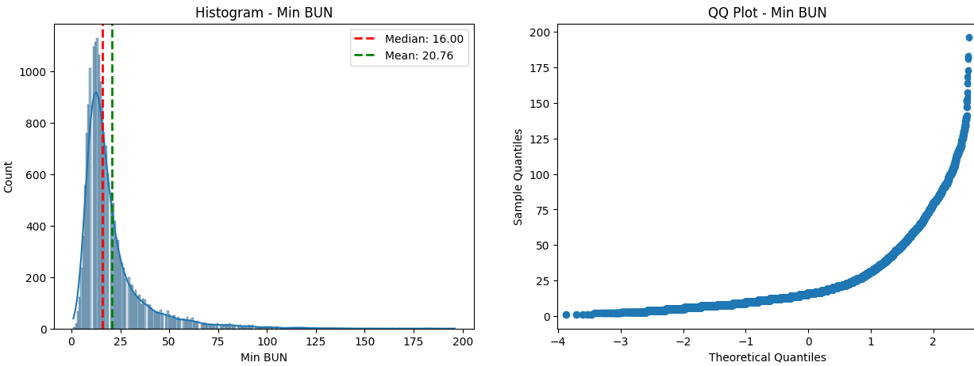

The Min BUN follows a right skewed distribution.

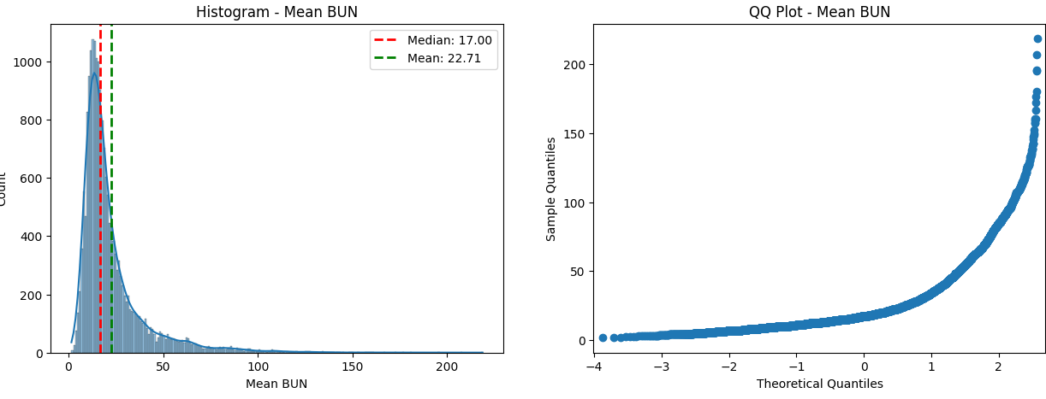

The Mean BUN follows a right skewed distribution.

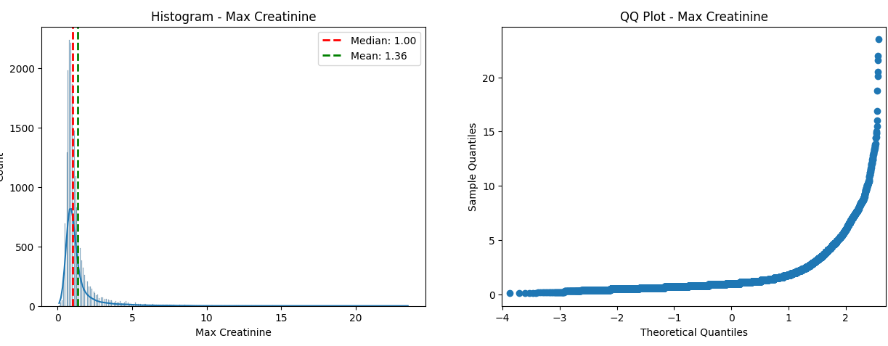

The Max Creatinine follows a right skewed curve.

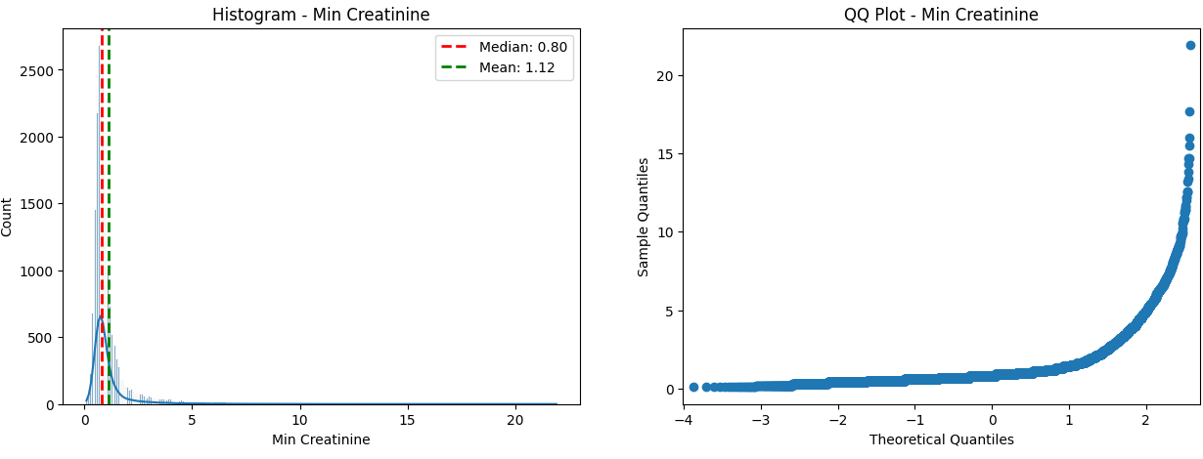

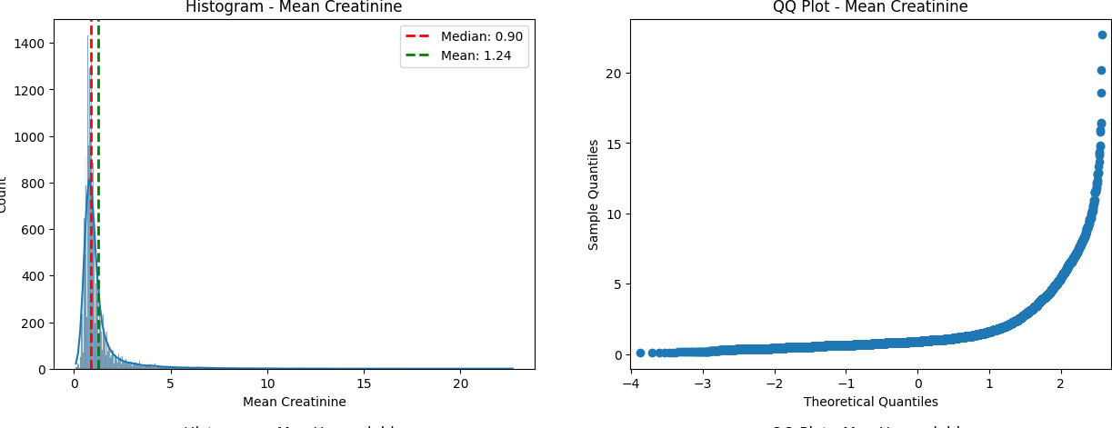The Min Creatinine follows a right skewed curve.

The Mean Creatinine follows a right skewed curve.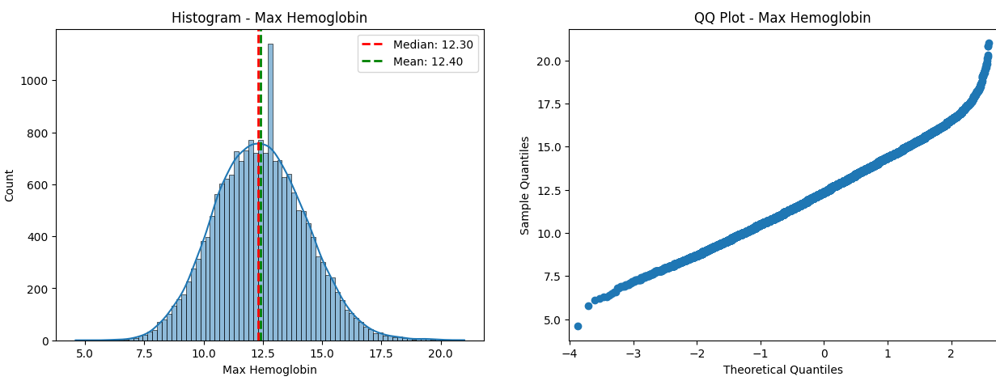

The Max Hemoglobin follows a normal distribution. This is apparent in the QQ plot where the points falls on to a straight line.

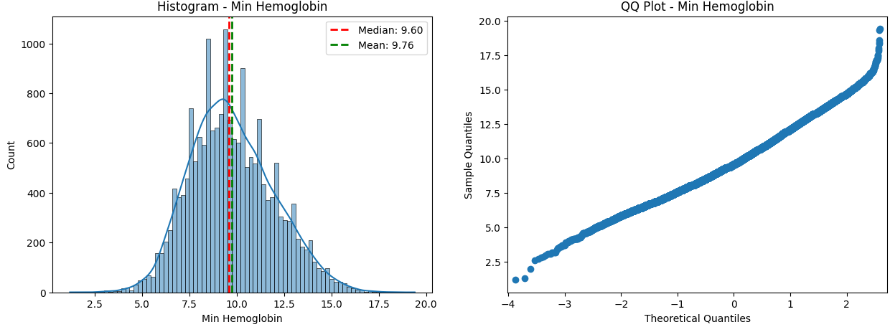

The Min Hemoglobin follows a normal distribution. This is apparent in the QQ plot where the points fall on to a straight line.

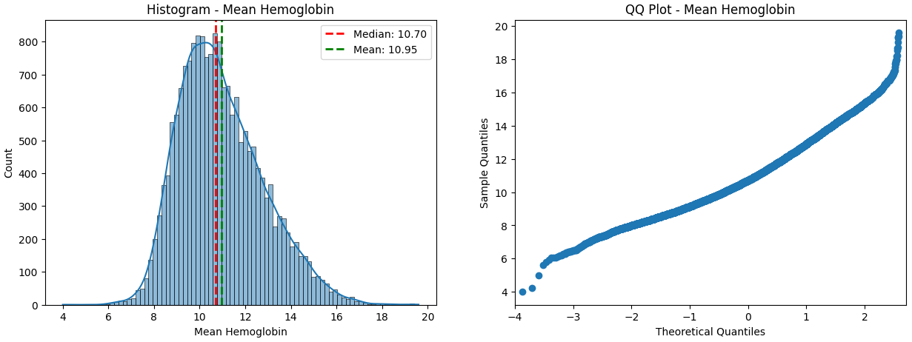

The Mean Hemoglobin follows a normal distribution approximately.

### Shapiro Wilk test

We performed the Shapiro-Wilk test to confirm the normality of the above variables.

Shapiro-Wilk test for Age:

Statistic: 0.9588286876678467

p-value: 0.0

---------------------------------------------------------------------

The following columns are all presented p-value with 0.

---------------------------------------------------------------------

Shapiro-Wilk test for Max Hemoglobin:

Statistic: 0.9976174831390381

p-value: 1.2826694035654755e-15

The distribution of Max Hemoglobin is significantly different from normal.

---------------------------------------------------------------------

Shapiro-Wilk test for Min Hemoglobin:

Statistic: 0.9931529760360718

p-value: 2.2844843665866908e-27

The distribution of Min Hemoglobin is significantly different from normal.

---------------------------------------------------------------------

Shapiro-Wilk test for Mean Hemoglobin:

Statistic: 0.9779326319694519

p-value: 1.5414283107572988e-44

The distribution of Mean Hemoglobin is significantly different from normal.

---------------------------------------------------------------------

**/usr/local/lib/python3.10/dist-packages/scipy/stats/_morestats.py:1882: UserWarning: p-value may not be accurate for N > 5000.**

**warnings.warn("p-value may not be accurate for N > 5000.")**

Upon reviewing the test results, we observed that none of the variables conform to a normal distribution. This discrepancy may be due to a failure to meet one of the test’s conditions. Specifically, the sample size exceeds 5000, which violates a condition for this test.”

## Normalization

Since the continuous variables do not follow a normal distribution, we used four methods to normalize them as our purpose was to perform parametric tests on these variables.

### Method 1 – Log Transformation Method

We applied log transformation method to achieve normal distributions in the variables.

**Result**

In the case of Max Heart Rate, Mean Heart Rate, Max Systolic Pressure, Max Hemoglobin and Mean Hemoglobin, we were able to achieve distributions that closely resemble a normal distribution.

For the remaining variables, there was still significant deviation from the normal distribution.

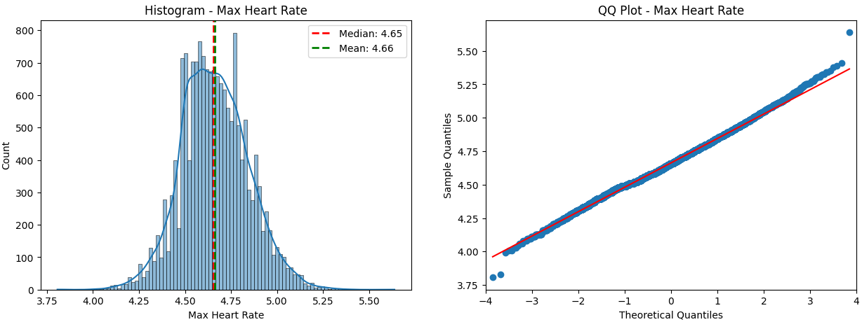

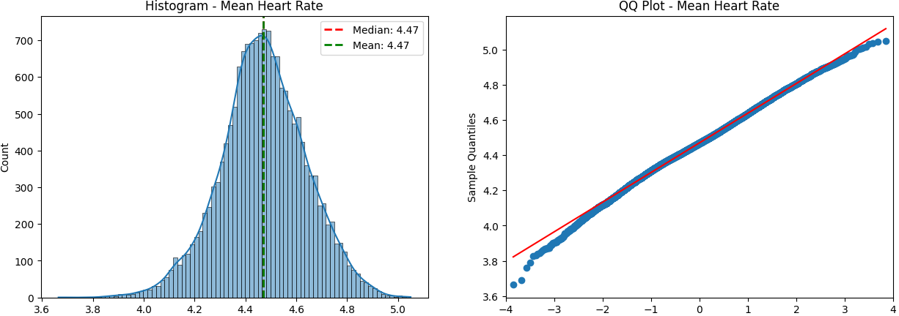

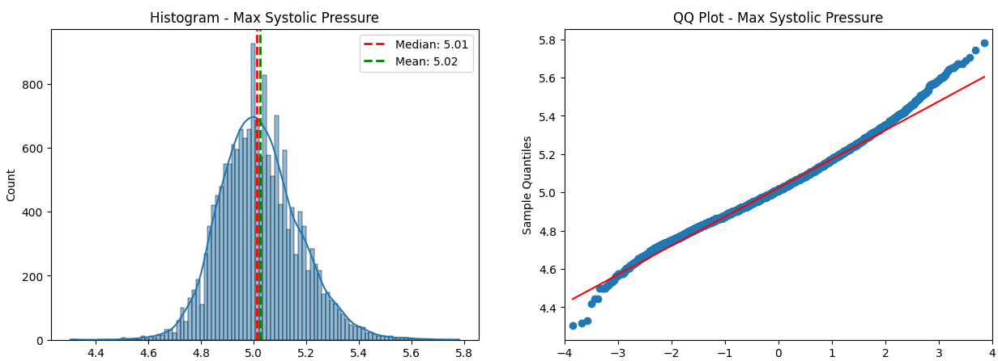

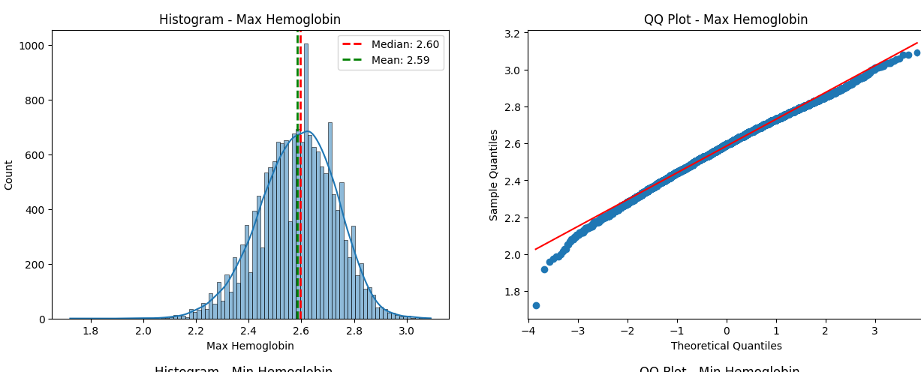

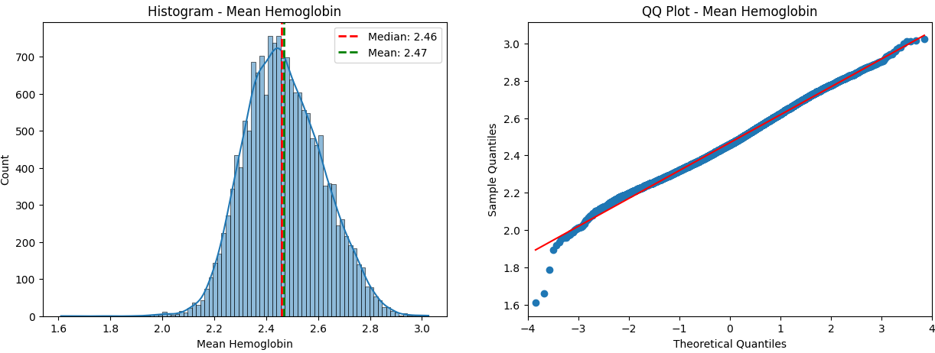

However, the Shapiro-Wilk test conducted after the Log Transformation indicated that all the variables exhibit distributions significantly different from the normal distribution.”

### Method 2 – L2 Normalization

We used the Euclidean normalization method to achieve a normal distribution for the data. The L2 norm is a measure of the magnitude (length) of a vector and is defined as the square root of the sum of the squared elements of the vector.

Among the variables we examined, Mean Heart Rate, Min Diastolic Pressure, Max Hemoglobin, and Min Hemoglobin exhibited distributions that closely resembled a normal distribution. However, for the remaining variables, there was significant deviation from the normal distribution.

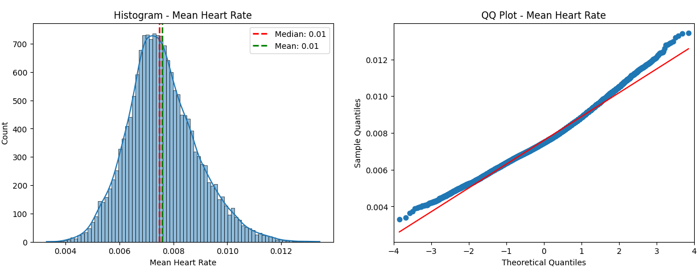

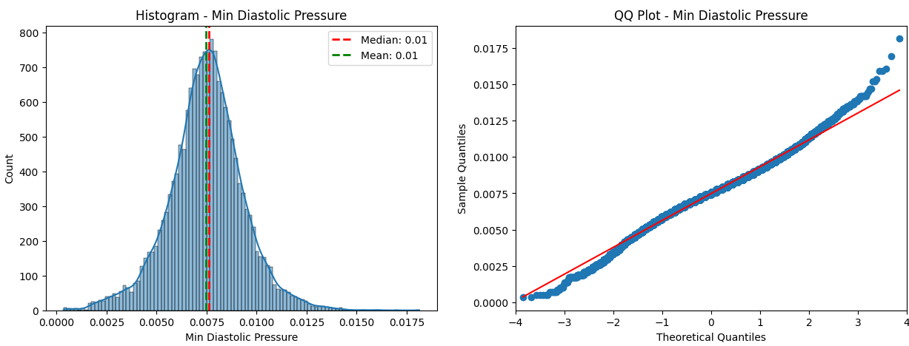

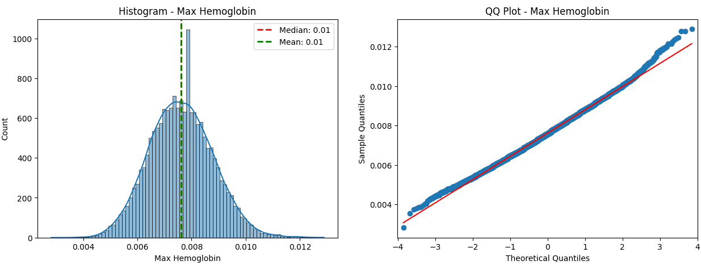

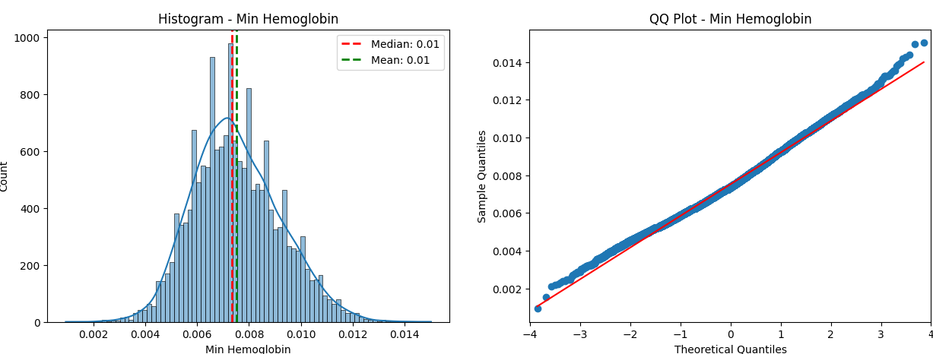

### Method 3 – BoxCox Method

To achieve normal distributions for the variables, we utilized the BoxCox transformation method. To align the data with a more Gaussian-like distribution, improving the suitability for statistical analyses

In our analysis, we observed that Mean Heart Rate, Min Diastolic Pressure, Max Hemoglobin, and Min Hemoglobin displayed distributions that closely resembled a normal distribution. However, for the remaining variables, there was significant deviation from the normal distribution.

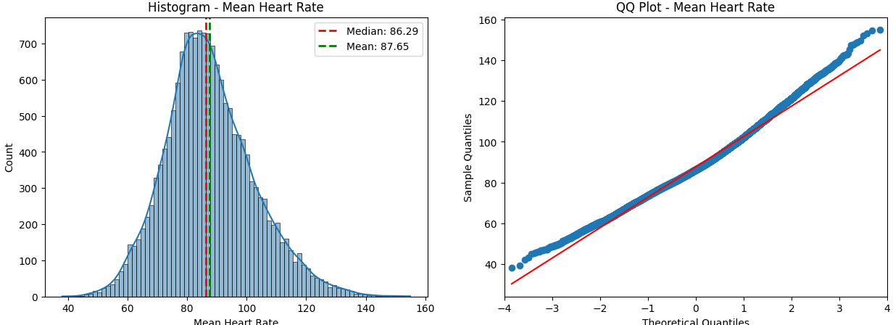

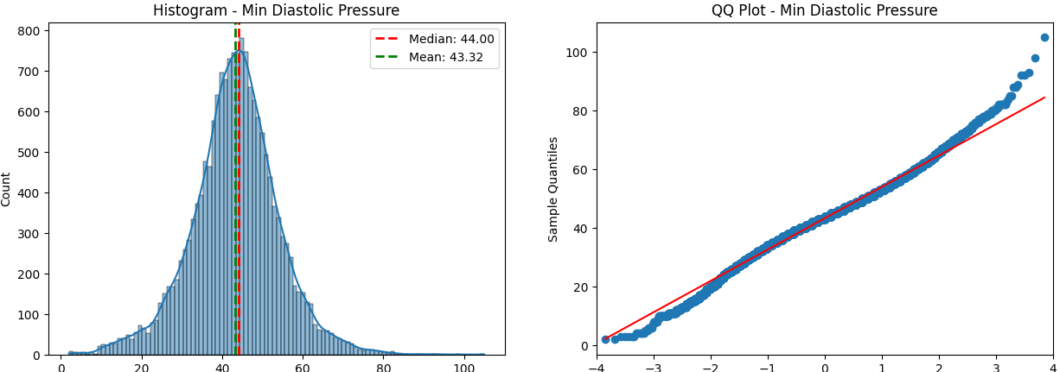

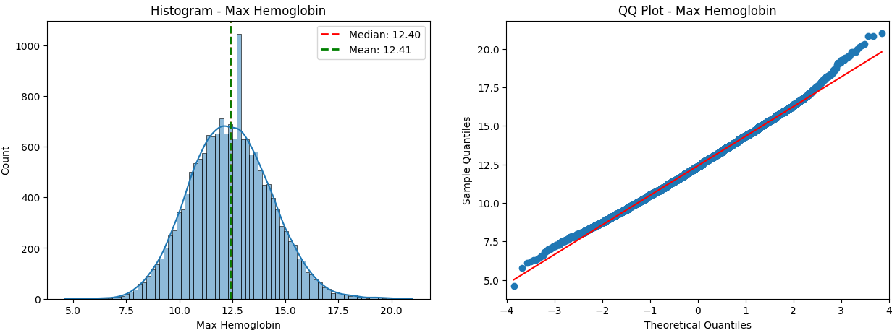

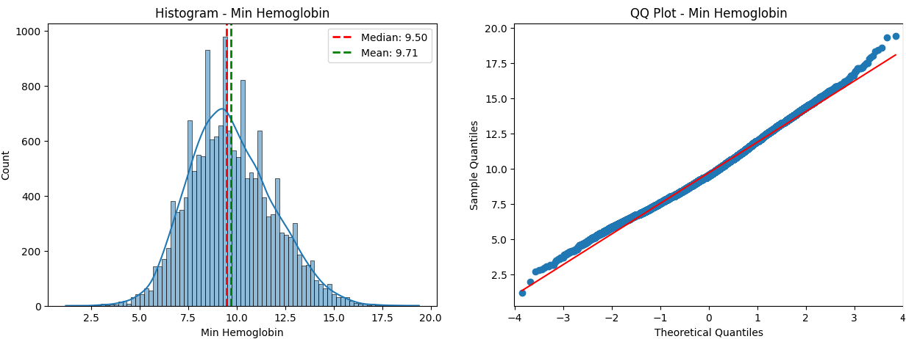

### Method 4 – Min-Max Method

We applied the Min-Max method to achieve normal distributions in the variables.

Among the variables we examined, Mean Heart Rate, Min Diastolic Pressure, Max Hemoglobin, and Min Hemoglobin exhibited distributions that closely resembled a normal distribution. However, for the remaining variables, there was significant deviation from the normal distribution.

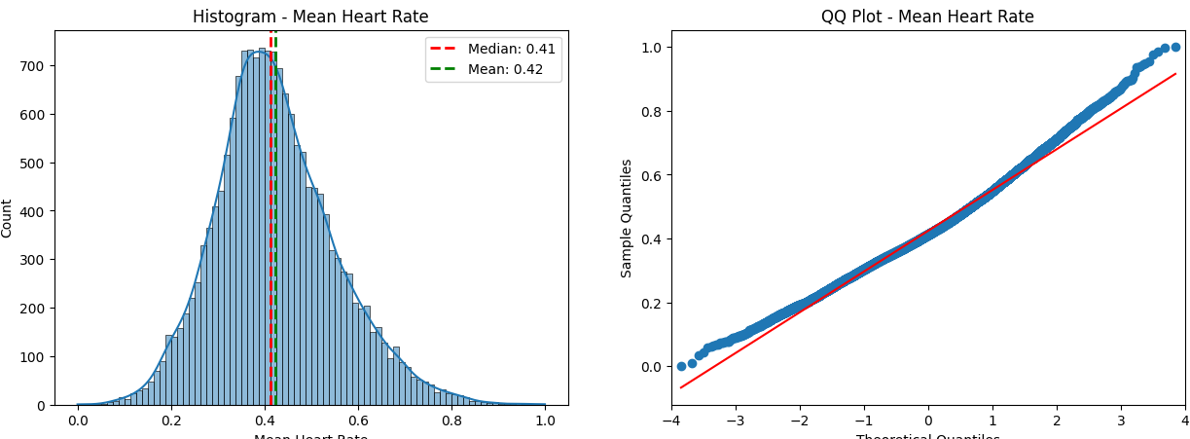

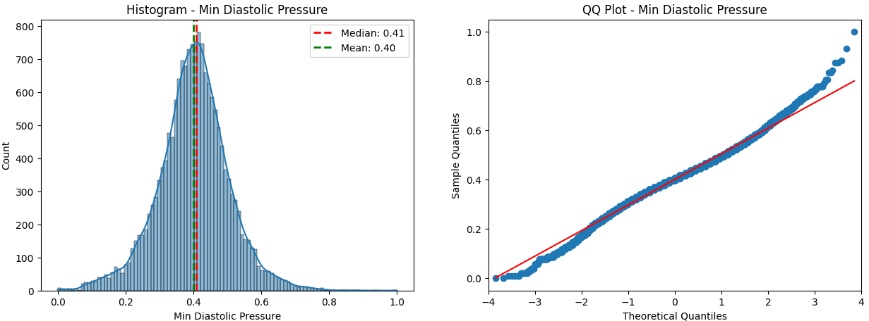

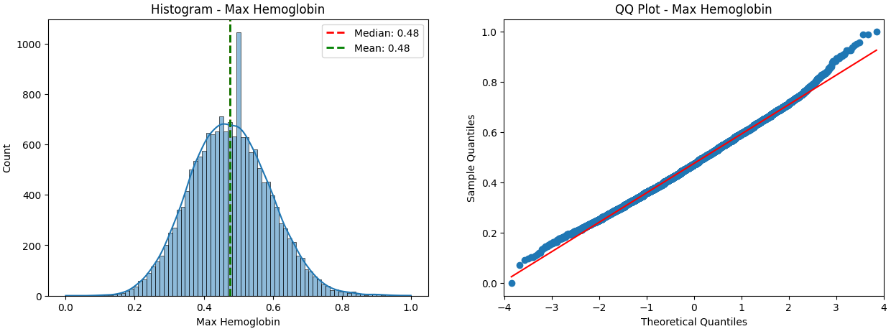

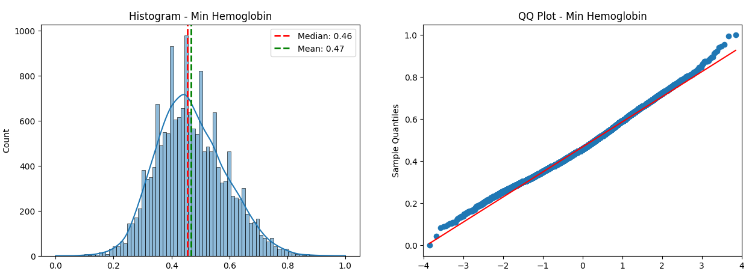

# Statistical Tests

## Ordinal Variables

### Mann-Whitney U test

We used the Mann-Whitney U and Spearman Correlation tests for the ordinal variables. Note that all assumptions listed below are met.

Mann-Whitney U Assumptions:

1. Observations in each group are independent of each other.
2. Random sampling is assumed.
3. The variables are ordinal or interval.
4. Shapes of the distributions in the two groups are similar.

**H0 = The distributions of the living group are equal to those of the deceased group.**

**Ha = There is a difference between the distributions of the two groups.**

Since the p-value is <.05 for all 3 variables, we have enough evidence to reject the null hypothesis. Therefore, can conclude that there is a difference between the distributions of the two groups, dead and alive.

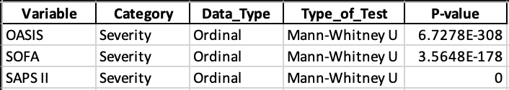

### Spearman Correlation

We divided the dataset into two groups, survivors and non-survivors, and calculated the Spearman correlation coefficient for each pair of variables within each group.

Spearman Correlation Assumption:

1. The variables are either ordinal or continuous data that follow a monotonic relationship.

**H0: There is no monotonic association between the two variables.**

**Ha: There is a monotonic association between the two variables.**

The result of the correlation test reveals that the correlation coefficients in the non-survivor groups are higher compared to the survivor groups which suggests that the relationship between variables differ between the two groups.

The resulting correlation coefficients suggests that there is moderate positive monotonic relationship between SAPS II and SOFA, and SAPS II and OASIS and a weak positive monotonic relationship between SOFA and OASIS. With the significance level at 0.05, the p-value tells us that the results are statistically significant.

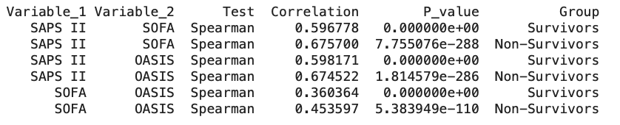

### Visualization of Ordinal Variables

##### Scatter Plot

The scatter plot illustrates that there is a positive relationship between each pair of the ordinal variables.

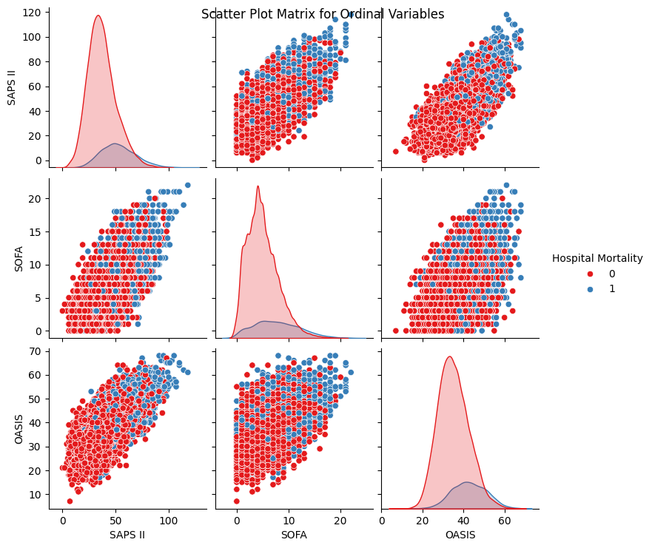

##### Density Plots

The density plots for all three severity-of-illness score variables reveal that the variability of scores for non-survivors is much more spread out compared to survivors.

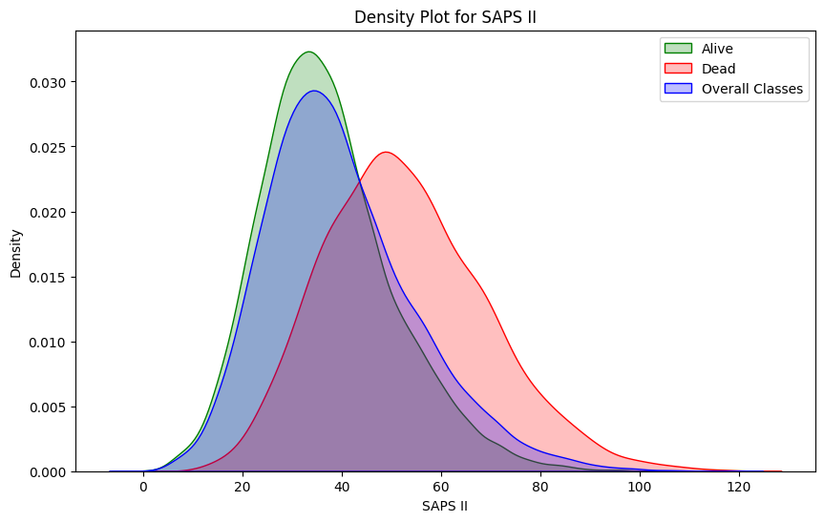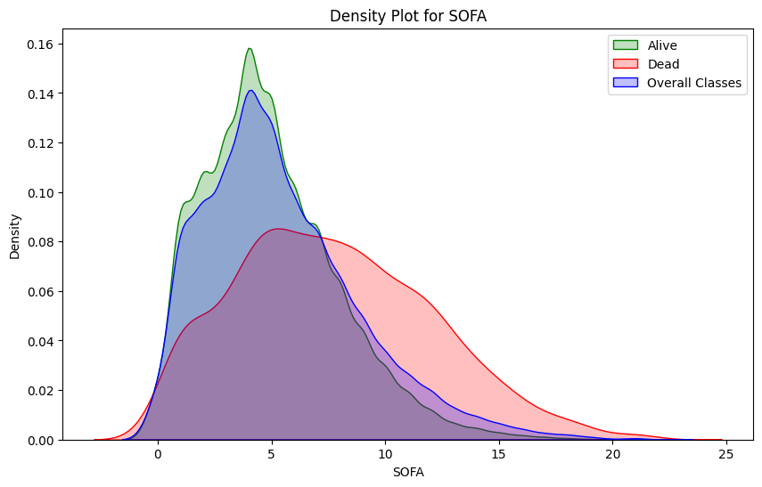

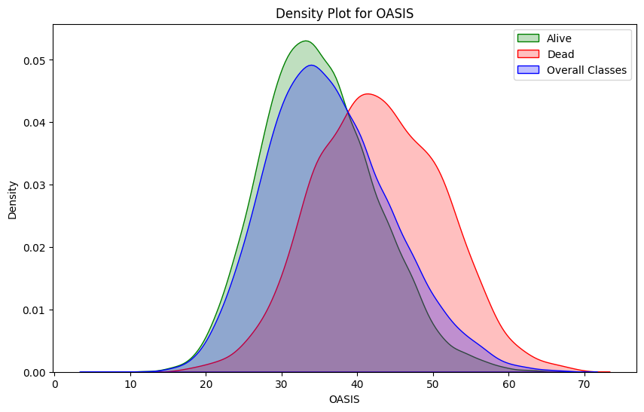

## Categorical Variables

### Chi-Square test

With respect to the categorical variables, we used the Chi-Square Test of Independence. Note that all assumptions listed below are met.

Assumptions:

1. The observations in the independence table must be independent.
2. The variables are categorical.
3. Random sampling is assumed.
4. Each cell in the contingency is >5.

**H0 = The presence of the medical condition and the survival outcome of the patients are independent**

**Ha = There is a significant association between the presence of the medical condition and the survival outcome of the patients.**

For all categorical variables, except uncomplicated diabetes, complicated diabetes, peripheral vascular disease and hypothyroidism, the resulting p-value is < 0.05. This implies that, for the mentioned variables, we failed to reject the null hypothesis and that there is no significant association between the presence of these medical conditions and the survival outcome of the patients. For the rest of the variables with p-value < 0.05, we can assume that there is significant association.

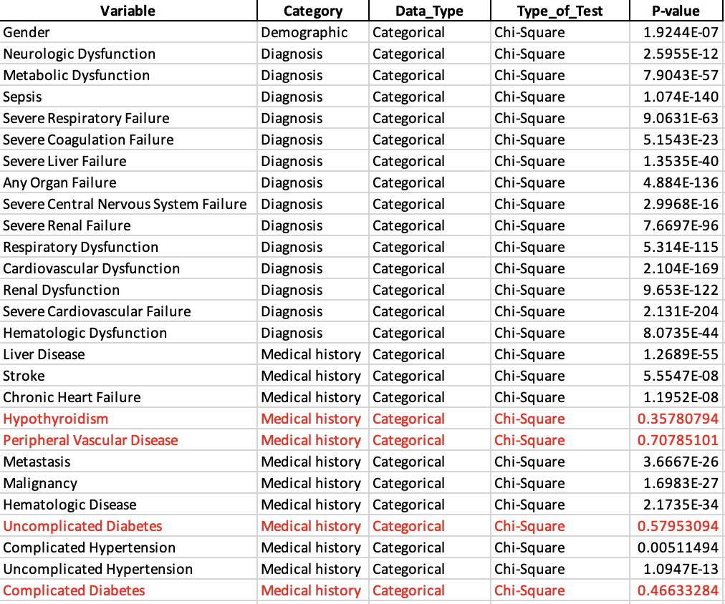

### Visualization of Categorical Variables

##### Bar Graphs

The following visualization of ordinal variables provides valuable insights into the differences in proportions between individuals with medical conditions and those without relative to the patient survival outcome.

In summary, these are the critical findings we can infer from the graphs:

* There are more males than females in both the non-survivor and survivor groups.

The following statistics relate to the non-survivor group:

* **80%** have any organ failure
* **50%** have respiratory dysfunction
* **49%** have renal dysfunction.
* **37%** have uncomplicated hypertension
* **37%** have sepsis
* **36%** have severe cardiovascular failure
* **36%** have cardiovascular dysfunction
* **29%** have chronic heart failure
* **25%** have hematologic diseases
* **23%** have metabolic dysfunction
* **21%** have hematologic dysfunction
* **20%** have liver disease
* **19%** have uncomplicated diabetes
* **19%** have malignancy
* **17%** have severe respiratory failure

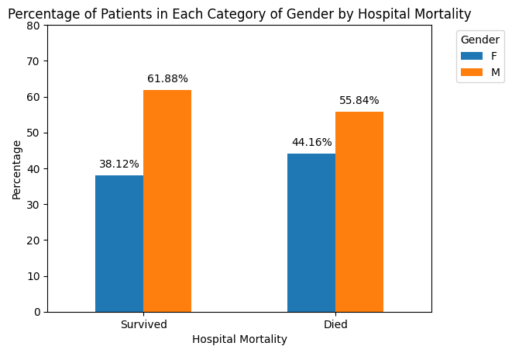

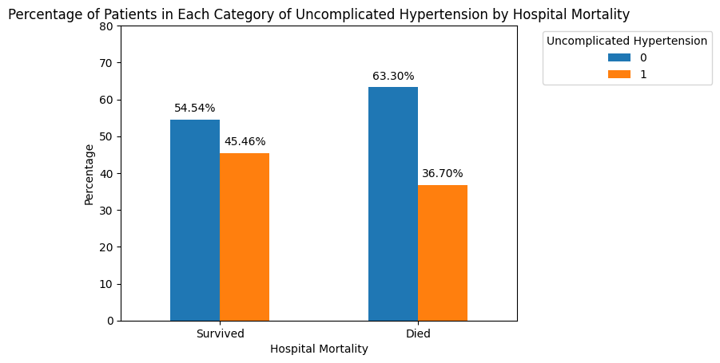

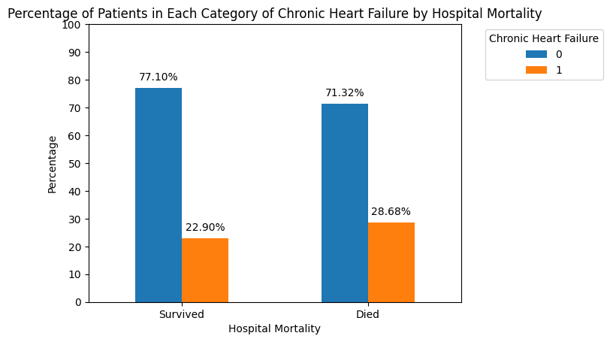

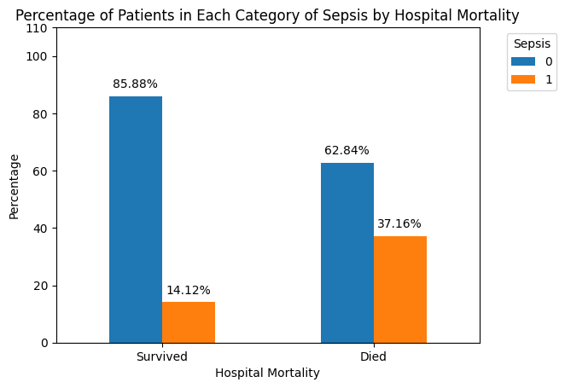

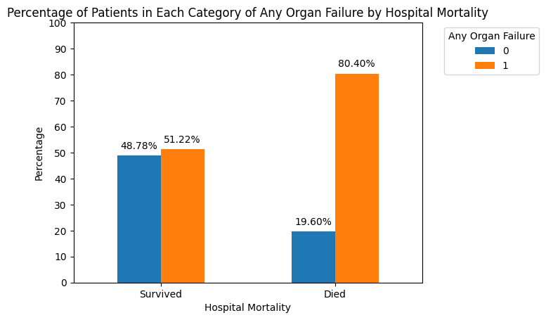

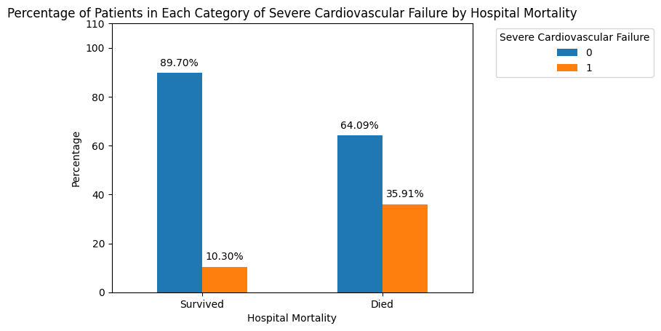

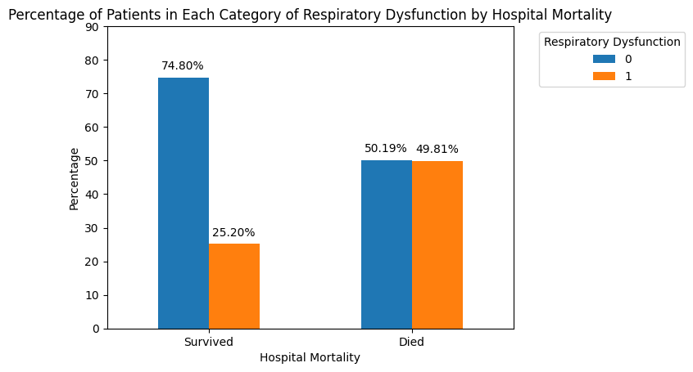

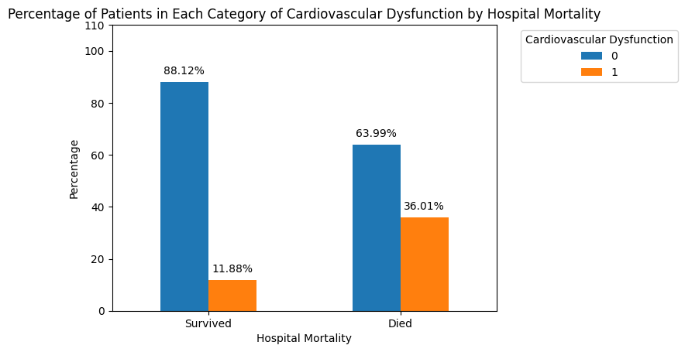

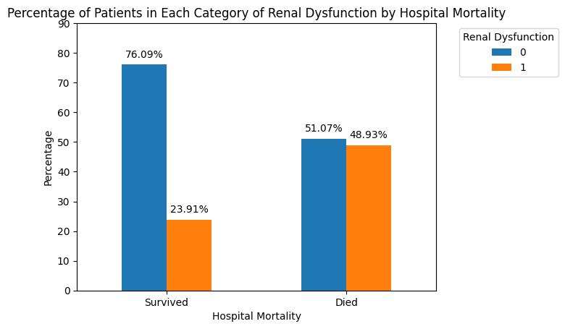

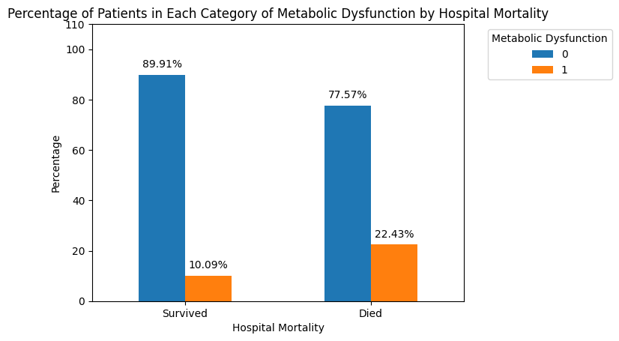

##### Box Plots

The median age is higher among non-survivors compared to survivors, with similar variability observed in both groups.

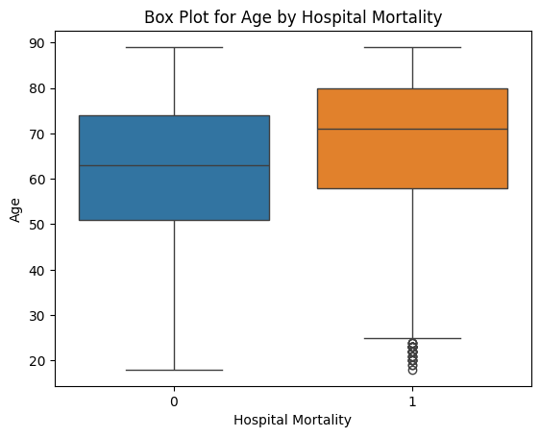

Non-survivors exhibit a slightly higher maximum heart rate compared to survivors. In the survivor group, data points are more concentrated around the center, while outliers contribute to the right skewed distribution observed in both groups.

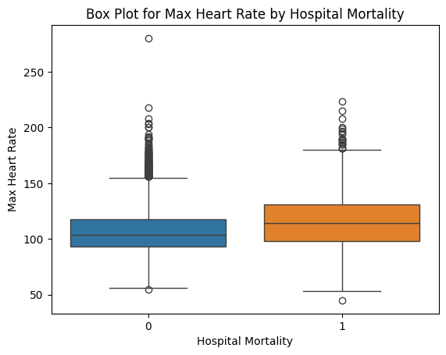

The median of the minimum heart rate is nearly identical for the two groups. The box plot illustrates a tighter concentration of data points around the median for the survivor group, resulting in a much narrower shape. 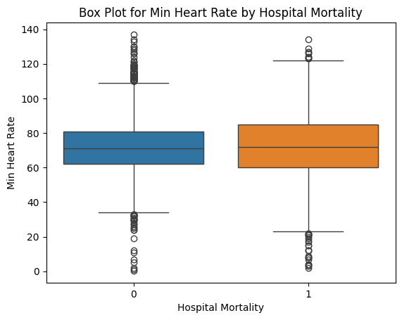

The box plot illustrates a slightly higher mean heart rate in the non-survivor group. Outliers are contributing to a right-skewed shape in the survivor group, while the non-survivor group exhibits a more normal distribution.

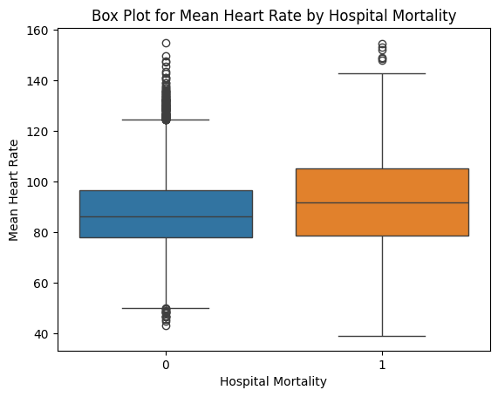

The medians of the maximum Mean Arterial Pressure (MAP) in the two groups are identical, but the shape of the distribution in both groups is highly influenced by outliers, causing it to become skewed.

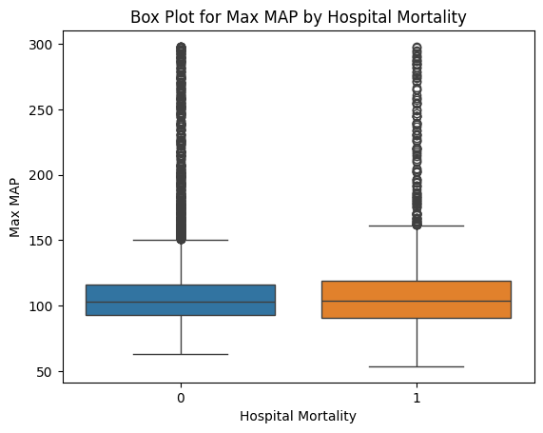

The median of min MAP is higher, and the data points are more concentrated around the median for the survivor group.

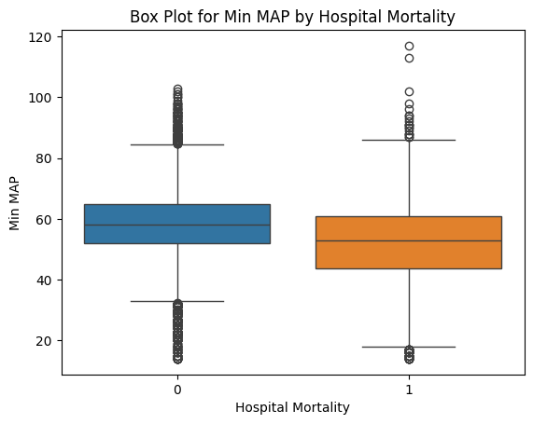

The variability is higher in the non-survivor group, but the median in both groups is almost the same.

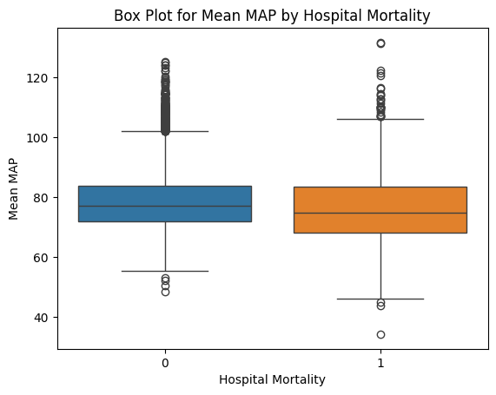

The variability is lower in the survivor group for max systolic pressure and the medial on both groups are almost the same.

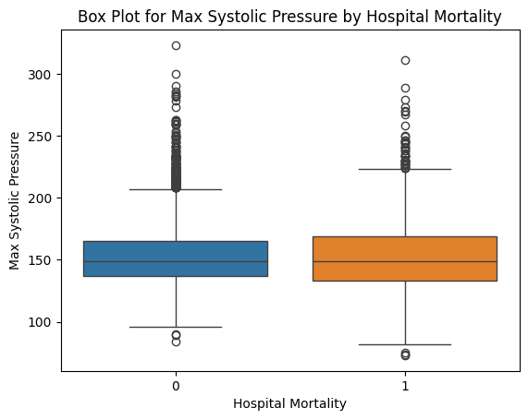

The min systolic pressure is higher in the survivor group and the datapoints are more concentrated around the median.

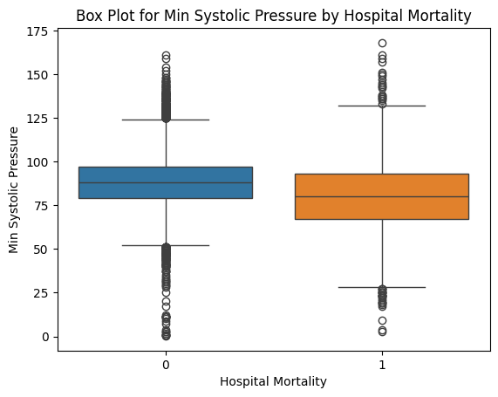

The variability is more in the non-survivor group and the median is less compared to the survivor group.

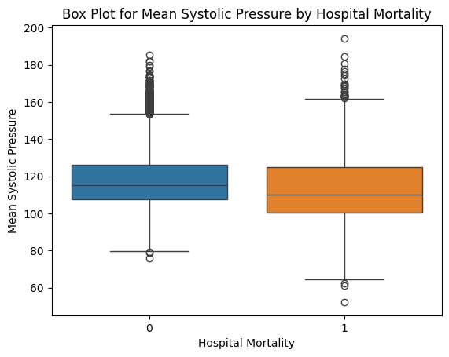

The median of max diastolic pressure in both groups are almost the same but the data points are more concentrated in the center in the survivor group. The outliers cause the shape to be right skewed in both groups.

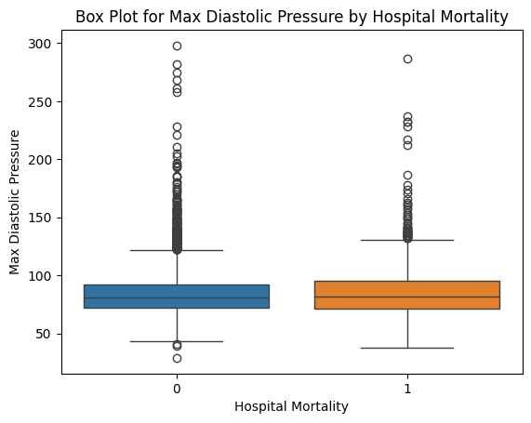

The min diastolic pressure is lower in the non-survivor group.  The data points are more concentrated around the center in the survivor group. Outliers are causing the distribution of the non-survivor group to be right skewed. The survivor group data appears normally distributed.

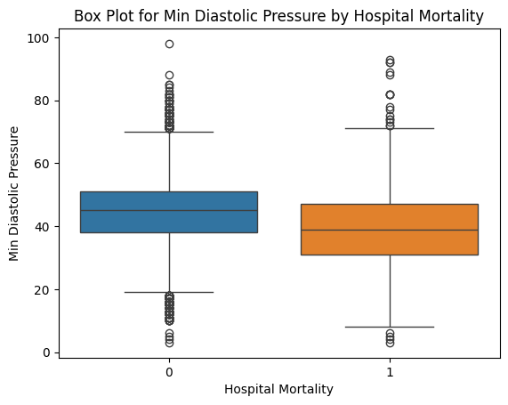

The variability in the survivor is less compared to the non-survivor group while the median in both groups is nearly identical.

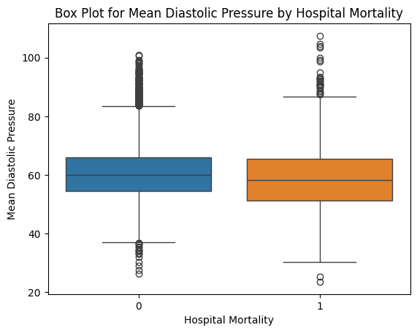

The variability in the non-survivor group is greater, while the median in both groups is identical. Outliers are influencing the distribution shape of the non-survivor data to become left skewed.

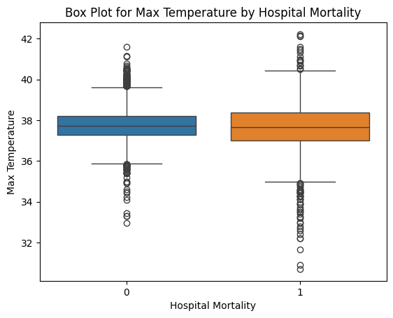

The outliers are causing the shape of the distribution in both groups to be left skewed.

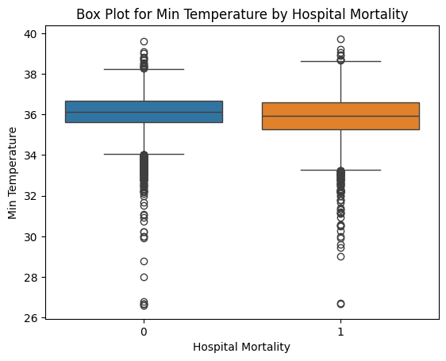

The outliers in the mean temperature are causing the distribution shape of non-survivors to become left skewed.

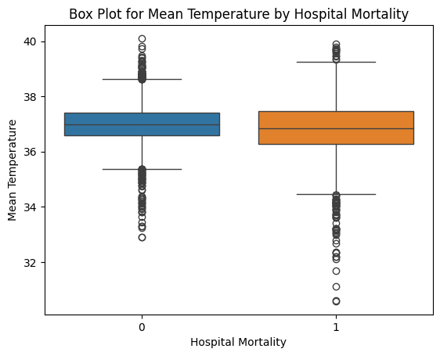

The datapoints in the survivor group is concentrated tightly around the center. The outliers are causing the distribution to be right skewed in both groups.

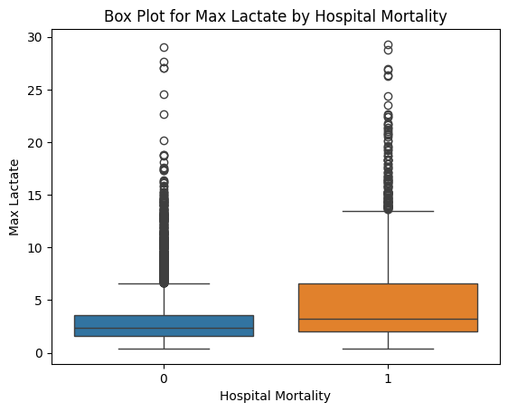

The data points in the survivor group are much more concentrated around the median in the survivor group. The variability in the non-survivor group is higher.

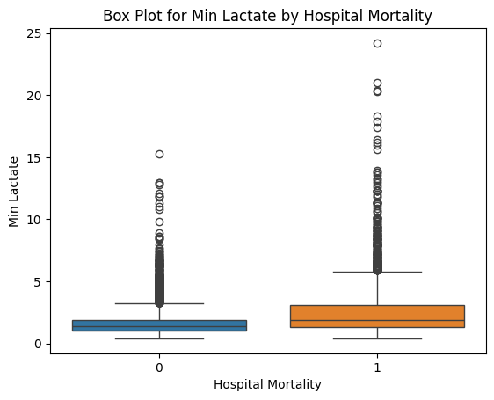

We can say the same observations as the min lactate.

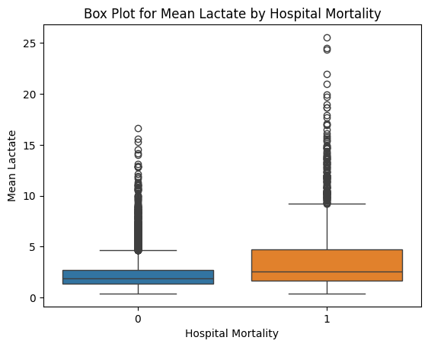

The outliers are causing the distribution to be skewed in both groups.

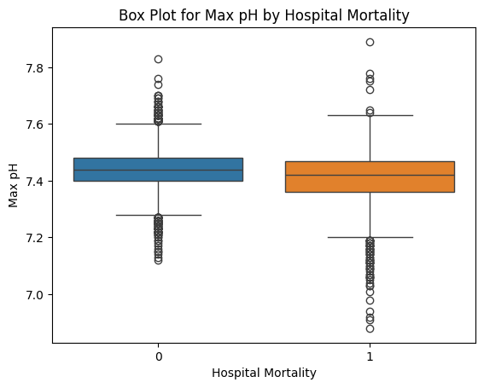

The outliers are causing the distribution shape to become left skewed in both groups.

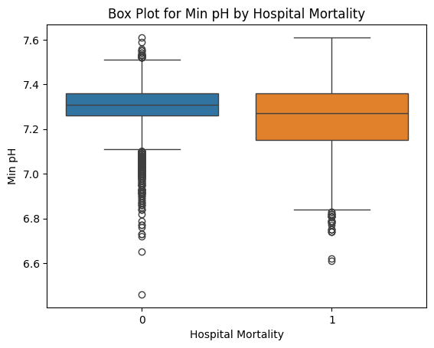

Both groups have a left skewed distribution because of the presence of outliers.

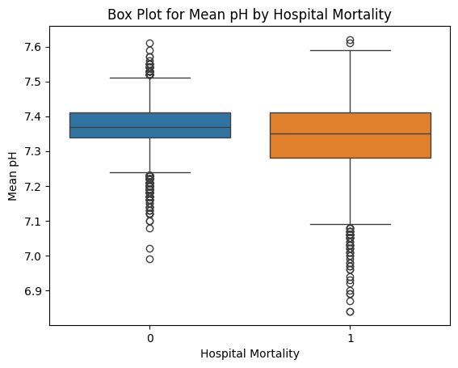

The variability is higher in the survivor group.

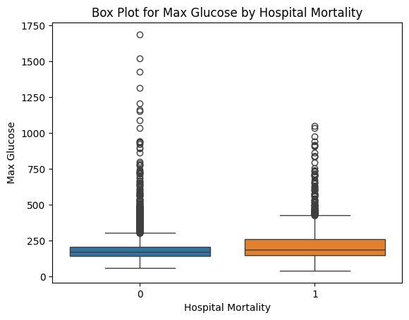

The distribution shape of the two groups is influenced by outliers.

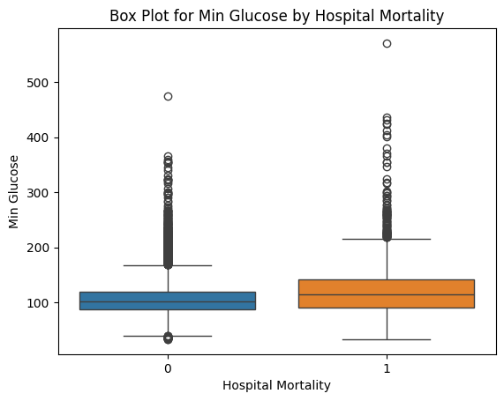

The distribution shape of the two groups is influenced by outliers.

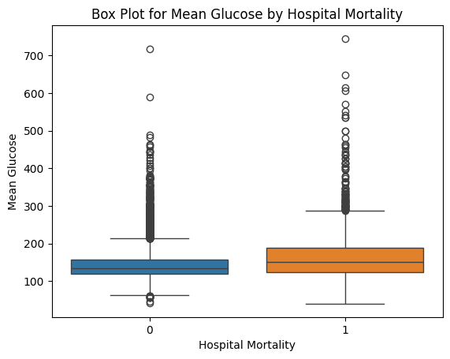

With respect to WBC, the distribution shape is greatly influenced by the outliers in the data of the two groups.

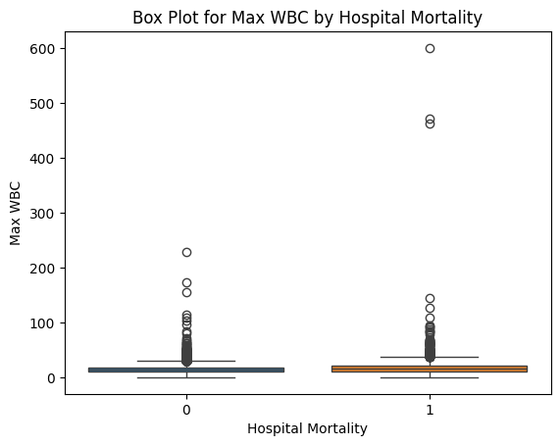 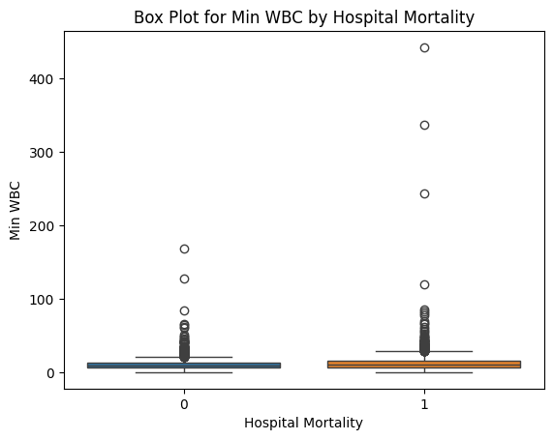

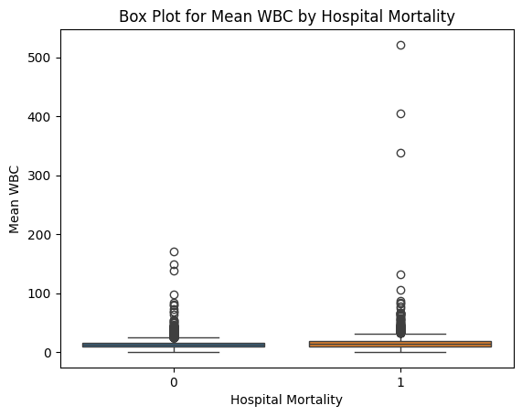

The data points of the max BUN in the survivor group are tightly concentrated around the center. In both groups, the outliers are causing the distribution shape to become right skewed.

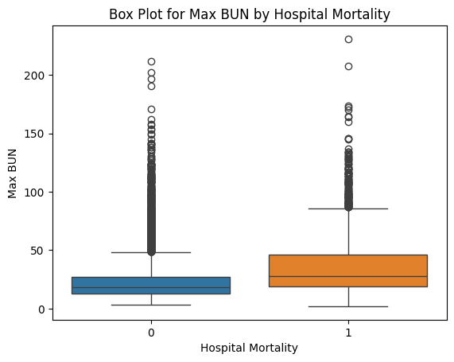

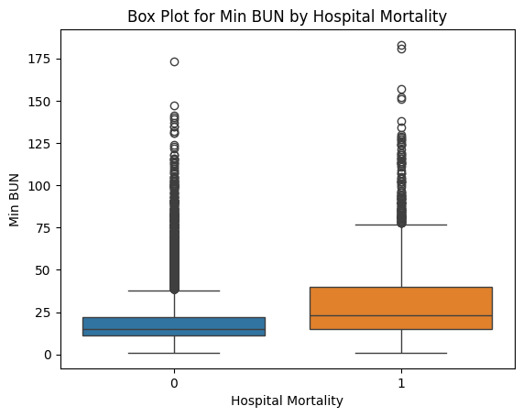

The data points of the mean BUN in the survivor group are tightly concentrated around the center. In both groups, the outliers are causing the distribution shape to become right skewed.

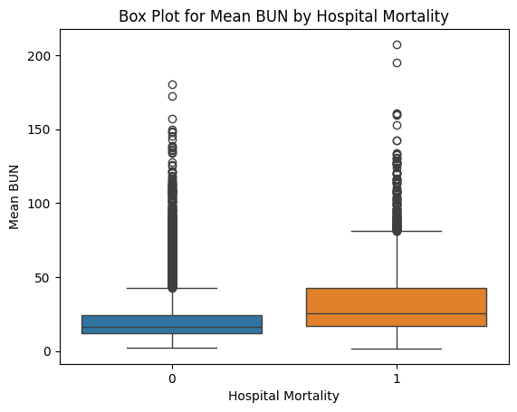

The variability of max creatinine is high in the non-survivor group, but it is even higher in the survivor group. The shapes of both groups are highly positively skewed.

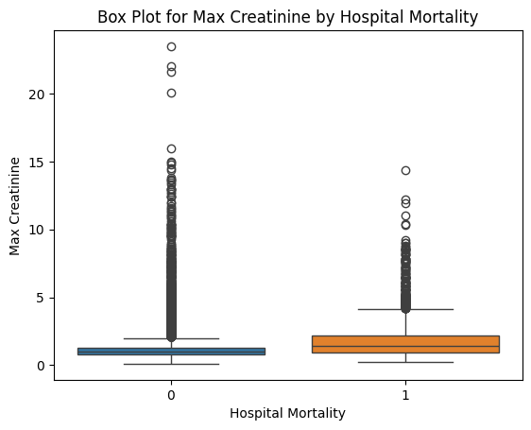

The variability of min creatinine is high in the non-survivor group, but it is even higher in the survivor group. The shapes of both groups are highly positively skewed.

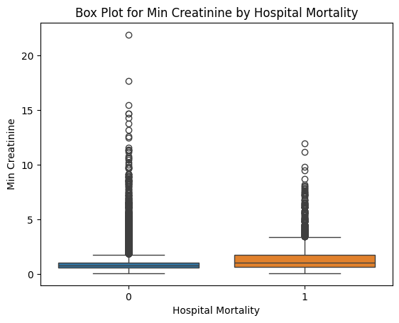

The variability of mean creatinine is high in the non-survivor group, but it is even higher in the survivor group. The shapes of both groups are highly positively skewed.

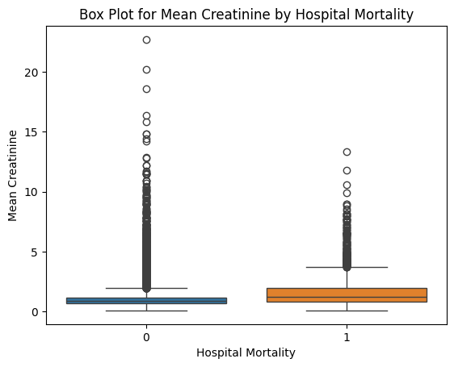

The median of max hemoglobin for non-survivor group is slightly lower compared to the survivor group.

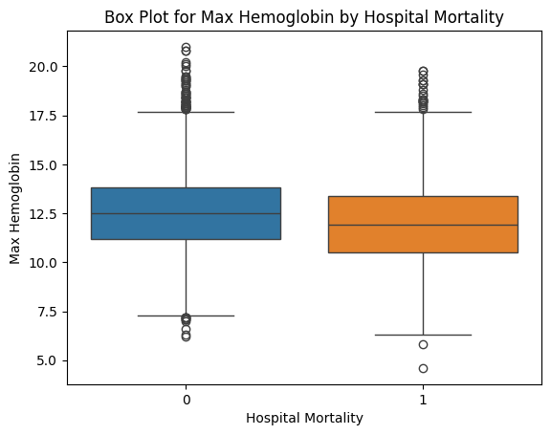

The median of min hemoglobin for non-survivor group is slightly higher compared to the survivor group.

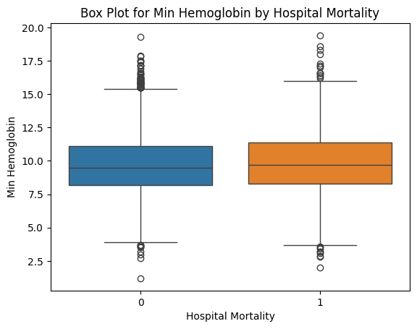

The shape of the distribution for mean hemoglobin is similar is both groups.

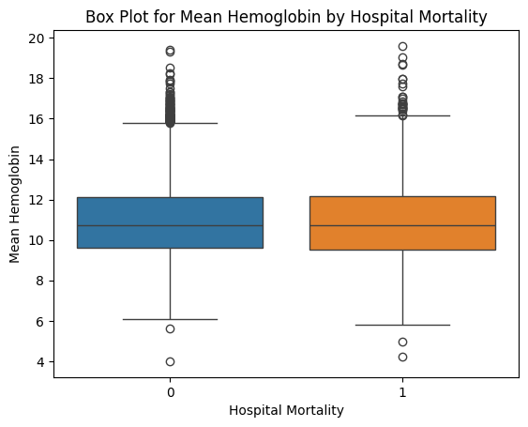

# Continuous Variables

After the Log Transformation the variables Max Heart Rate, Mean Heart Rate, Mean MAP, Mean Systolic Pressure, Mean Diastolic Pressure, Mean BUN, Max Haemoglobin, Mean Haemoglobin were identified to have a normal distribution.

We performed the Levene Test for homogeneity to identify the suitable parametric test that should be performed on these variables.

## Levene Test for homogeneity

We performed Levene test to assess the equality of variances between the two groups of Hospital Mortality in all the Continuous variables. It is a statistical test used to determine whether the variances of two or more groups are statistically significantly different from each other.

This was tested to determine whether it is appropriate to proceed with parametric statistical tests that assume equal variances across groups, or whether alternative methods that do not assume equal variances should be used.

Note that all assumptions listed below are met.

* The observations within each group or category are assumed to be independent.
* The variables being analysed are quantitative.

**H0 = The population variances are equal among the two groups of mortality**

**Ha = The population variances are not equal among the two groups of mortality**

α = 0.05

Based on the summary table below all the variables have a p – values less that set α = 0.05. Hence, we rejected the null hypothesis, concluding that in none of the variables the population variances are not equal among the two groups of mortality.

|  |  |  |  |
| --- | --- | --- | --- |
| **Variable** | **Levene Statistic** | **P - value** | **Homogeneity** |
| Age | 9.766476 | 1.78e-03 | No |
| Max Heart Rate | 228.955 | 2.87e-51 | No |
| Min Heart Rate | 381.173 | 1.21e-83 | No |
| Mean Heart Rate | 242.539 | 3.55e-54 | No |
| Max MAP | 51.128 | 9.14e-13 | No |
| Min MAP | 280.885 | 2.31e-62 | No |
| Mean MAP | 128.331 | 1.32e-29 | No |
| Max Systolic Pressure | 151.111 | 1.57e-34 | No |
| Min Systolic Pressure | 309.132 | 2.24e-68 | No |
| Mean Systolic Pressure | 225.881 | 1.31e-50 | No |
| Max Diastolic Pressure | 67.658 | 2.14e-16 | No |
| Min Diastolic Pressure | 167.035 | 5.76e-38 | No |
| Mean Diastolic Pressure | 77.282 | 1.67e-18 | No |
| Max Temperature | 586.364 | 1.26e-126 | No |
| Min Temperature | 329.538 | 1.04e-72 | No |
| Mean Temperature | 644.301 | 1.23e-138 | No |
| Max Lactate | 850.402 | 6.38e-181 | No |
| Min Lactate | 820.759 | 7.00e-175 | No |
| Mean Lactate | 1041.35 | 1.66e-219 | No |
| Max pH | 364.313 | 4.45e-80 | No |
| Min pH | 940.224 | 3.84e-199 | No |
| Mean pH | 1061.326 | 1.64e-223 | No |
| Max Glucose | 241.999 | 4.63e-54 | No |
| Min Glucose | 361.134 | 2.10e-79 | No |
| Mean Glucose | 393.565 | 2.93e-86 | No |
| Max WBC | 146.193 | 1.81e-33 | No |
| Min WBC | 224.203 | 2.99e-50 | No |
| Mean WBC | 190.961 | 4.07e-43 | No |
| Max BUN | 373.597 | 4.84e-82 | No |
| Min BUN | 453.03 | 8.89e-09 | No |
| Mean BUN | 417.703 | 2.39e-91 | No |
| Max Creatinine | 149.299 | 3.86e-34 | No |
| Min Creatinine | 167.901 | 3.74e-38 | No |
| Mean Creatinine | 158.743 | 3.53e-36 | No |
| Max Hemoglobin | 59.074 | 1.63e-14 | No |
| Min Hemoglobin | 15.581 | 7.95e-05 | No |
| Mean Hemoglobin | 39.784 | 2.93e-10 | No |

# Parametric Tests

Since we identified from the Levene Test that none of variables have equal variances among the two groups of mortality, we decided to perform the Welch’s t-test as it is used to compare the means of two independent groups when the assumption of equal population variances is violated.

## Welch’s t-test

We decided to use the Welch’s t-test on the variables Max Heart Rate, Mean Heart Rate, Mean MAP, Mean Systolic Pressure, Mean Diastolic Pressure, Mean BUN, Max Haemoglobin, Mean Haemoglobin as they followed a normal distribution closely after the Log Transformation.

**Note the data after Log Transformation were used in performing Welch’s t Test.**

The below assumptions were met by the variables.

* The observations within each group are assumed to be independent.
* The data for each group should be approximately normally distributed.

**H0 = The means for the two groups of mortality are equal.**

**Ha = The means for the two groups of mortality are not equal.**

α = 0.05

Based on the summary table of results below we can see the p values of Max Heart Rate, Mean Heart Rate, Mean MAP, Mean Systolic Pressure, Mean Diastolic Pressure, Mean BUN and Mean Hemoglobin are less than 0.05 level, concluding the difference between survivors and non-survivors for each variable is statistically significant.

However, in the variable Mean Haemoglobin the p value is greater than 0.05 level, where we accept the null hypothesis concluding the means of survivors and non-survivors are equal.

|  |  |  |  |
| --- | --- | --- | --- |
| **Variable** | **T-statistic** | **P-value** | **Conclusion** |
| Max Heart Rate | -14.42535 | 1.5137e-45 | The difference is statistically significant. |
| Mean Heart Rate | -9.820534 | 2.11329e-22 | The difference is statistically significant. |
| Mean MAP | 9.96346 | 5.40936e-23 | The difference is statistically significant. |
| Mean Systolic Pressure | 11.31721 | 4.935026e-29 | The difference is statistically significant. |
| Mean Diastolic Pressure | 8.72391 | 4.528457e-18 | The difference is statistically significant. |
| Mean BUN | -27.185729 | 4.778132e-145 | The difference is statistically significant. |
| Max Haemoglobin | 9.4272588 | 8.44463e-21 | The difference is statistically significant. |
| Mean Haemoglobin | 0.8239296 | 0.410047 | There is no significant difference |

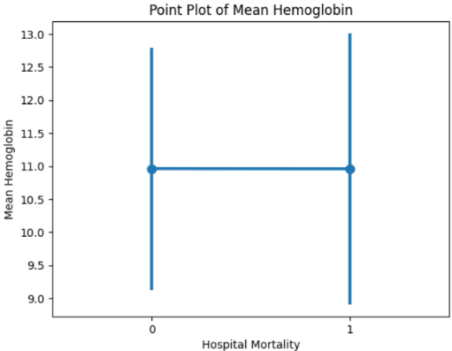

The above test results can also be verified by the point plot which shows the means of two groups of mortality are same.

# Non-Parametric Test

### Mann-Whitney U Test

Since the shape of the distribution for the remaining continuous variables are not normal, we decided to use a non-parametric test called the Mann-Whitney on the dataset before log transformation. Note that all assumptions listed below are met.

Assumptions:

1. Observations in each group are independent of each other.
2. Random sampling is assumed.
3. The variables are ordinal or interval.
4. Shapes of the distributions in the two groups are similar.

**H0 = The distributions of the living group are equal to the distributions of the deceased group.**

**Ha = There is a difference between the distributions of the two groups.**

Based on the summary table only Min Heart Rate, Max MAP, Max Systolic Pressure and Max Diastolic Pressure have a p-value of > 0.05. For the said variables, we can assume that the distributions of the living group are equal to the distributions of the deceased group. We can also refer to the density plots in the Appendix to confirm this assumption. For the rest of the variables, results show that there is a difference between the distributions of the two groups.

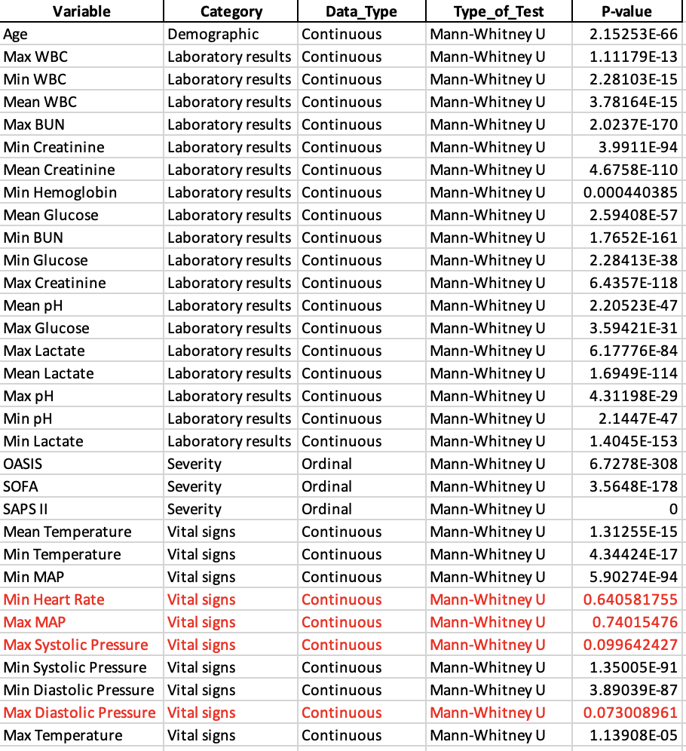

### Comparison of Mann Whitney & Welch T test

We performed the Mann Whitney U test for the same variables (Max Heart Rate, Mean Heart Rate, Mean MAP, Mean Systolic Pressure, Mean Diastolic Pressure, Mean BUN, Max Haemoglobin, Mean Haemoglobin) that Welch T test was performed, to compare the results from two different tests. The null and alternative hypothesis were same as above with the α = 0.05.

Considering the below results obtained from the Mann-Whitney test, we can observe that it leads to the similar conclusion derived from the Welch t-test discussed earlier.

For the Mean Haemoglobin the means of survivors and non -survivors are equal, whereas for the other variables the means are statistically significant between survivors and non-survivors.

|  |  |  |  |
| --- | --- | --- | --- |
| **Variable** | **U-statistic** | **P-value** | **Conclusion** |
| Max Heart Rate | 8640638.5 | 7.52e-61 | The difference is statistically significant. |
| Mean Heart Rate | 9409815 | 3.95e-30 | The difference is statistically significant. |
| Mean MAP | 12733640.5 | 2.12e-25 | The difference is statistically significant. |
| Mean Systolic Pressure | 13073048.5 | 1.22e-36 | The difference is statistically significant. |
| Mean Diastolic Pressure | 12469046 | 4.03e-18 | The difference is statistically significant. |
| Mean BUN | 6923118 | 2.92e-169 | The difference is statistically significant. |
| Max Haemoglobin | 12656776 | 3.71e-23 | The difference is statistically significant. |
| Mean Haemoglobin | 11249336 | 0.502333204 | There is no significant difference |

### 

### Spearman Correlation

The below correlation matrix illustrates the pair of variables per group that exhibit a moderate to strong positive or negative correlation according to Spearman correlation coefficient.

Spearman Correlation Assumption:

1. The variables are either ordinal or continuous data that follow a monotonic relationship.

**H0: There is no monotonic association between the two variables.**

**Ha: There is a monotonic association between the two variables.**

With the significance level at 0.05, the results are statistically significant.

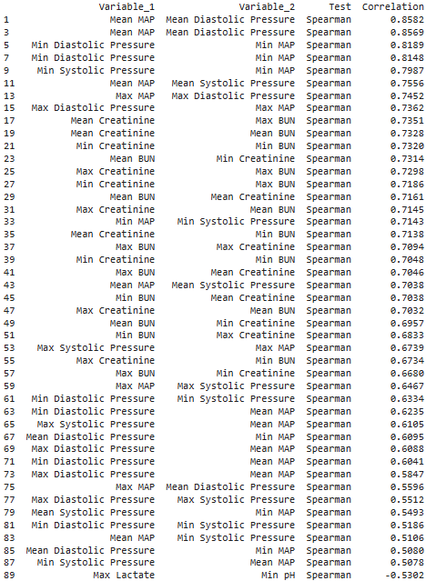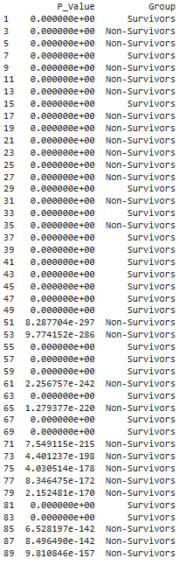

### Visualization of Continuous Variables

##### Scatter Plot

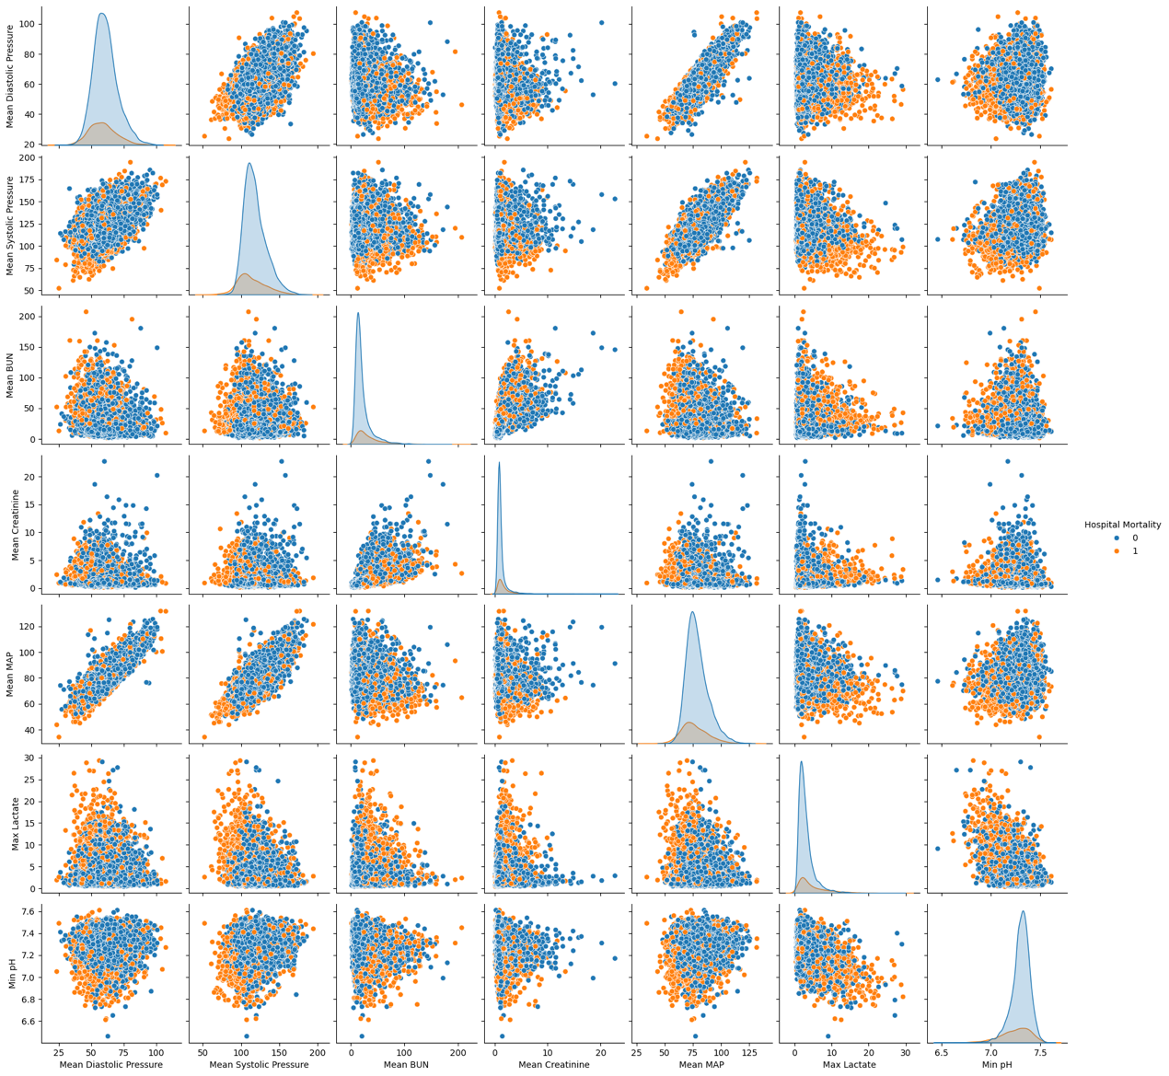

##### Density Plots

Please refer to the Appendix.

# Results Summary Table

Summary table for statistical tests conducted.

|  |  |  |  |  |
| --- | --- | --- | --- | --- |
| **Variable** | **Category** | **Data_Type** | **Type_of_Test** | **P-value** |
| Gender | Demographic | Categorical | Chi-Square | 1.92E-07 |
| Age | Demographic | Continuous | Mann-Whitney U | 2.15E-66 |
| Neurologic Dysfunction | Diagnosis | Categorical | Chi-Square | 2.6E-12 |
| Metabolic Dysfunction | Diagnosis | Categorical | Chi-Square | 7.9E-57 |
| Sepsis | Diagnosis | Categorical | Chi-Square | 1.1E-140 |
| Severe Respiratory Failure | Diagnosis | Categorical | Chi-Square | 9.06E-63 |
| Severe Coagulation Failure | Diagnosis | Categorical | Chi-Square | 5.15E-23 |
| Severe Liver Failure | Diagnosis | Categorical | Chi-Square | 1.35E-40 |
| Any Organ Failure | Diagnosis | Categorical | Chi-Square | 4.9E-136 |
| Severe Central Nervous System Failure | Diagnosis | Categorical | Chi-Square | 3E-16 |
| Severe Renal Failure | Diagnosis | Categorical | Chi-Square | 7.67E-96 |
| Respiratory Dysfunction | Diagnosis | Categorical | Chi-Square | 5.3E-115 |
| Cardiovascular Dysfunction | Diagnosis | Categorical | Chi-Square | 2.1E-169 |
| Renal Dysfunction | Diagnosis | Categorical | Chi-Square | 9.7E-122 |
| Severe Cardiovascular Failure | Diagnosis | Categorical | Chi-Square | 2.1E-204 |
| Hematologic Dysfunction | Diagnosis | Categorical | Chi-Square | 8.07E-44 |
| Max WBC | Laboratory results | Continuous | Mann-Whitney U | 1.11E-13 |
| Min WBC | Laboratory results | Continuous | Mann-Whitney U | 2.28E-15 |
| Mean WBC | Laboratory results | Continuous | Mann-Whitney U | 3.78E-15 |
| Max BUN | Laboratory results | Continuous | Mann-Whitney U | 2E-170 |
| Min Creatinine | Laboratory results | Continuous | Mann-Whitney U | 3.99E-94 |
| Mean Creatinine | Laboratory results | Continuous | Mann-Whitney U | 4.7E-110 |
| Min Hemoglobin | Laboratory results | Continuous | Mann-Whitney U | 0.00044 |
| Mean Glucose | Laboratory results | Continuous | Mann-Whitney U | 2.59E-57 |
| Min BUN | Laboratory results | Continuous | Mann-Whitney U | 1.8E-161 |
| Min Glucose | Laboratory results | Continuous | Mann-Whitney U | 2.28E-38 |
| Max Creatinine | Laboratory results | Continuous | Mann-Whitney U | 6.4E-118 |
| Mean pH | Laboratory results | Continuous | Mann-Whitney U | 2.21E-47 |
| Max Glucose | Laboratory results | Continuous | Mann-Whitney U | 3.59E-31 |
| Max Hemoglobin | Laboratory results | Continuous | Welch's T-test | 8.44E-21 |
| Mean BUN | Laboratory results | Continuous | Welch's T-test | 4.8E-145 |
| Max Lactate | Laboratory results | Continuous | Mann-Whitney U | 6.18E-84 |
| Mean Hemoglobin | Laboratory results | Continuous | Welch's T-test | 0.410047 |
| Mean Lactate | Laboratory results | Continuous | Mann-Whitney U | 1.7E-114 |
| Max pH | Laboratory results | Continuous | Mann-Whitney U | 4.31E-29 |
| Min pH | Laboratory results | Continuous | Mann-Whitney U | 2.14E-47 |
| Min Lactate | Laboratory results | Continuous | Mann-Whitney U | 1.4E-153 |
| Liver Disease | Medical history | Categorical | Chi-Square | 1.27E-55 |
| Stroke | Medical history | Categorical | Chi-Square | 5.55E-08 |
| Chronic Heart Failure | Medical history | Categorical | Chi-Square | 1.2E-08 |
| Hypothyroidism | Medical history | Categorical | Chi-Square | 0.357808 |
| Peripheral Vascular Disease | Medical history | Categorical | Chi-Square | 0.707851 |
| Metastasis | Medical history | Categorical | Chi-Square | 3.67E-26 |
| Malignancy | Medical history | Categorical | Chi-Square | 1.7E-27 |
| Hematologic Disease | Medical history | Categorical | Chi-Square | 2.17E-34 |
| Uncomplicated Diabetes | Medical history | Categorical | Chi-Square | 0.579531 |
| Complicated Hypertension | Medical history | Categorical | Chi-Square | 0.005115 |
| Uncomplicated Hypertension | Medical history | Categorical | Chi-Square | 1.09E-13 |
| Complicated Diabetes | Medical history | Categorical | Chi-Square | 0.466333 |
| OASIS | Severity | Ordinal | Mann-Whitney U | 6.7E-308 |
| SOFA | Severity | Ordinal | Mann-Whitney U | 3.6E-178 |
| SAPS II | Severity | Ordinal | Mann-Whitney U | 0 |
| Mean Heart Rate | Vital signs | Continuous | Welch's T-test | 2.11E-22 |
| Mean MAP | Vital signs | Continuous | Welch's T-test | 5.41E-23 |
| Mean Systolic Pressure | Vital signs | Continuous | Welch's T-test | 4.94E-29 |
| Mean Diastolic Pressure | Vital signs | Continuous | Welch's T-test | 4.53E-18 |
| Mean Temperature | Vital signs | Continuous | Mann-Whitney U | 1.31E-15 |
| Min Temperature | Vital signs | Continuous | Mann-Whitney U | 4.34E-17 |
| Min MAP | Vital signs | Continuous | Mann-Whitney U | 5.9E-94 |
| Min Heart Rate | Vital signs | Continuous | Mann-Whitney U | 0.640582 |
| Max MAP | Vital signs | Continuous | Mann-Whitney U | 0.740155 |
| Max Systolic Pressure | Vital signs | Continuous | Mann-Whitney U | 0.099642 |
| Min Systolic Pressure | Vital signs | Continuous | Mann-Whitney U | 1.35E-91 |
| Min Diastolic Pressure | Vital signs | Continuous | Mann-Whitney U | 3.89E-87 |
| Max Diastolic Pressure | Vital signs | Continuous | Mann-Whitney U | 0.073009 |
| Max Temperature | Vital signs | Continuous | Mann-Whitney U | 1.14E-05 |
| Max Heart Rate | Vital signs | Continuous | Welch's T-test | 1.51E-45 |

# Literature Review

### Feature Explanations in Recurrent Neural Networks for Predicting Risk of Mortality in Intensive Care Patients

**Summary**:

A recent study has proposed a framework that uses a Recurrent Neural Network (RNN) architecture to predict the risk of mortality in patients receiving intensive care. This is achieved by processing a time series of vital signs and laboratory results, which helps to produce a predicted mortality risk score. Additionally, the model identifies the contribution of each input feature to the prediction. The framework has been evaluated using three critical care databases - MIMIC-III, MIMIC-IV, and eICU - which yielded consistent results, establishing the robustness of the approach. The model also explains its predictions, which can aid clinical staff in understanding mortality-related factors.

**How does this article help the report?**

The article discusses using datasets, particularly Mimic iii, to predict mortality risk. It also highlights the importance of the vital signs and laboratory variables. In Table 2, the authors indicate the valid range for each variable in both categories. This information can be used to identify values that fall outside the valid range in our Mimic iii datasets. With this information, we can remove values outside the valid range. Those values may be caused by various reasons, such as machine malfunction, and they are not considered outliers.

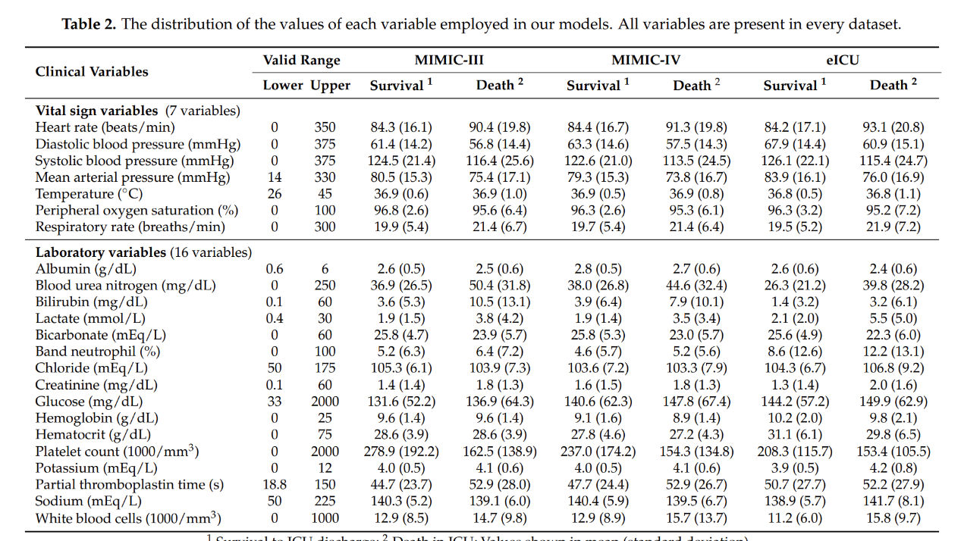

### Prognosis of Mechanically Ventilated Patients

**Summary:**

The prognosis of patients who need mechanical ventilation is affected by various factors, including age, serum albumin levels, APACHE II scores, and the timing of mechanical ventilation after CPR. The study shows that the one-year mortality rate is high, especially among patients aged over 70. Additionally, the APACHE II scoring system is an effective tool to predict the outcomes of mechanically ventilated patients, both on an individual hospital level and as a whole group among veterans receiving intensive care.

**How does this article help the report?**

In our report, we decided to remove the "ventilation duration" column as not all patients require mechanical ventilation upon admission to the ICU. Recent research has suggested that ventilation has little to no impact on patient survival, making it safe to eliminate this column.

Additionally, the article confirms our previous findings regarding the correlation between hospital mortality and patients' ages. Our density plot of age by hospital mortality revealed a significant drop in density after the age of 70, indicating that younger patients have a higher likelihood of survival.

### Machine Learning Prediction Models for Mechanically Ventilated Patients: Analyses of the MIMIC-III Database

The research utilized the MIMIC-III database to predict hospital mortality in ICU patients undergoing mechanical ventilation. Seven machine learning models were employed, with the XGBoost model proving the most effective. The five leading predictors of hospital mortality were age, respiratory dysfunction, SAPS II score, maximum hemoglobin, and minimum lactate. The study reveals that these factors are likely closely correlated with hospital mortality in mechanically ventilated ICU patients. However, external validation is essential to confirm these findings.

**How does this article help the report?**

This text contains important information for the second part of the assignment. According to the article, the XGBoost machine learning model achieved the highest AUCs (areas under the curve of the receiver operating characteristic). This is the model that we are going to use in our second part of assignment. Additionally, the article highlights that age is the most significant factor, followed by respiratory dysfunction, SAPS II score, maximum hemoglobin, and minimum lactate. We will use our dataset to confirm if we obtain similar results.

# References

Papadakis, M A, et al. “Prognosis of Mechanically Ventilated Patients.” *PubMed*, vol. 159, no. 6, 1 Dec. 1993, pp. 659–64. Accessed 17 Mar. 2024.

Tan, Yvette, et al. “Predicting Respiratory Decompensation in Mechanically Ventilated Adult ICU Patients.” *Frontiers in Physiology*, vol. 14, 14 Apr. 2023, https://doi.org/10.3389/fphys.2023.1125991. Accessed 30 Nov. 2023.

Thanakron Na Pattalung, et al. “Feature Explanations in Recurrent Neural Networks for Predicting Risk of Mortality in Intensive Care Patients.” *Journal of Personalized Medicine*, vol. 11, no. 9, 19 Sept. 2021, pp. 934–934, https://doi.org/10.3390/jpm11090934. Accessed 17 Mar. 2024.

Thanos Gentimis, et al. *Predicting Hospital Length of Stay Using Neural Networks on MIMIC III Data*. 1 Nov. 2017, https://doi.org/10.1109/dasc-picom-datacom-cyberscitec.2017.191. Accessed 21 May 2023.

Zhu, Yibing, et al. “Machine Learning Prediction Models for Mechanically Ventilated Patients: Analyses of the MIMIC-III Database.” *Frontiers in Medicine*, vol. 8, 1 July 2021, https://doi.org/10.3389/fmed.2021.662340.

# Appendix

## Normalization

### Before normalization

#### Histograms and QQ Plots

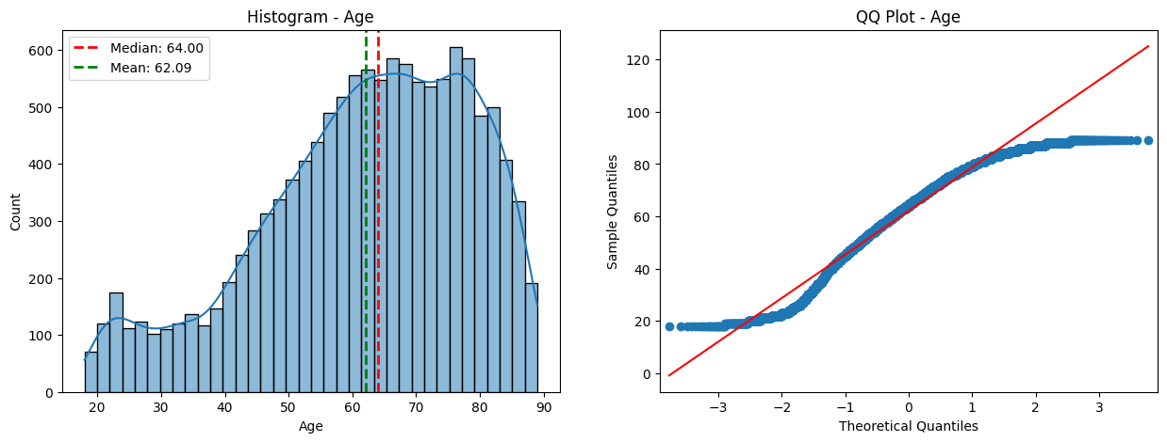

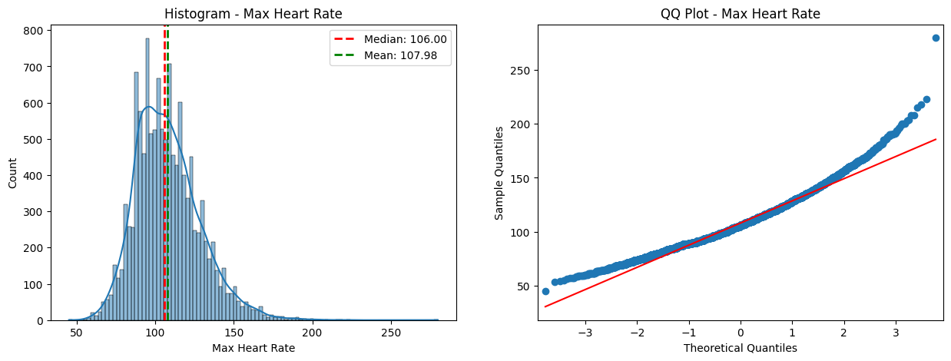

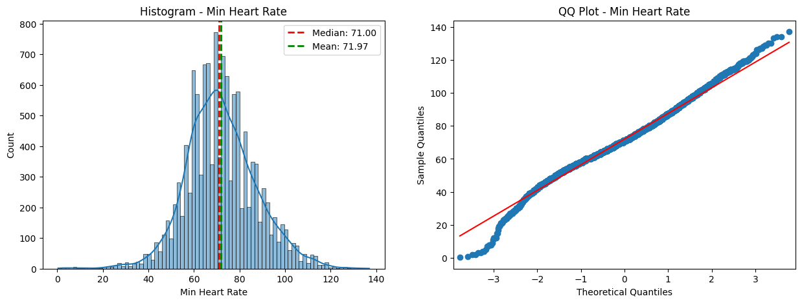

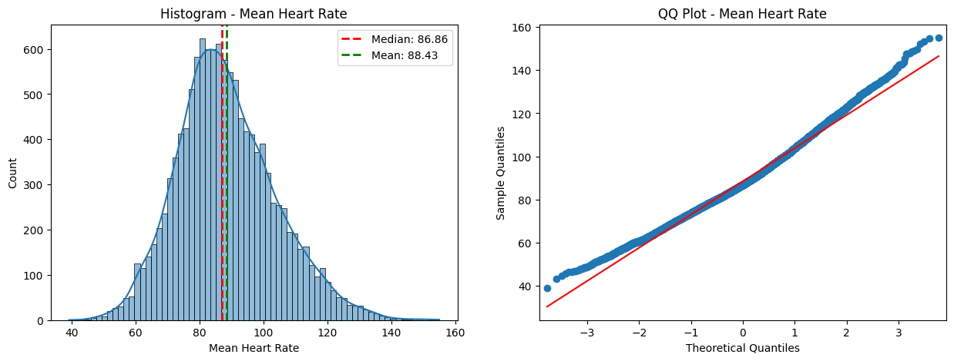

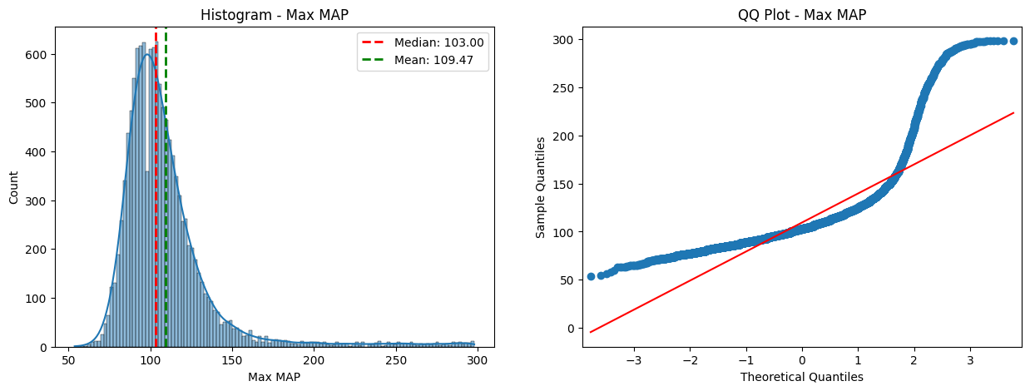

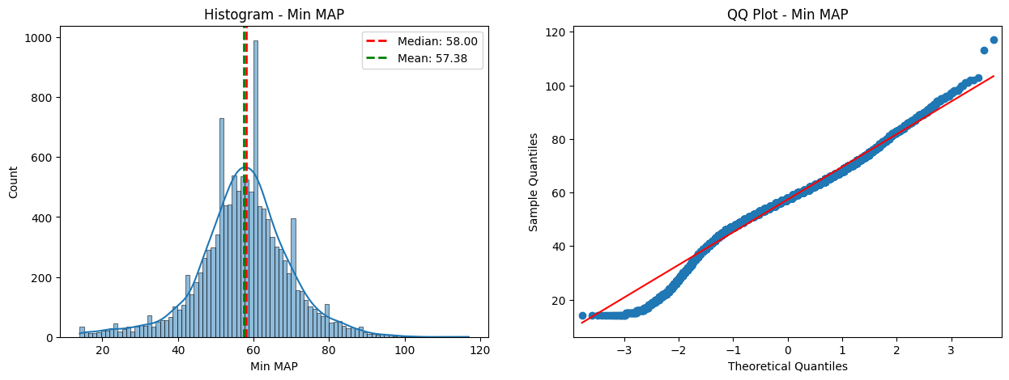

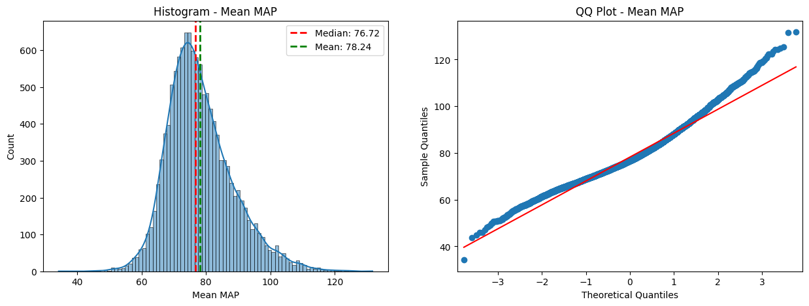

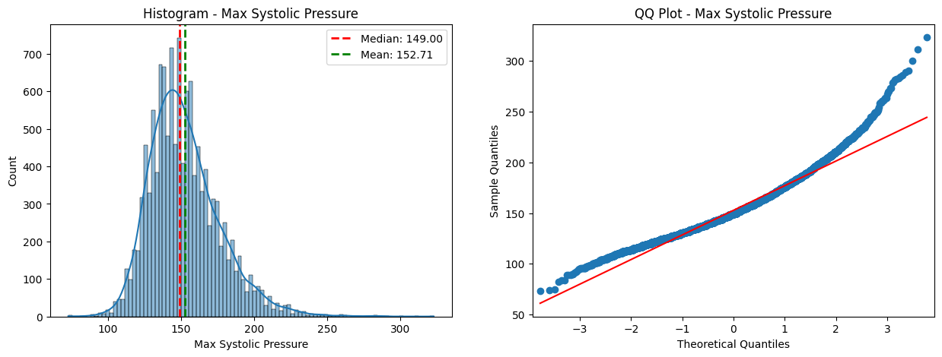

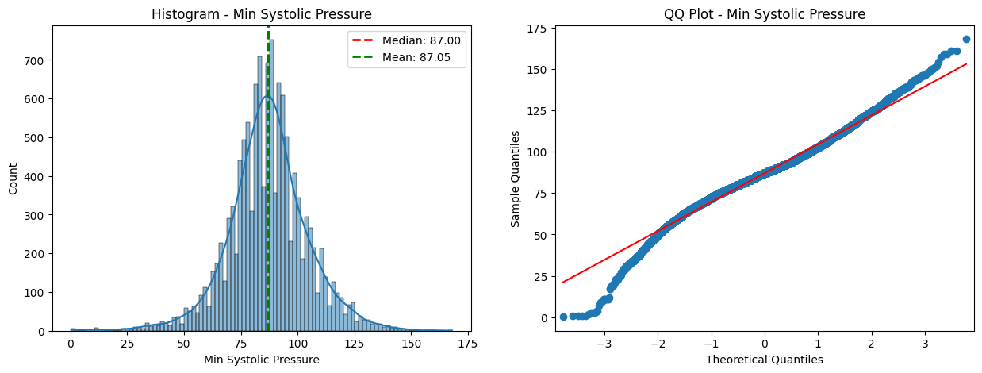

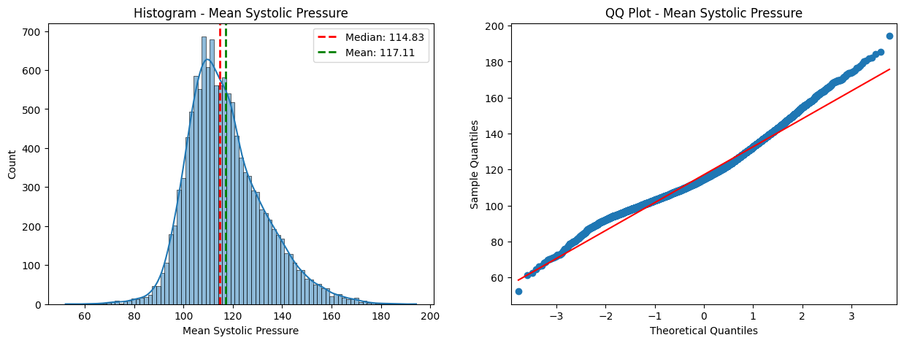

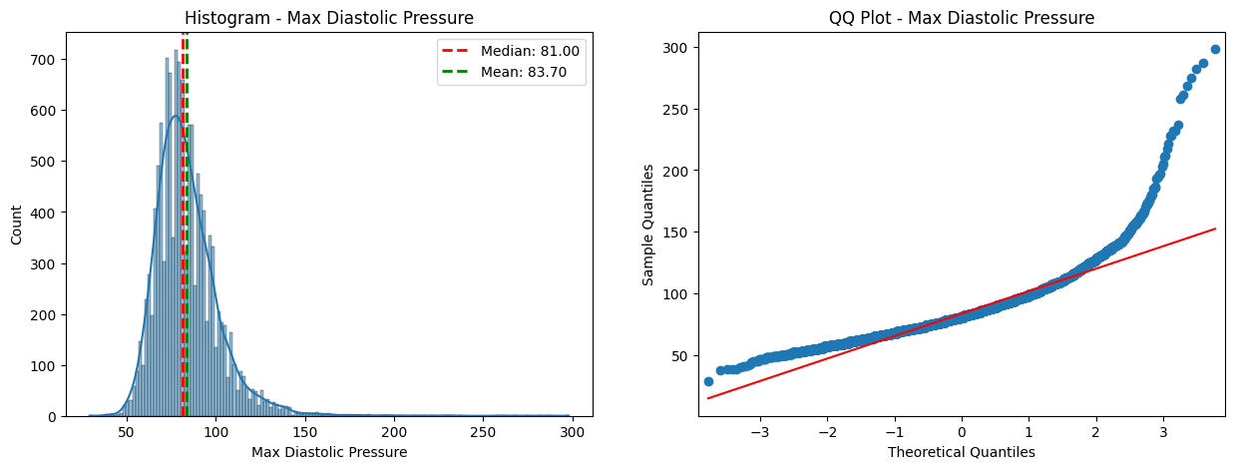

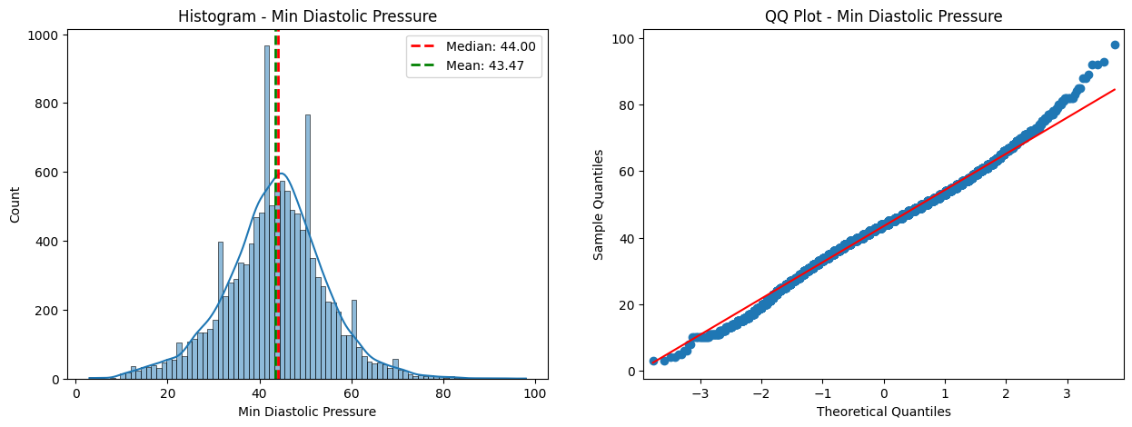

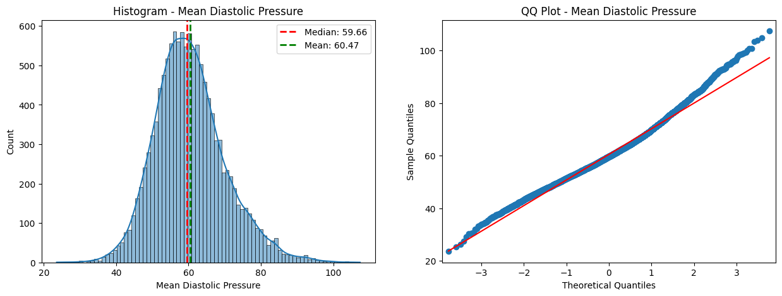

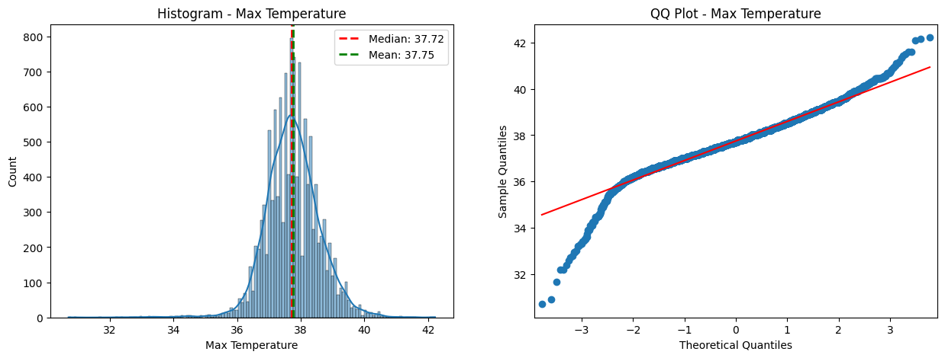

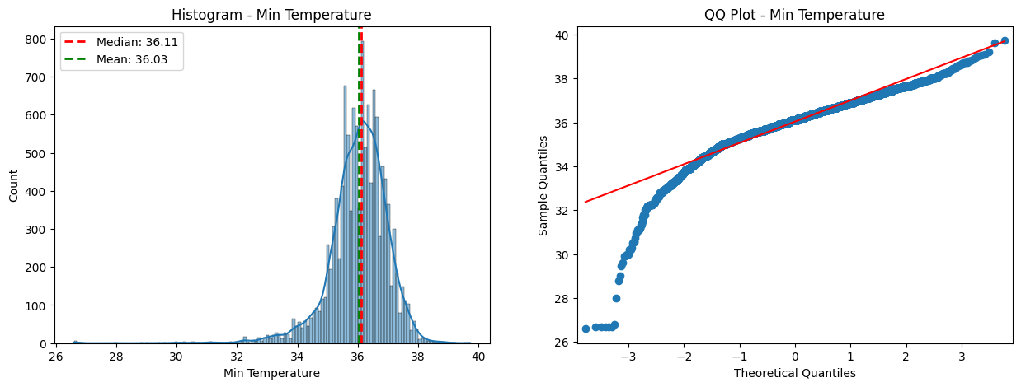

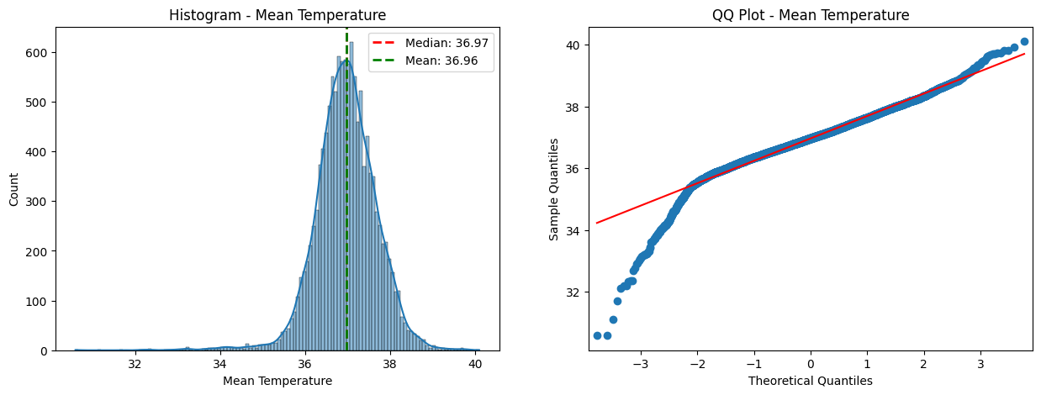

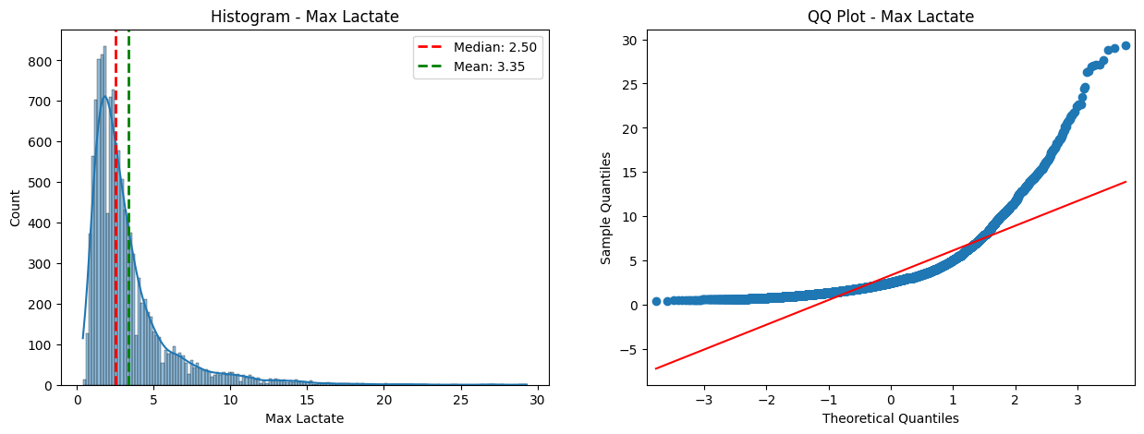

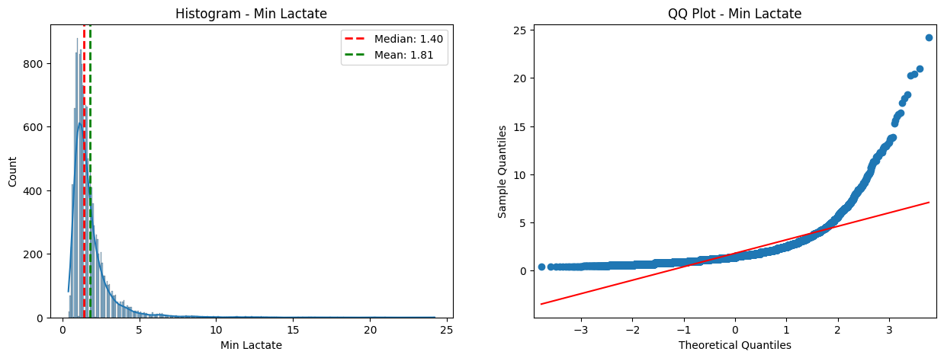

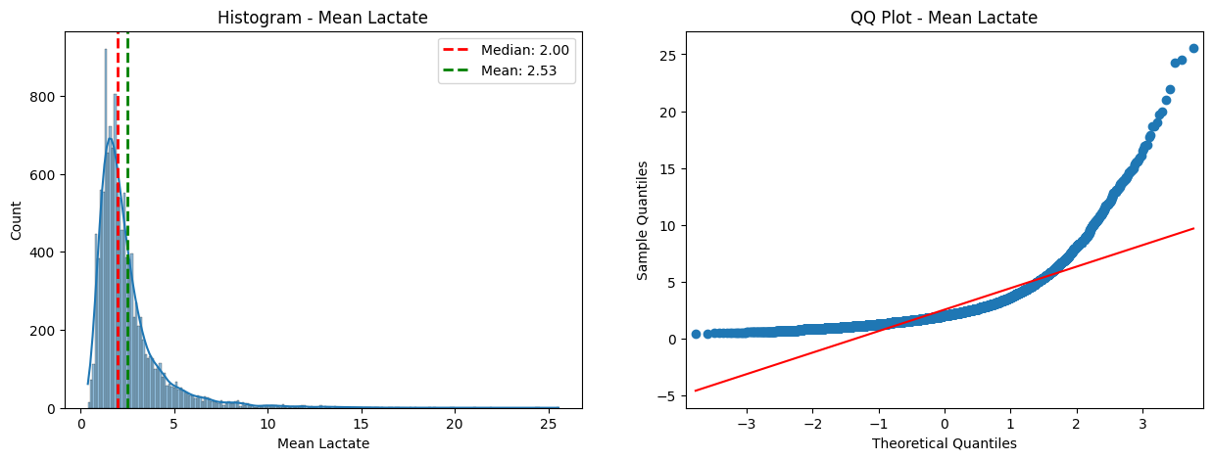

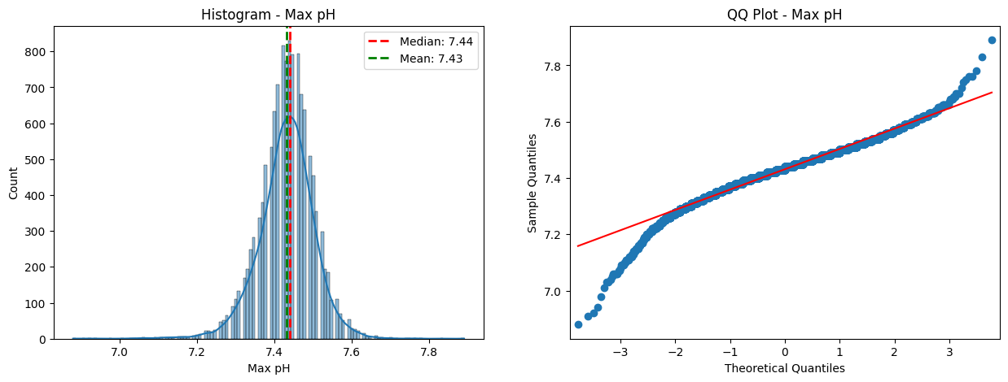

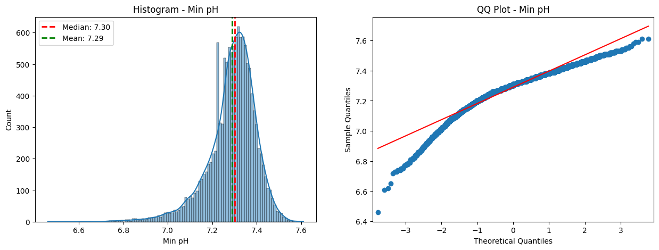

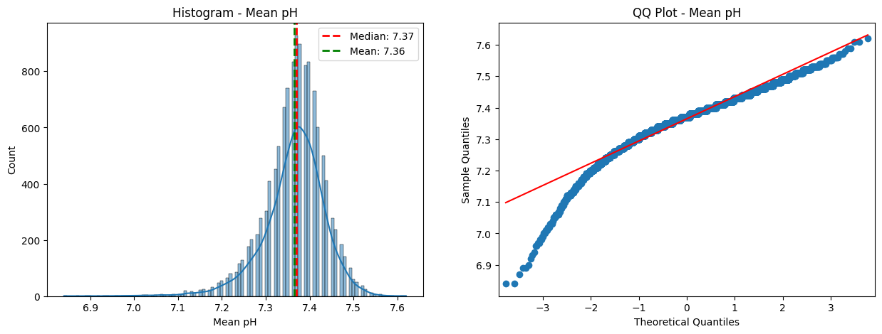

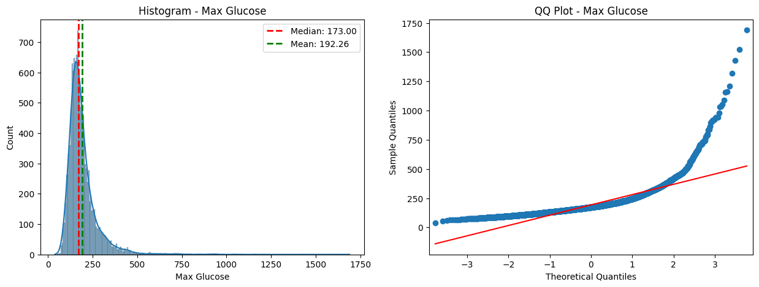

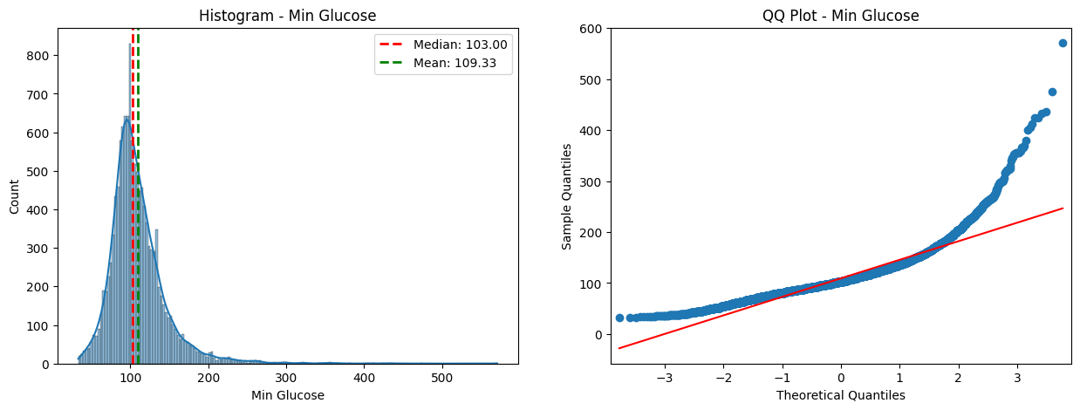

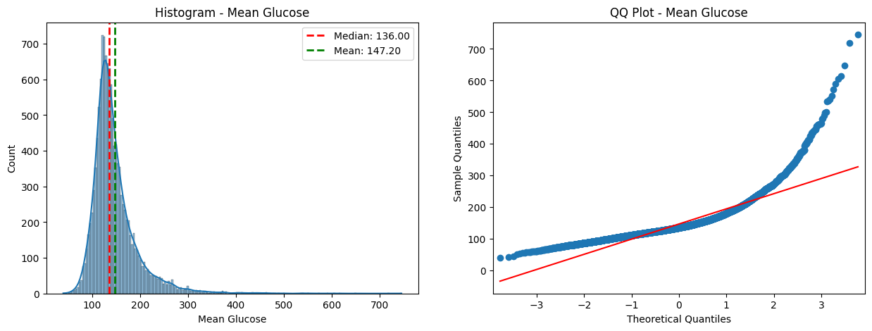

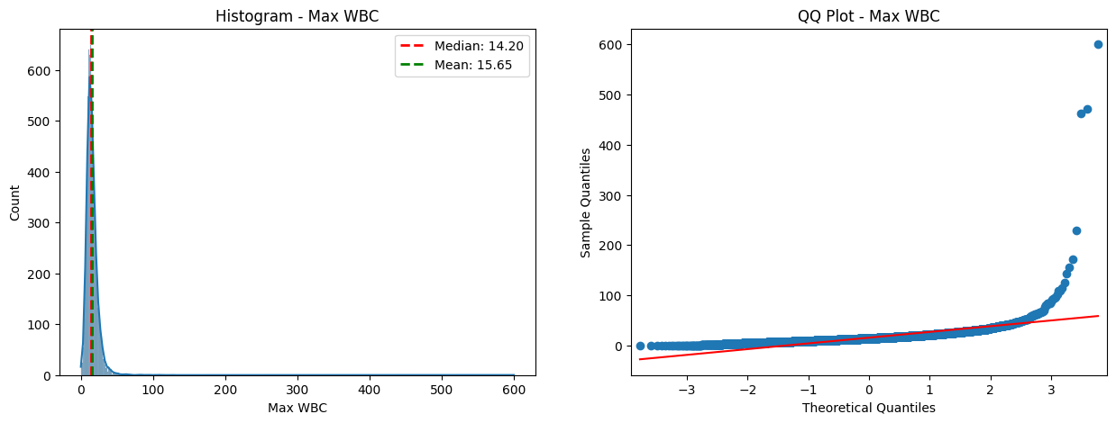

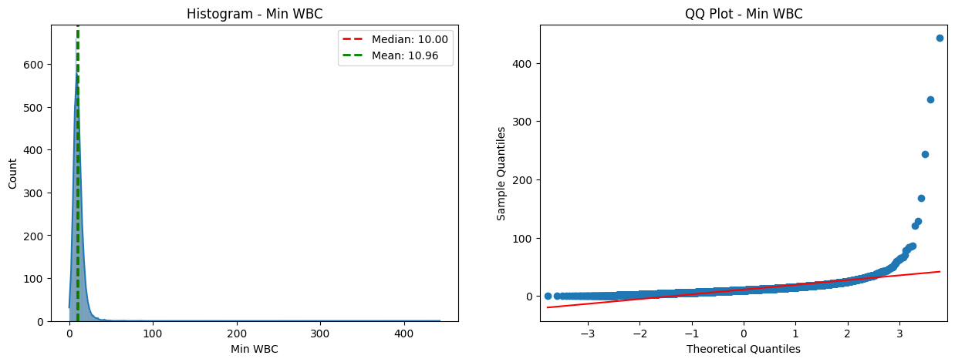

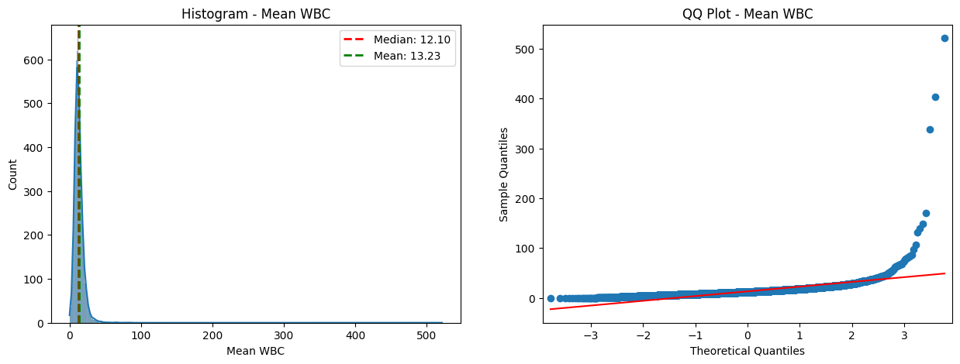

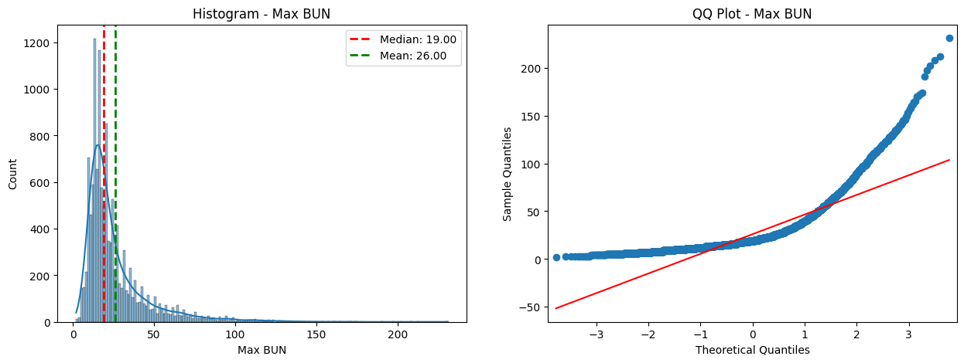

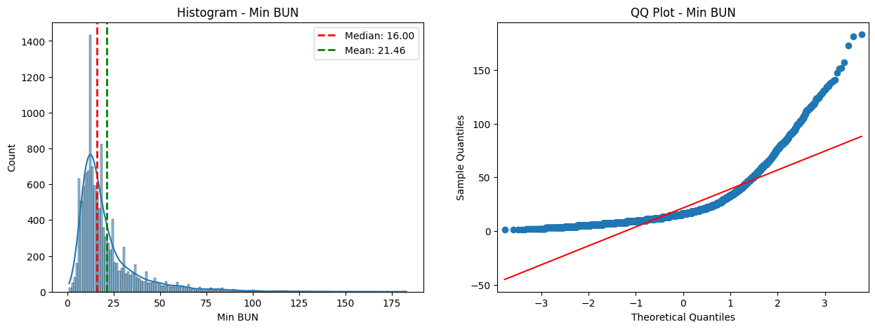

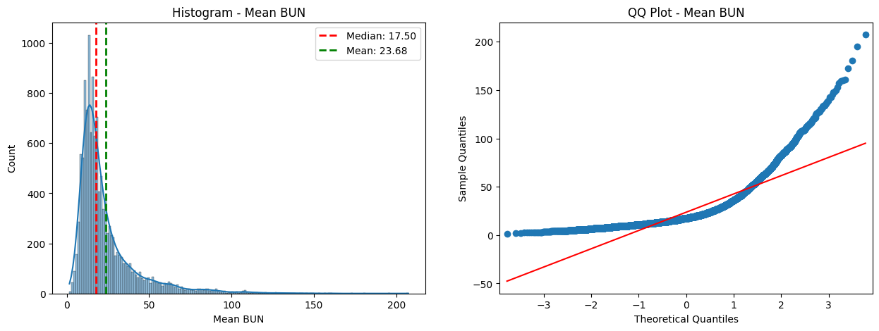

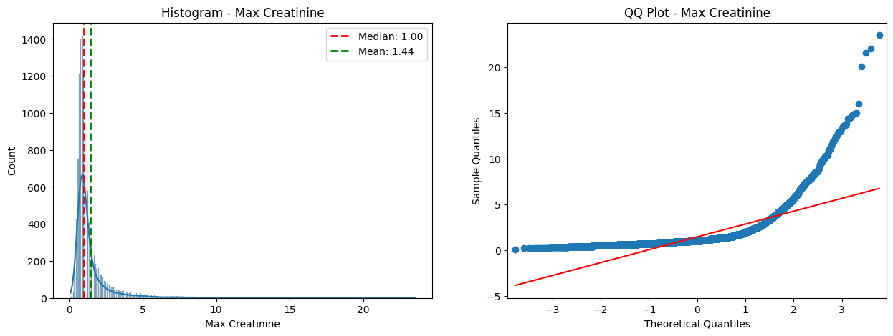

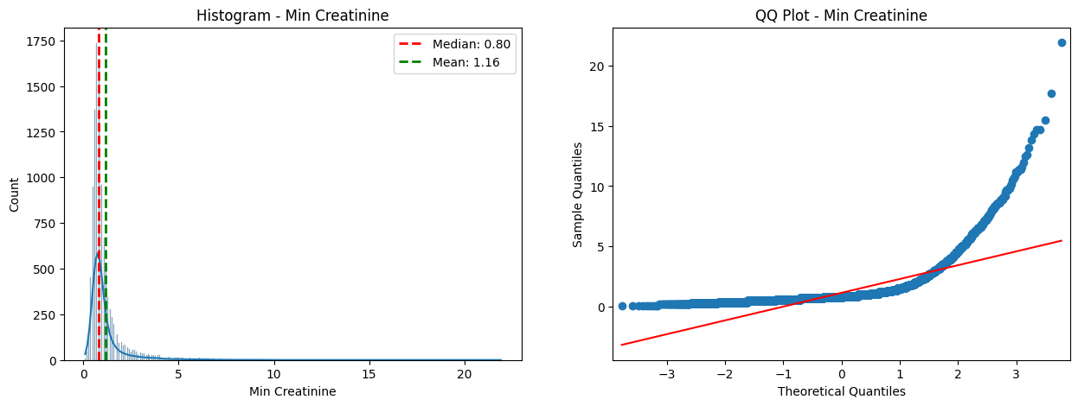

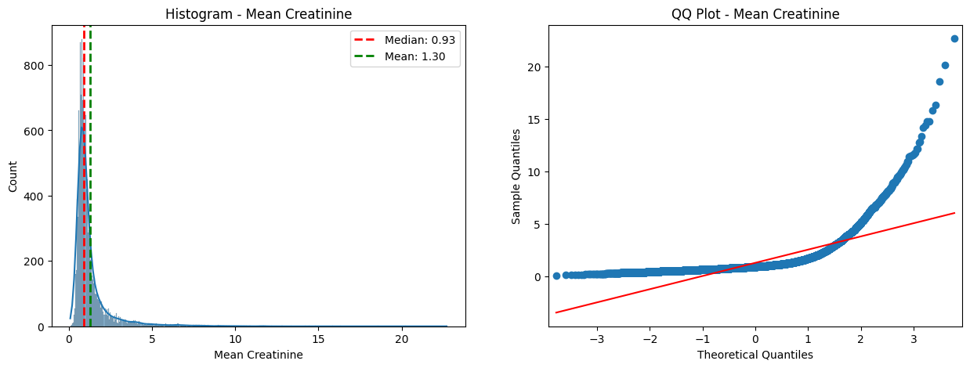

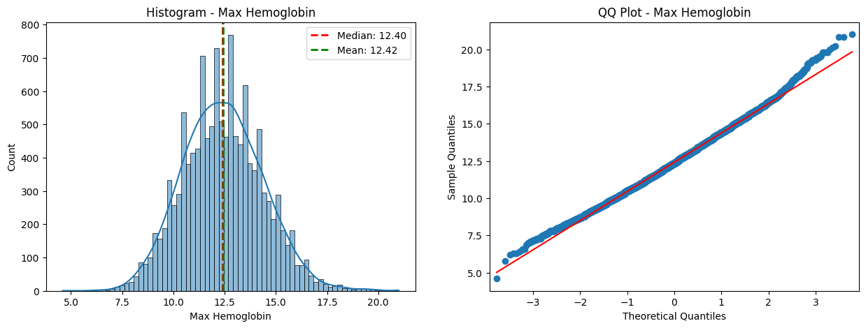

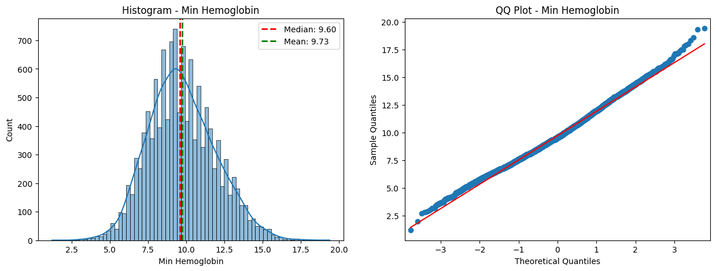

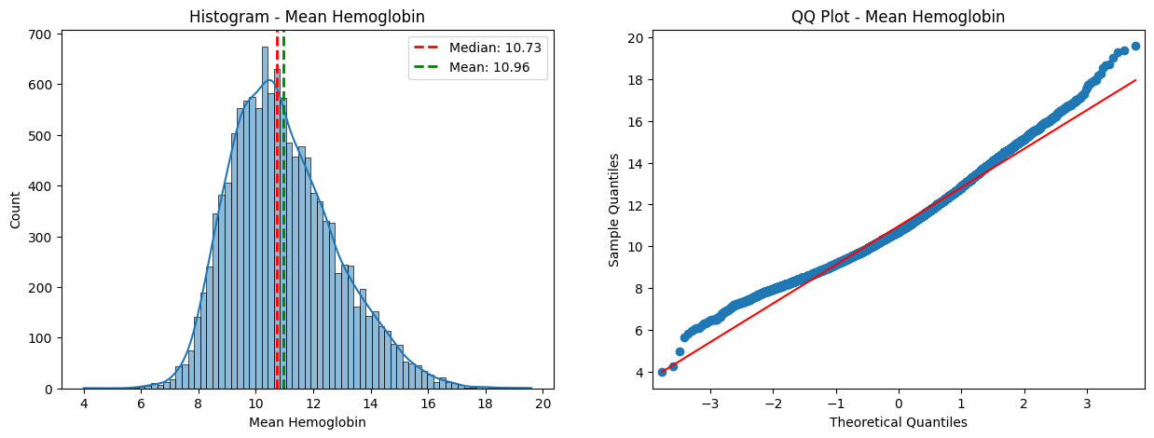

## After normalization

### Method 1 – Log Transformation Method

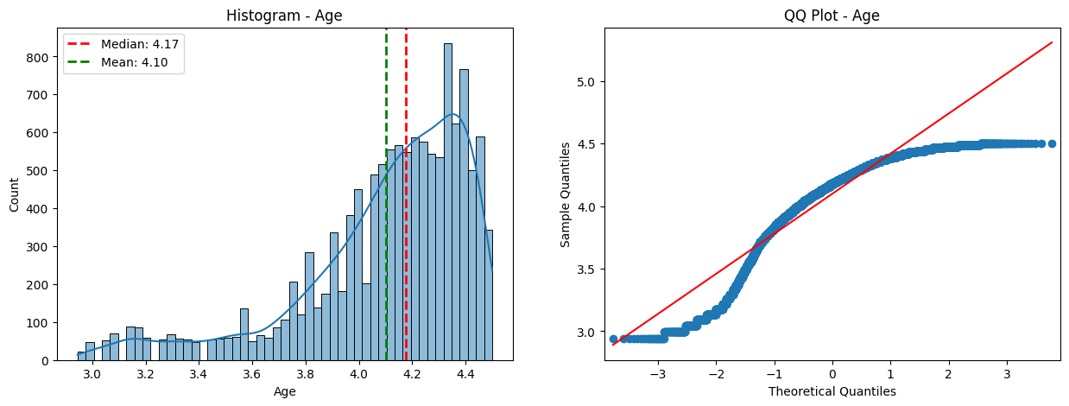

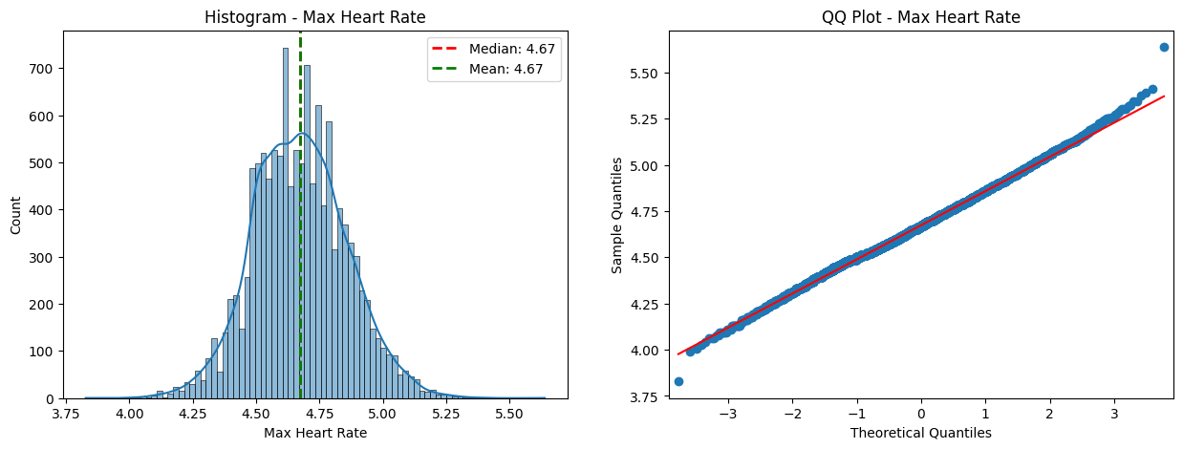

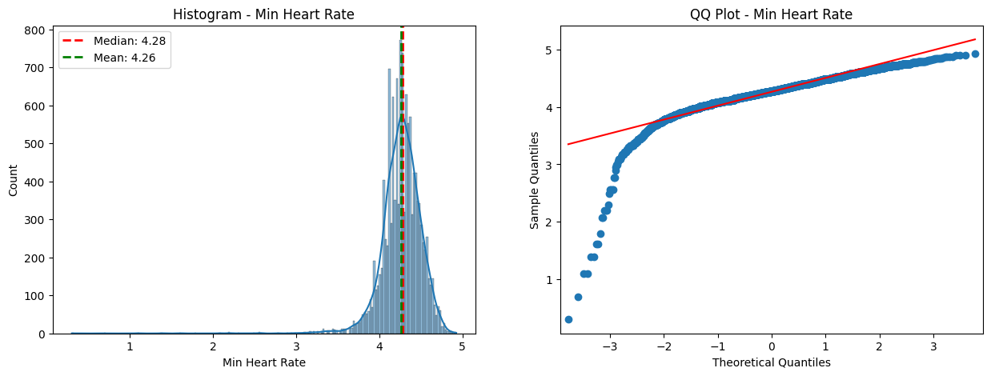

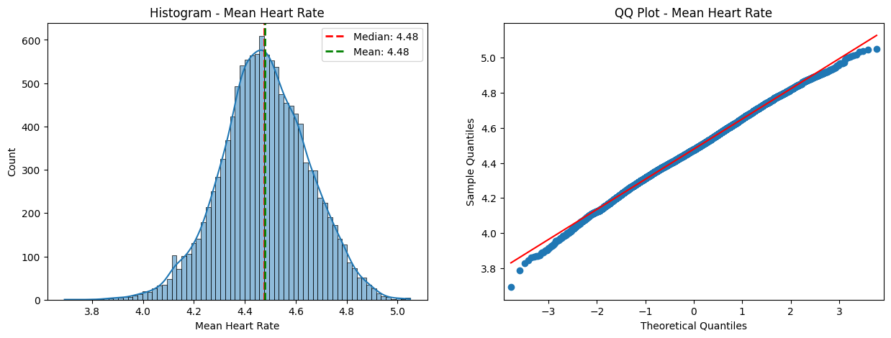

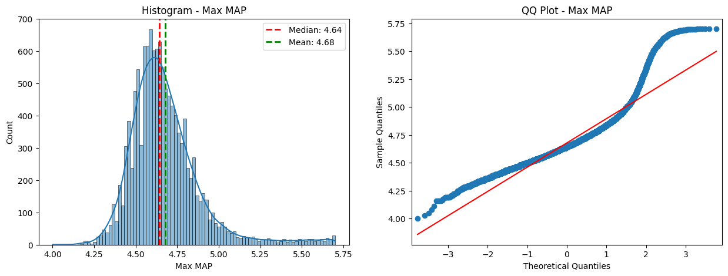

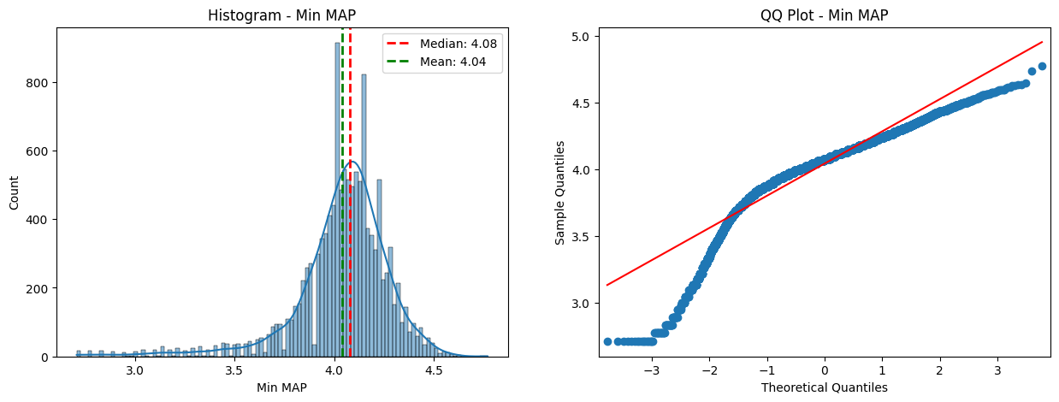

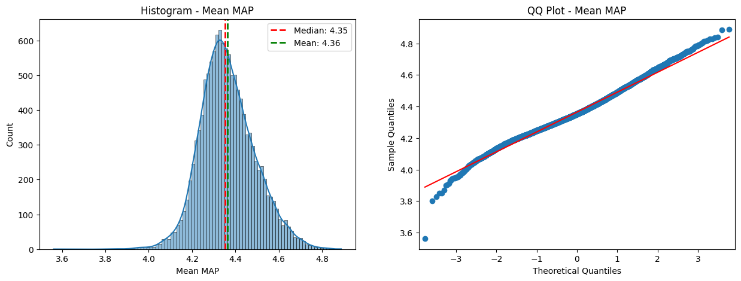

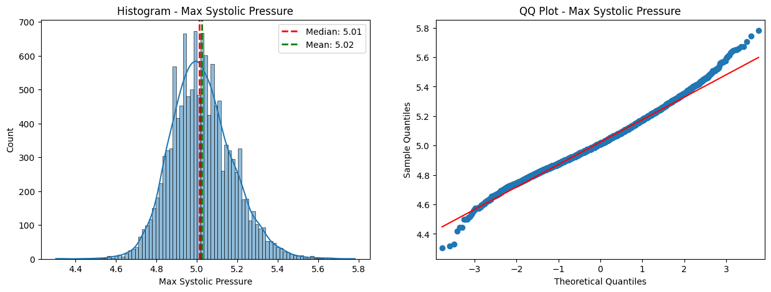

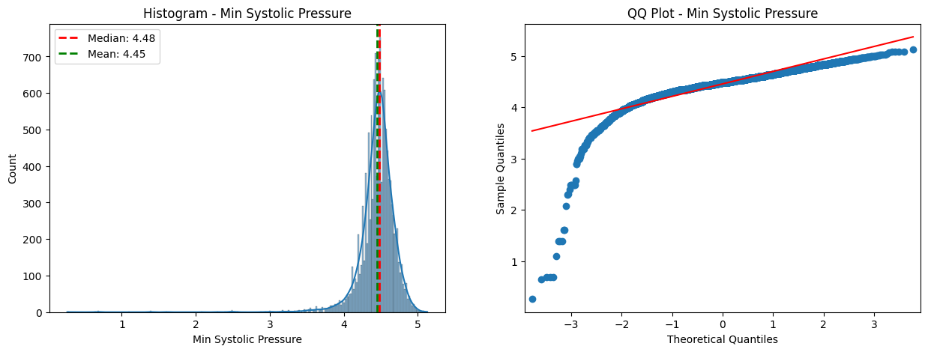

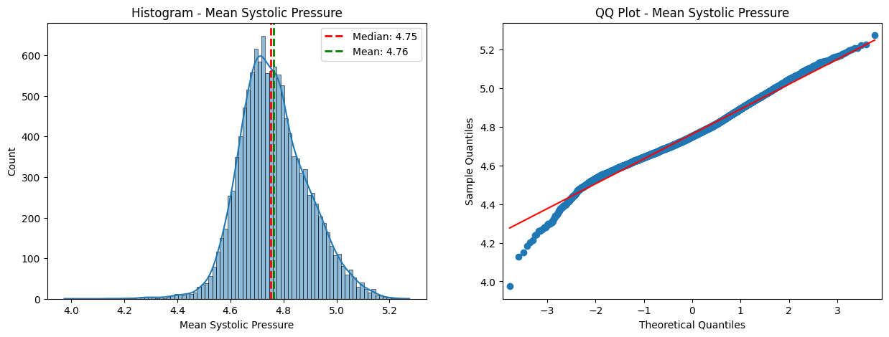

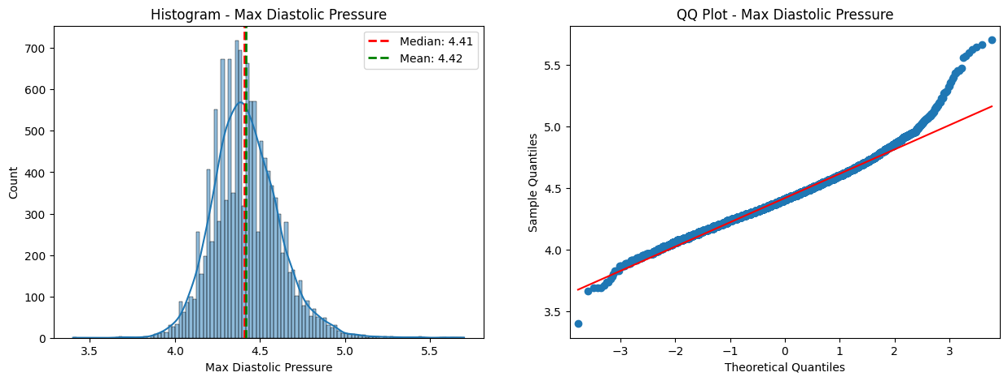

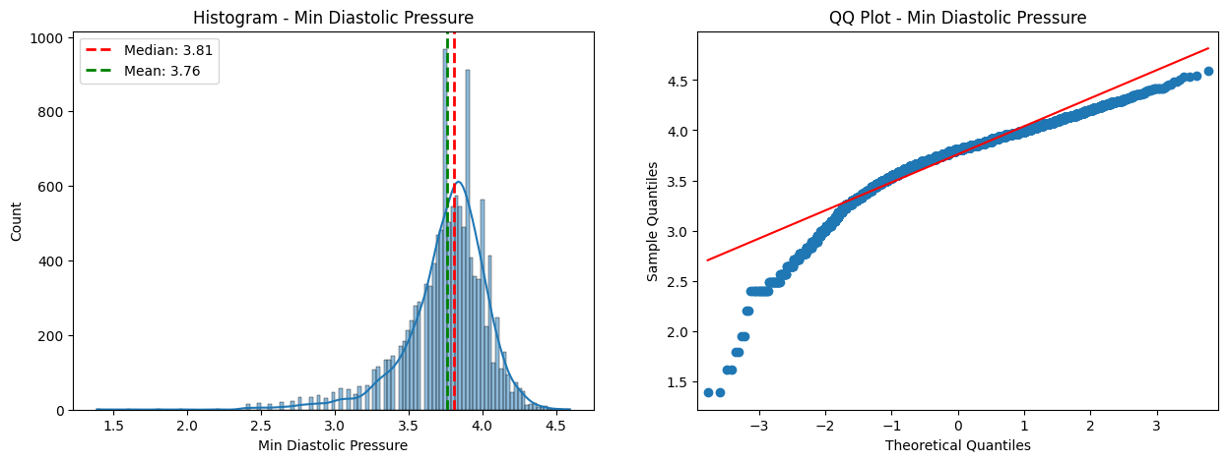

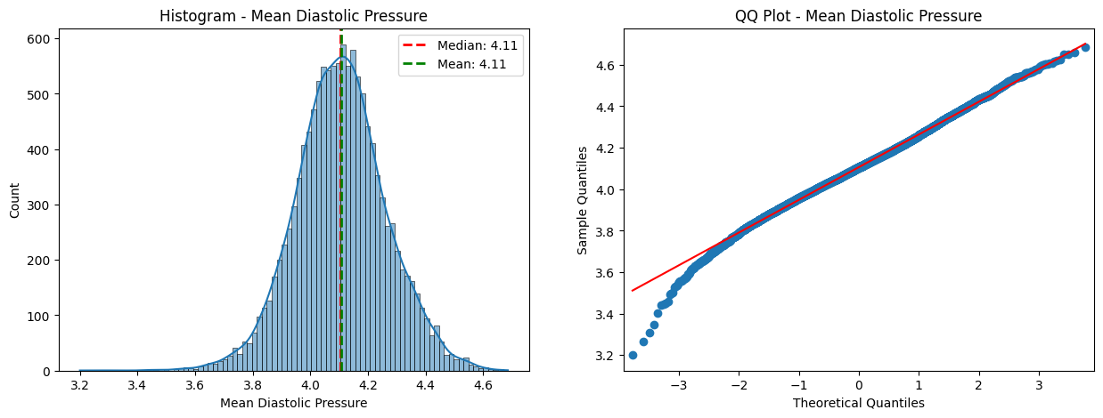

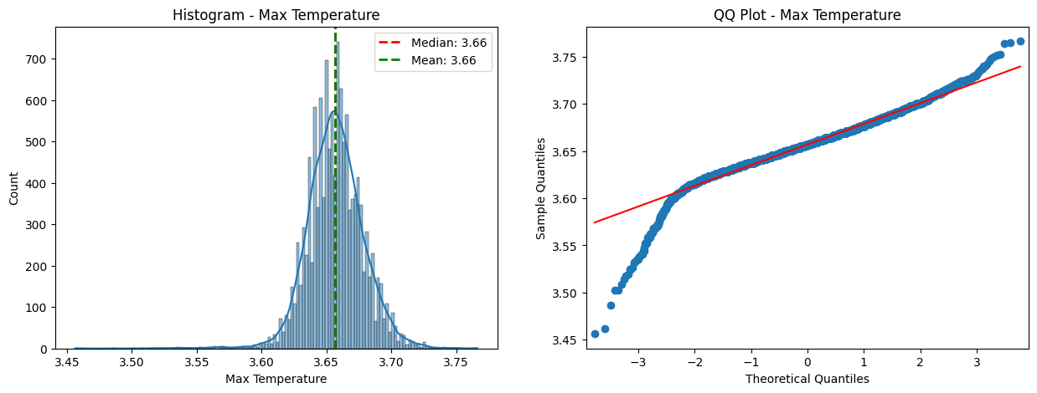

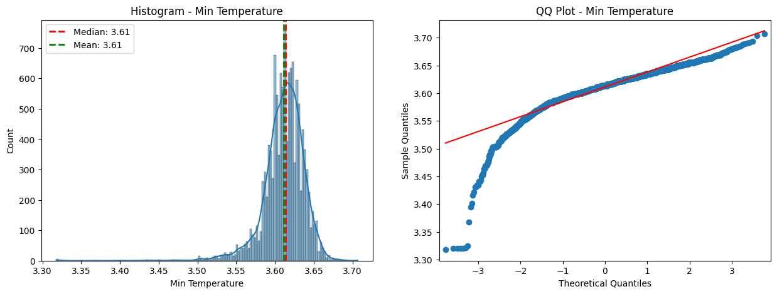

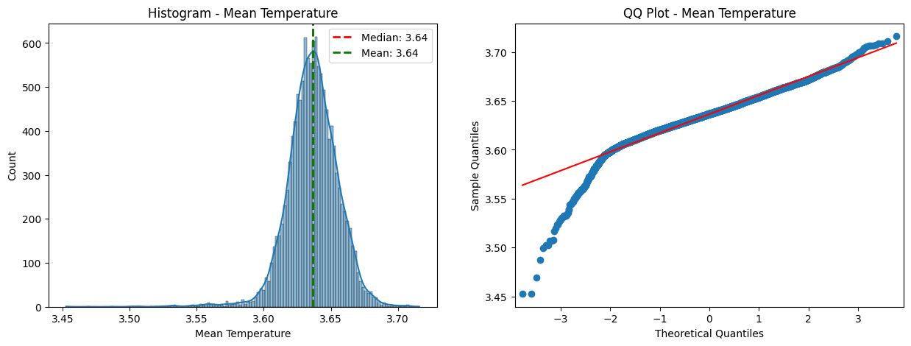

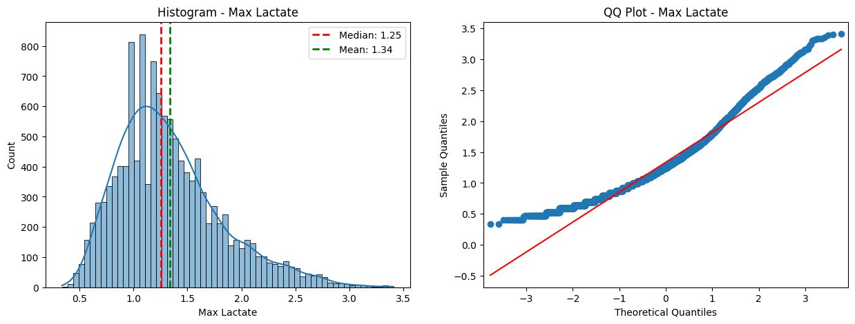

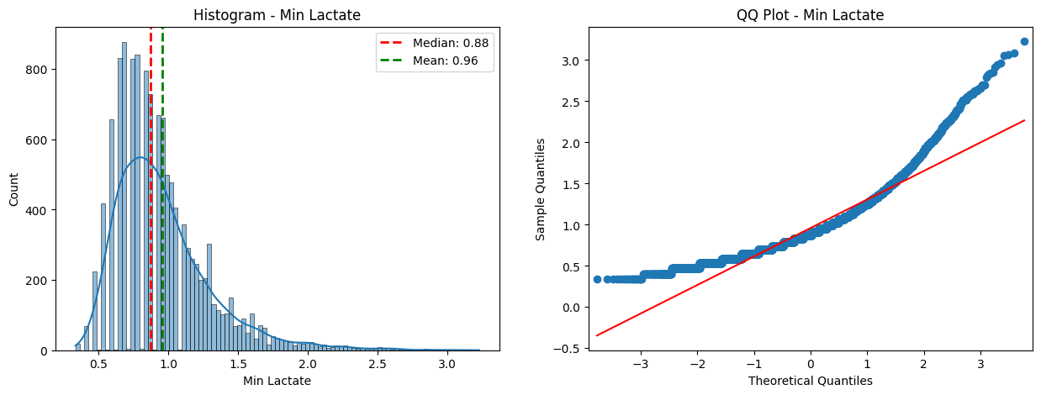

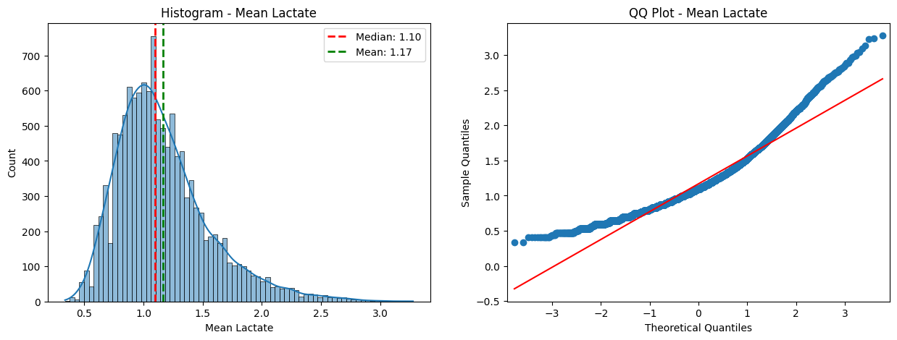

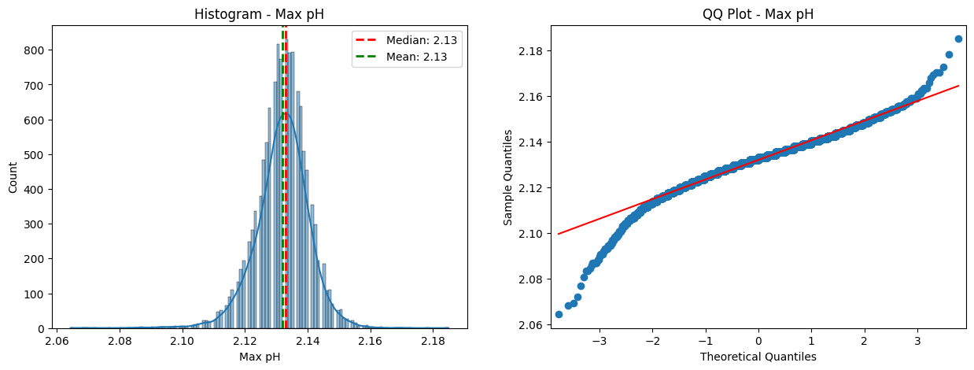

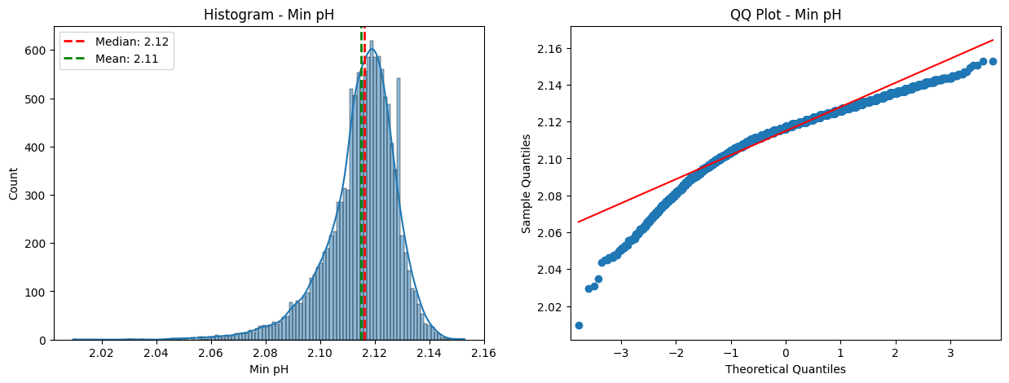

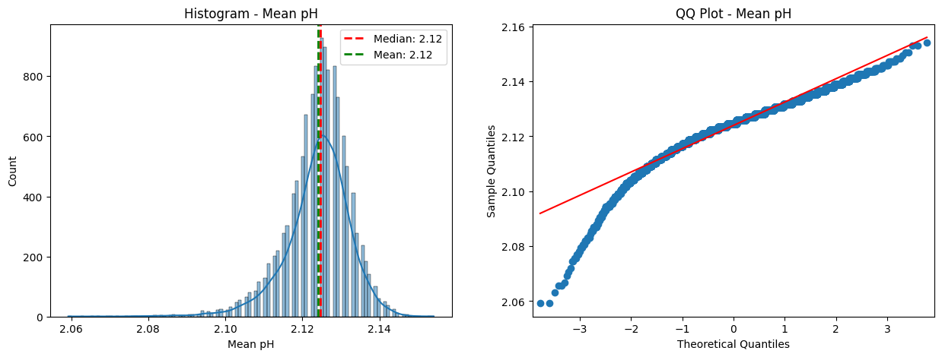

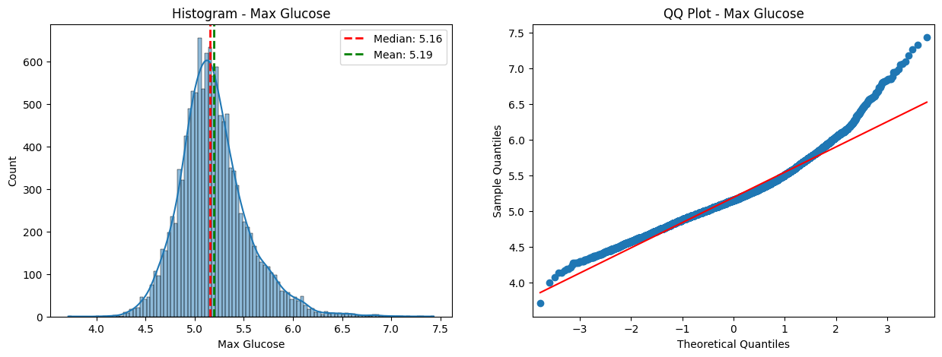

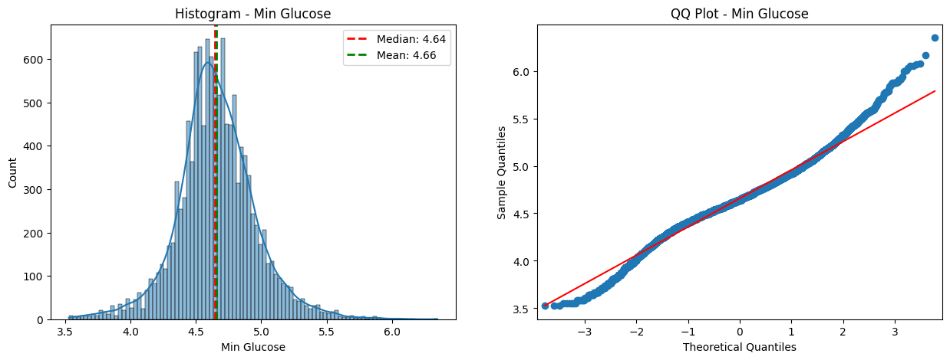

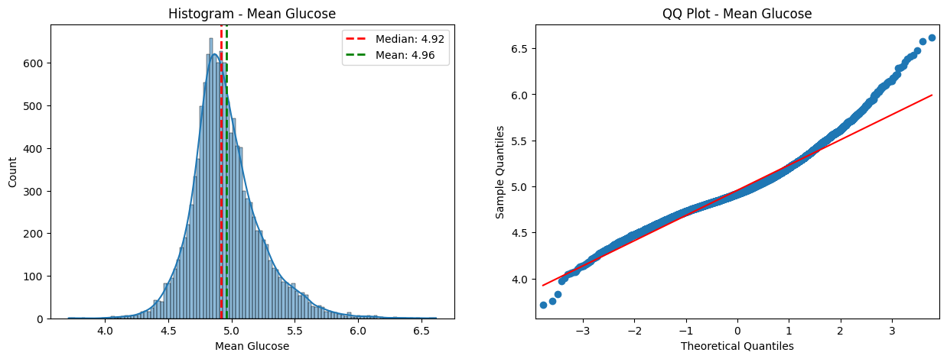

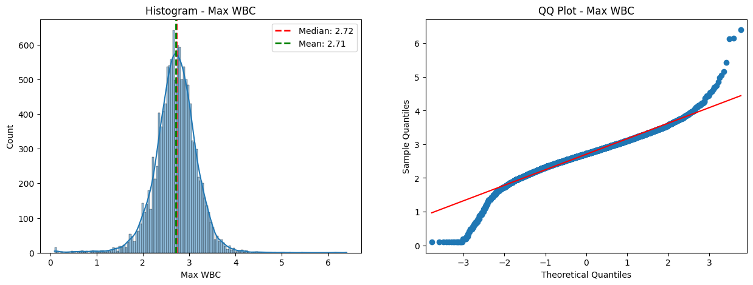

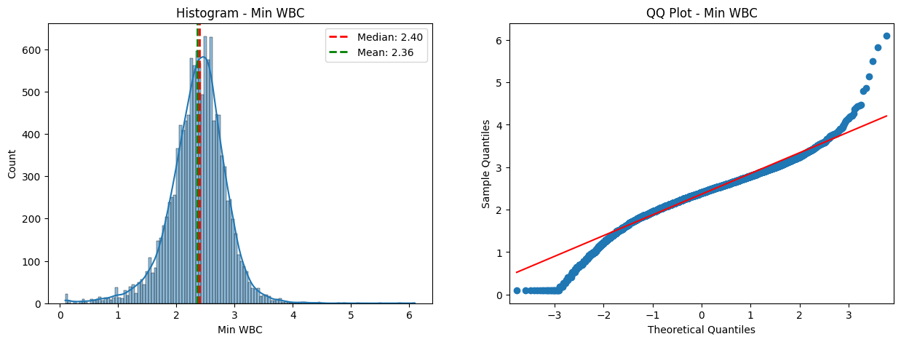

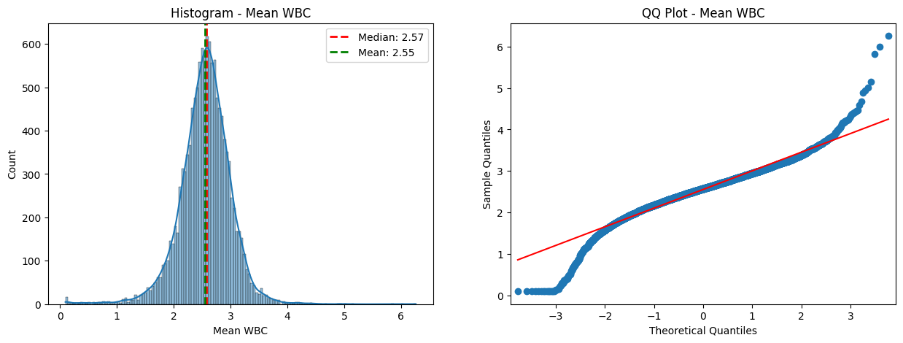

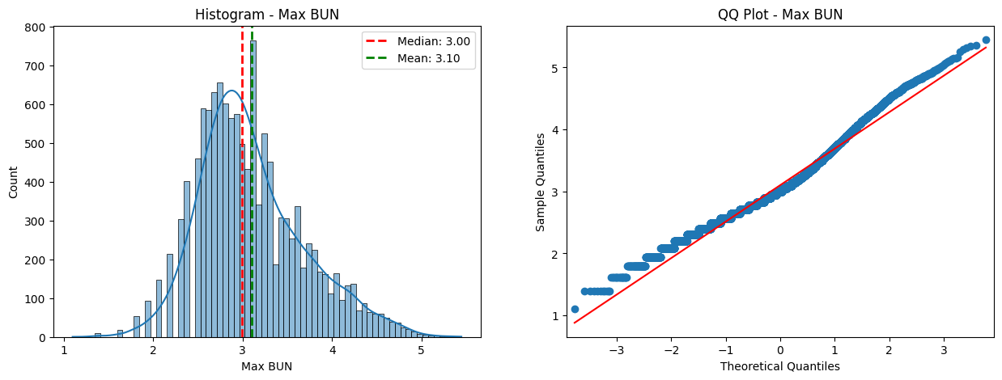

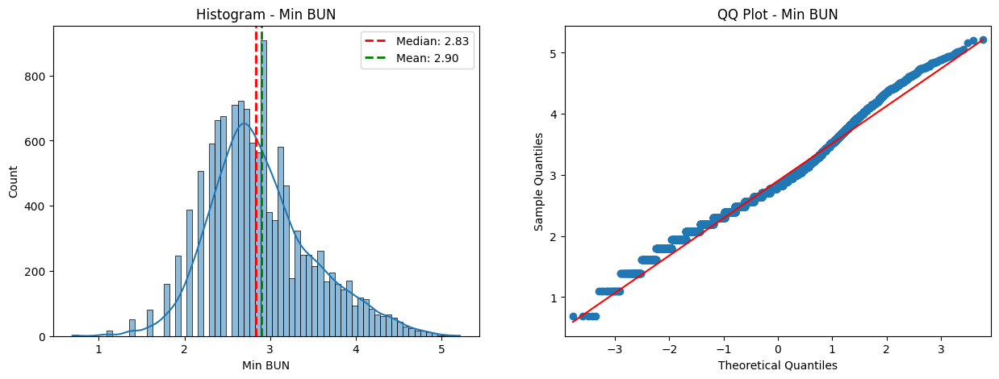

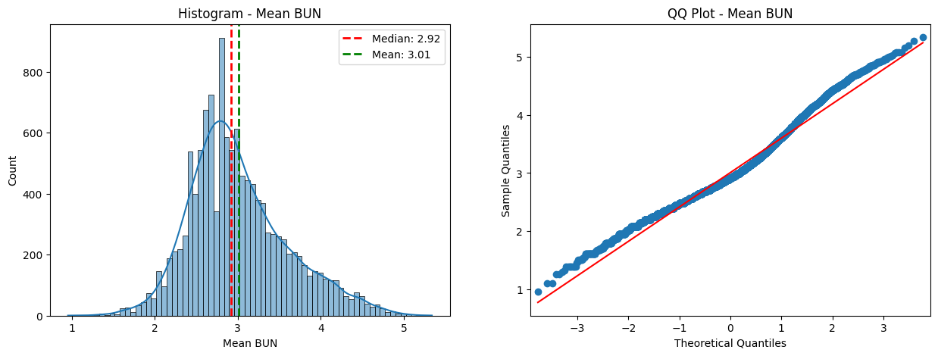

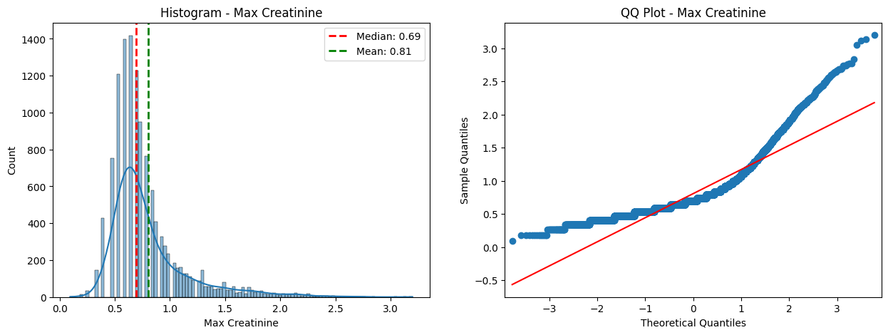

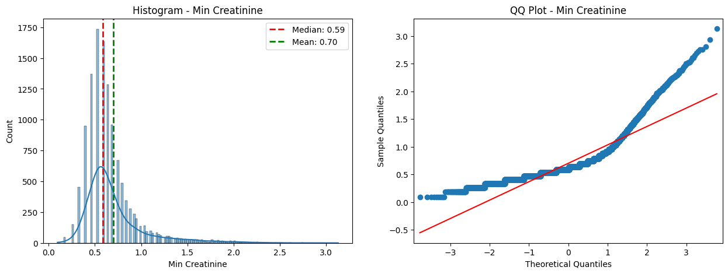

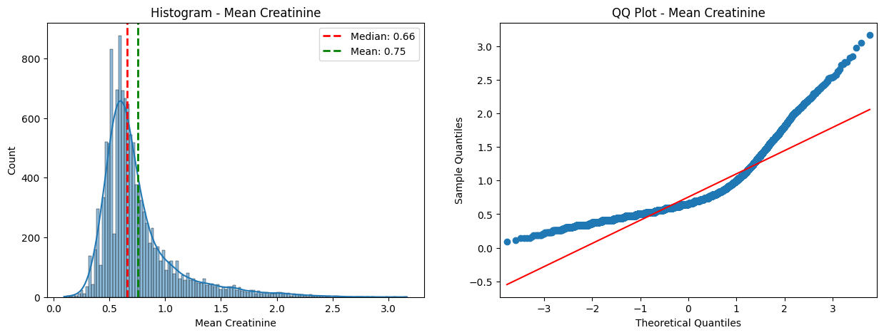

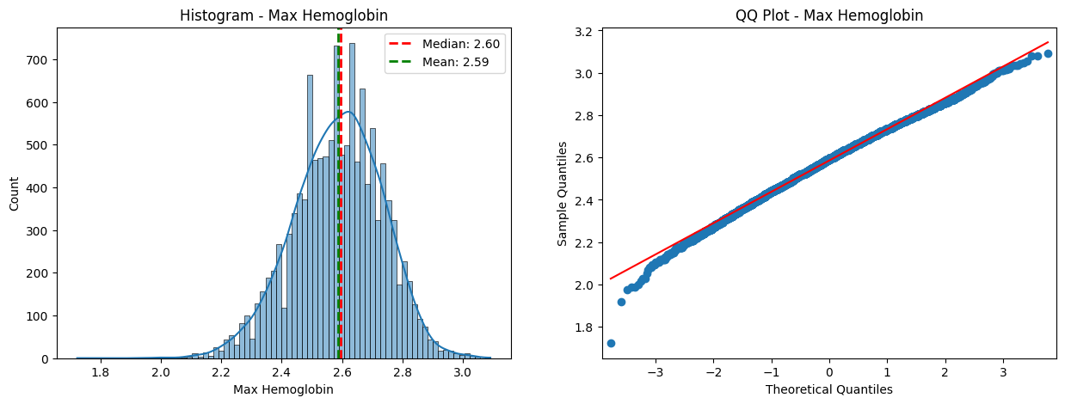

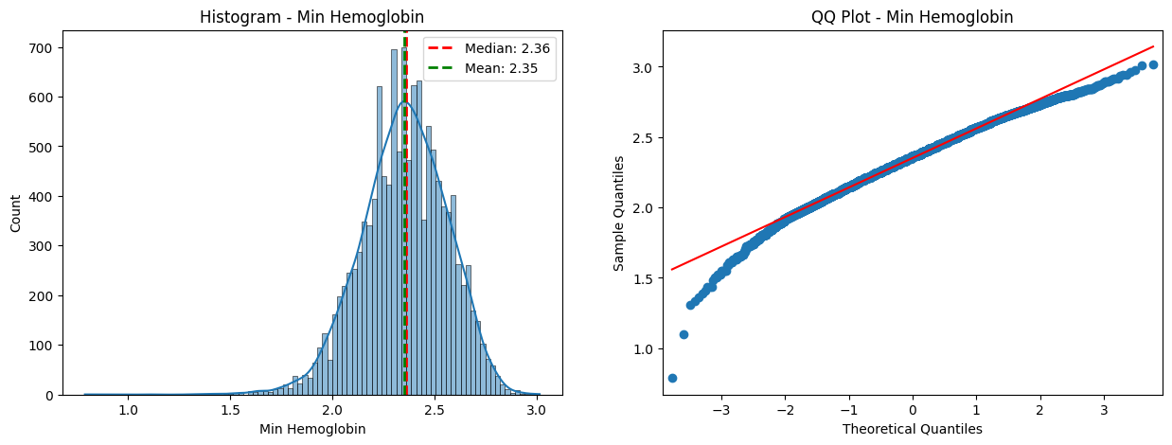

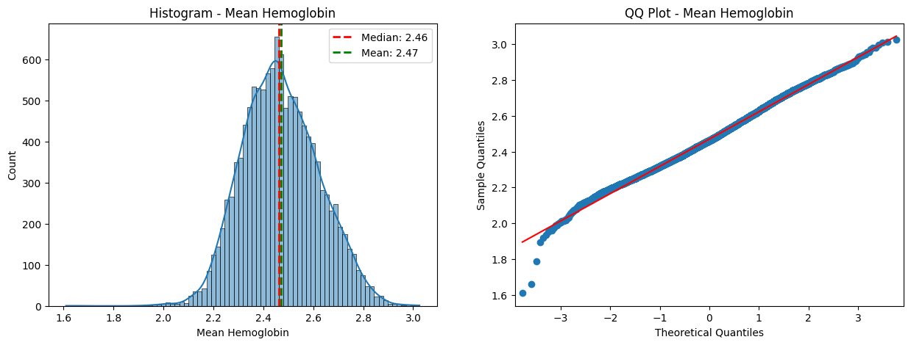

## Visualization of Categorical Variables

### Bar Graphs





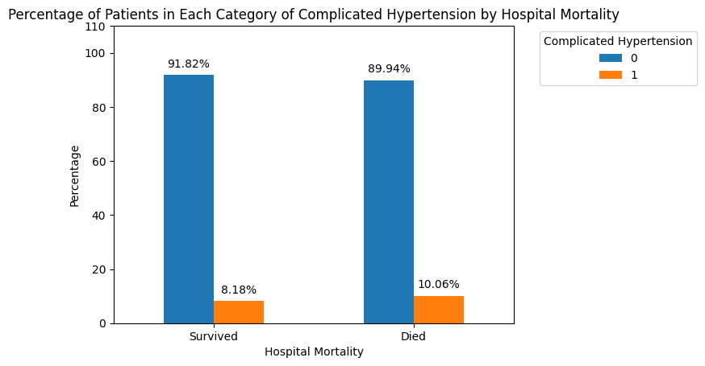

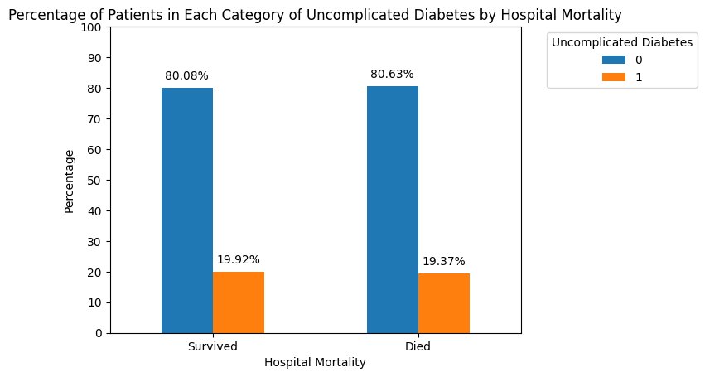

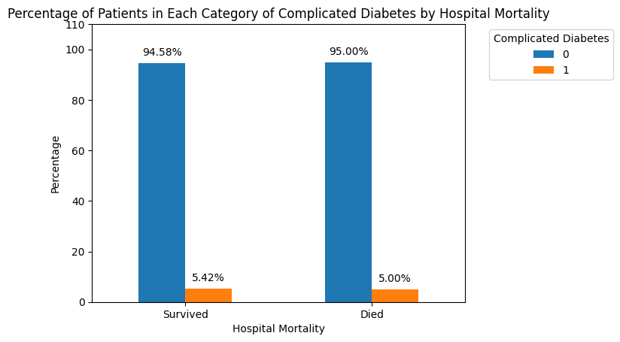

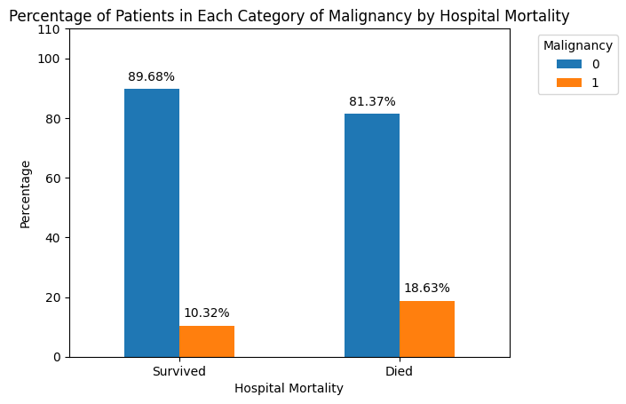

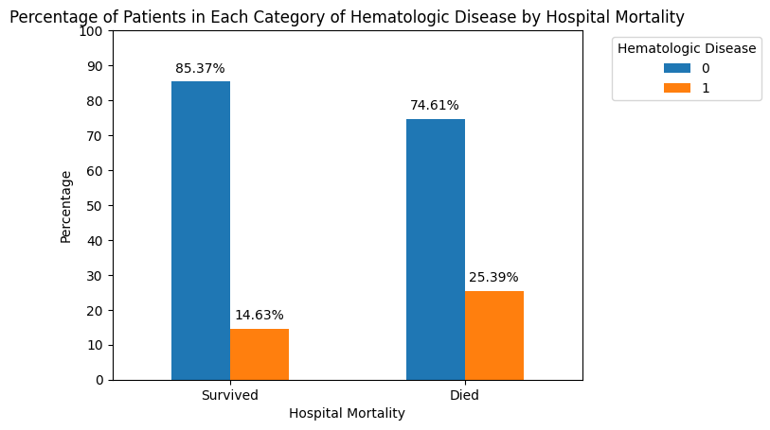

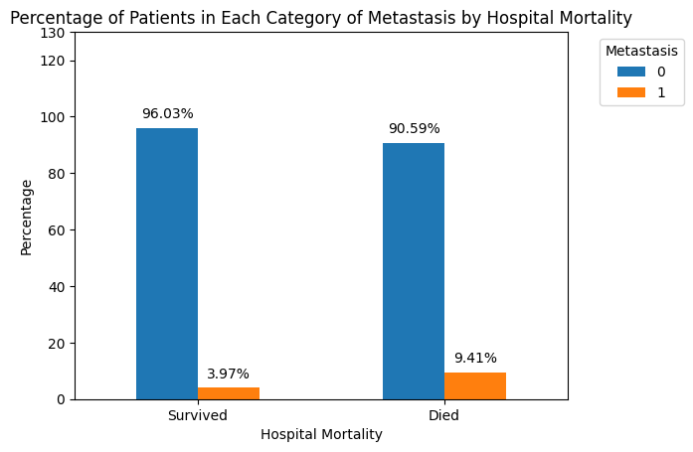

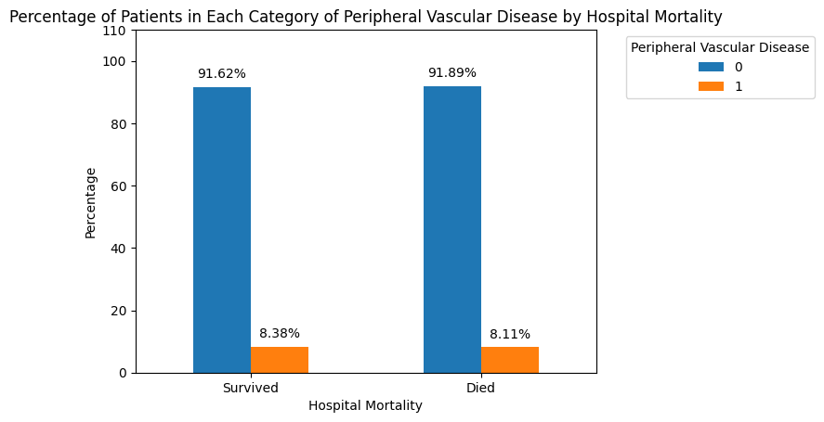

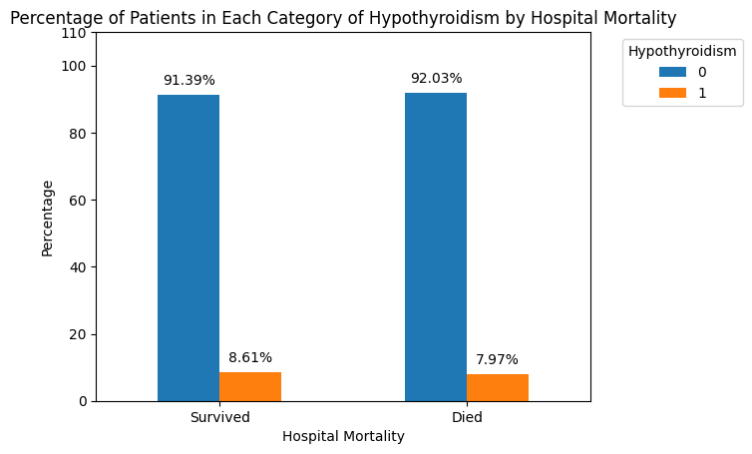



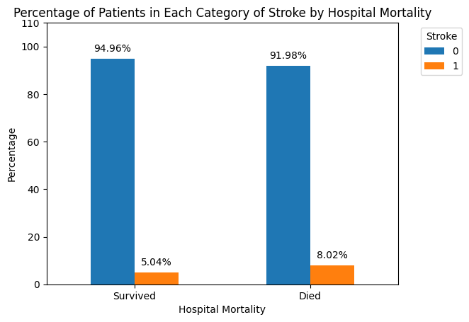

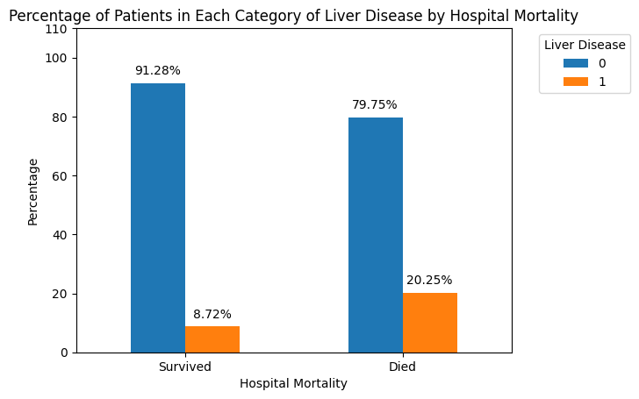





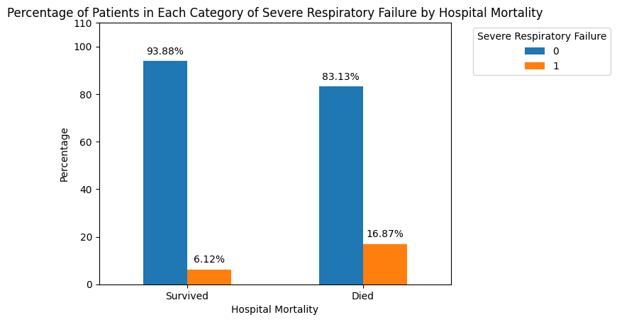

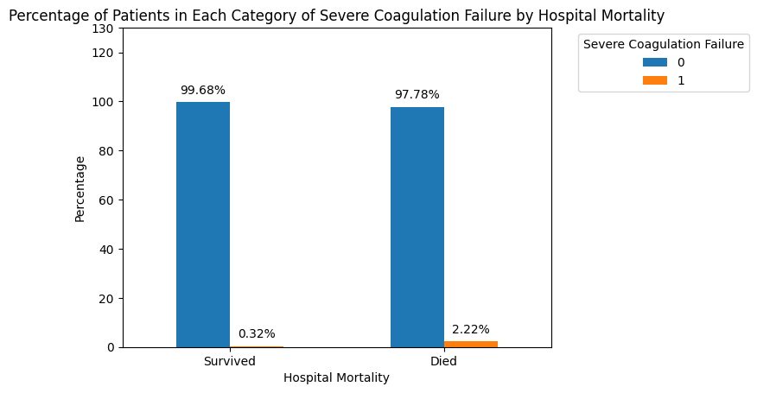

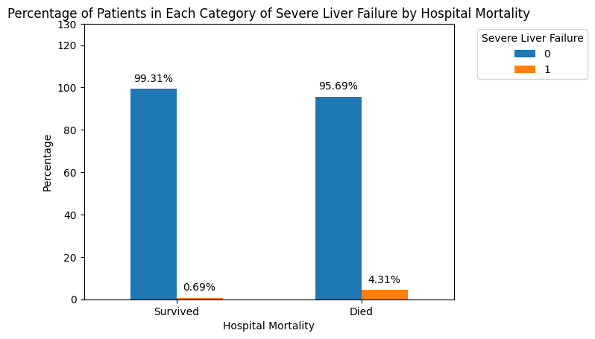



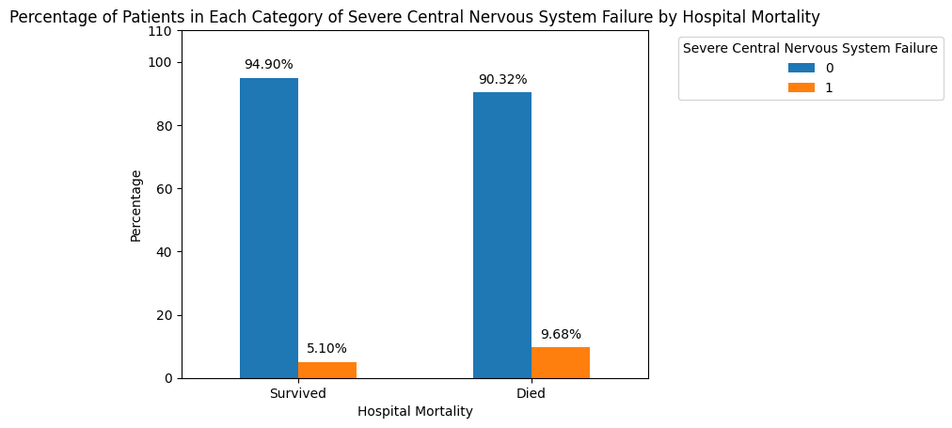

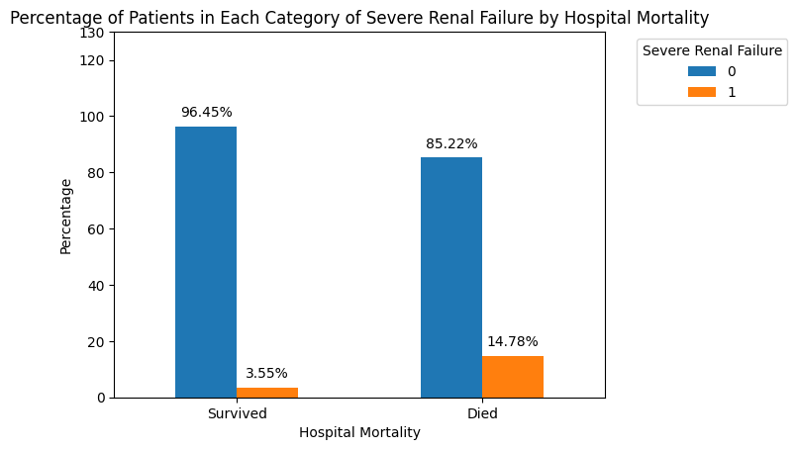







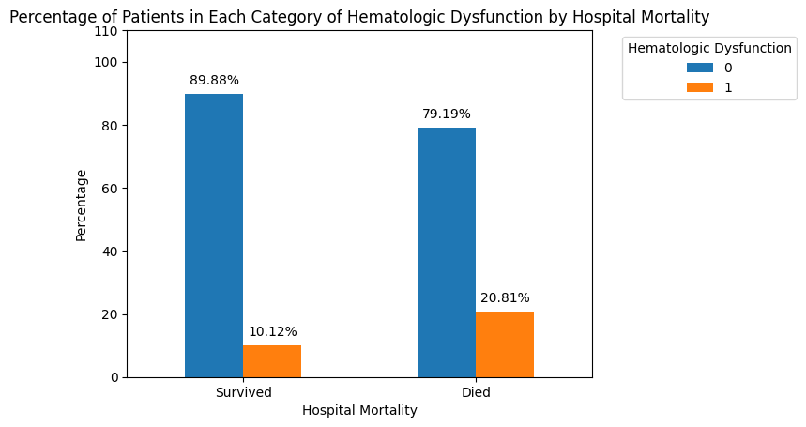



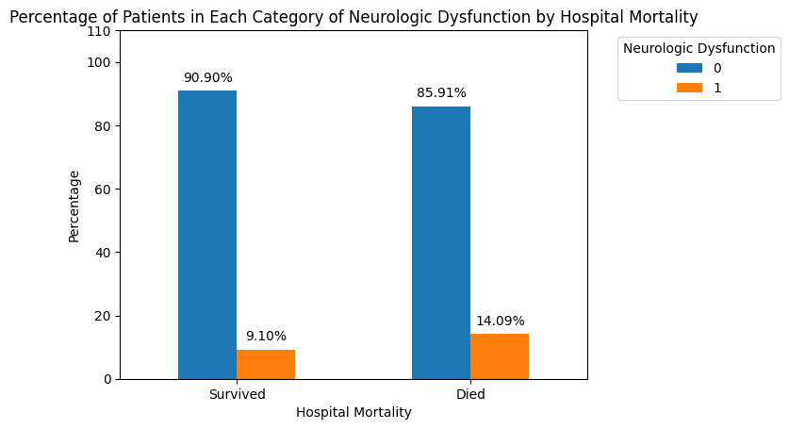

### Box Plots











































































## Visualization of Continuous Variable

### Density plots

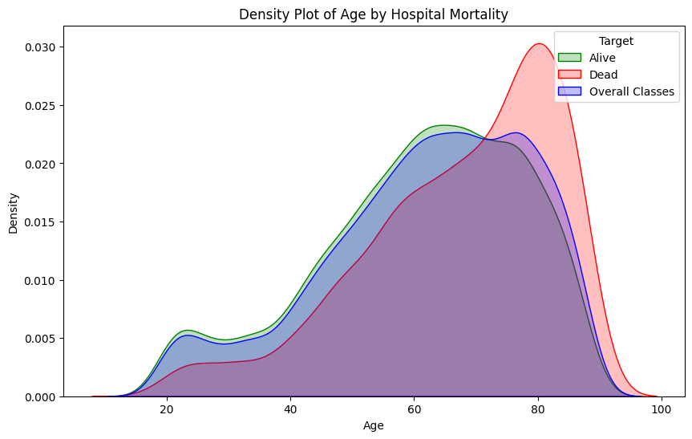

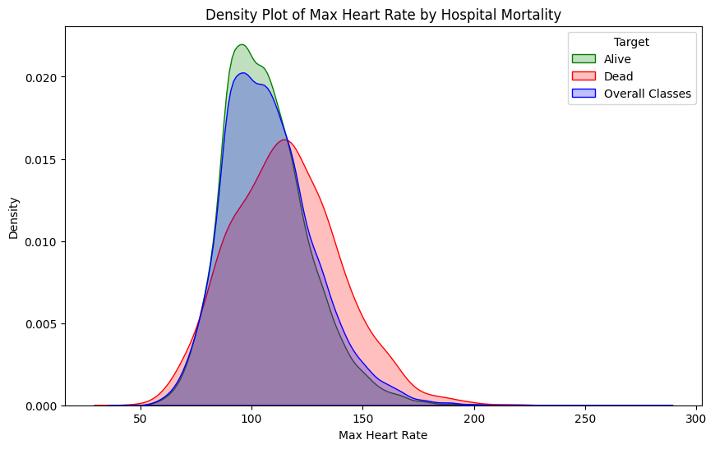

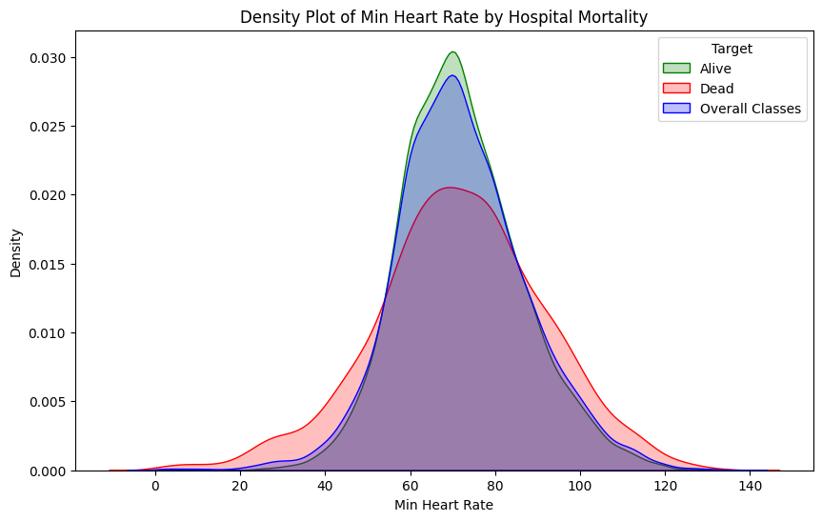

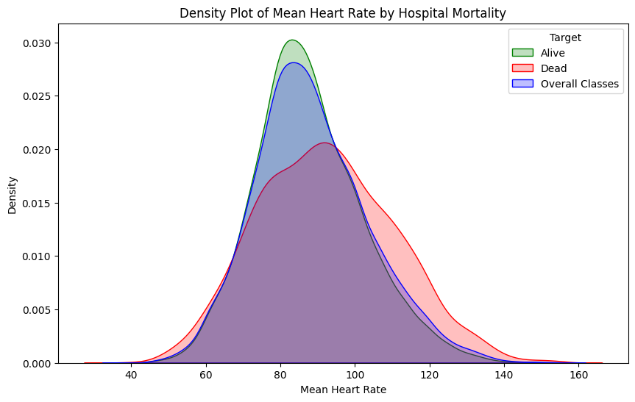

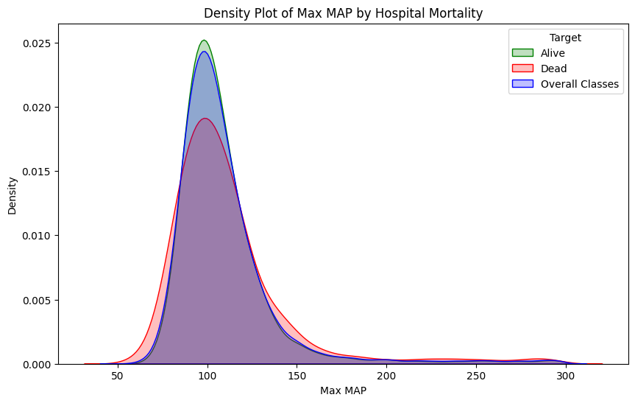

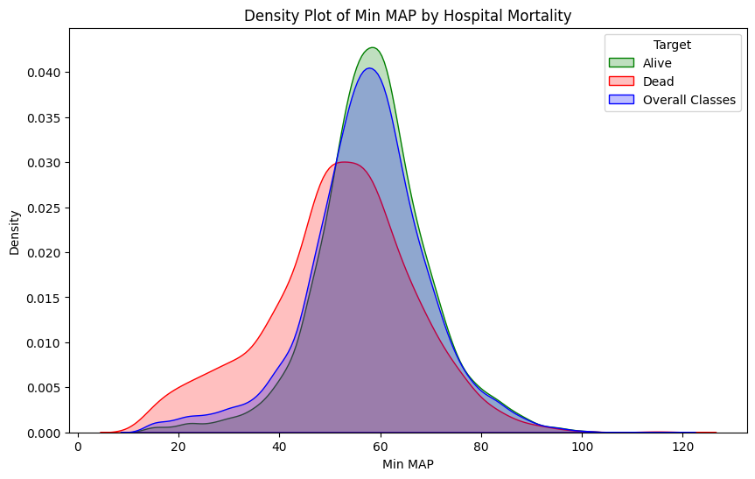

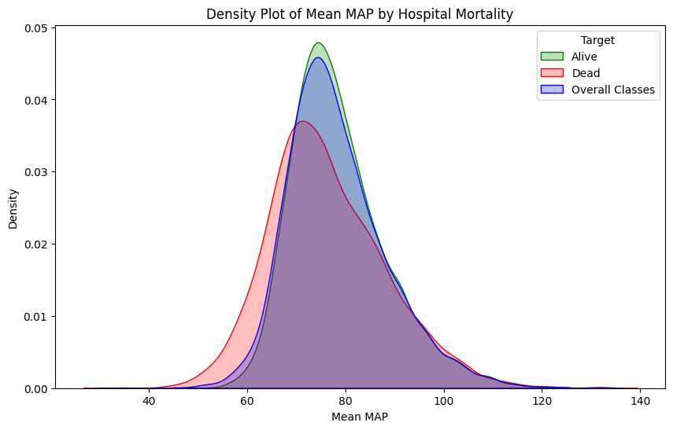

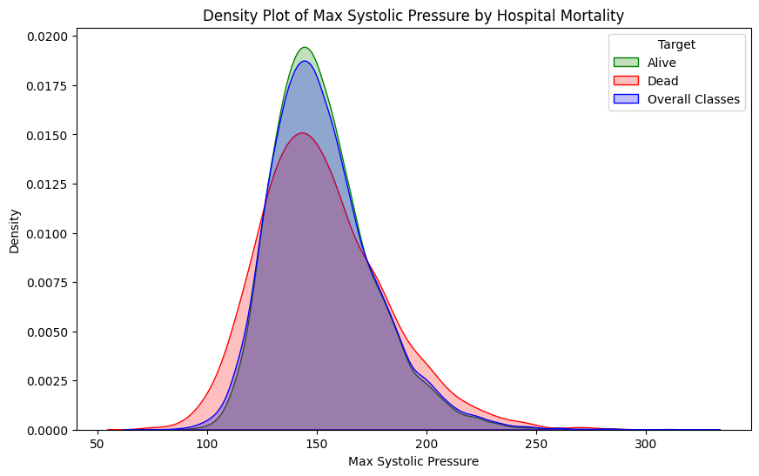

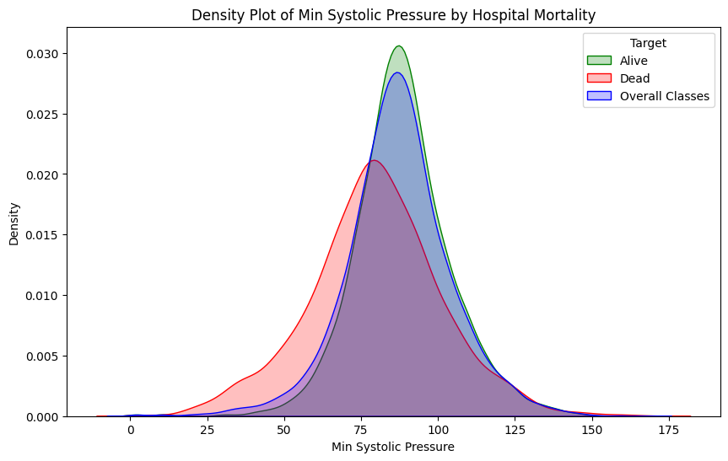

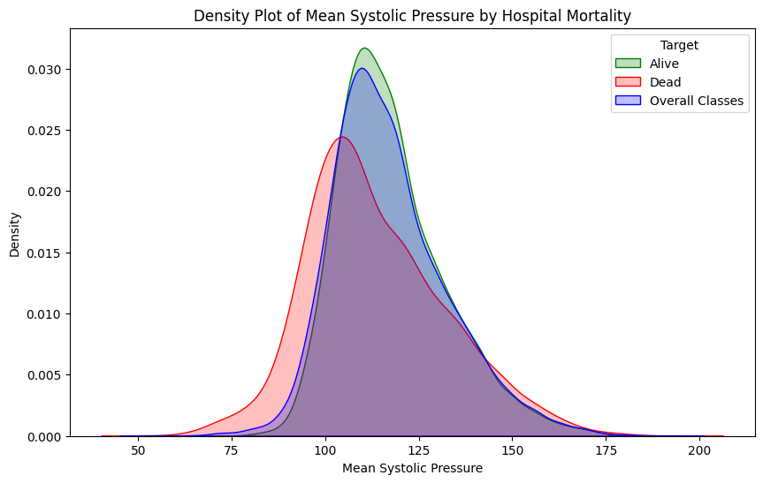

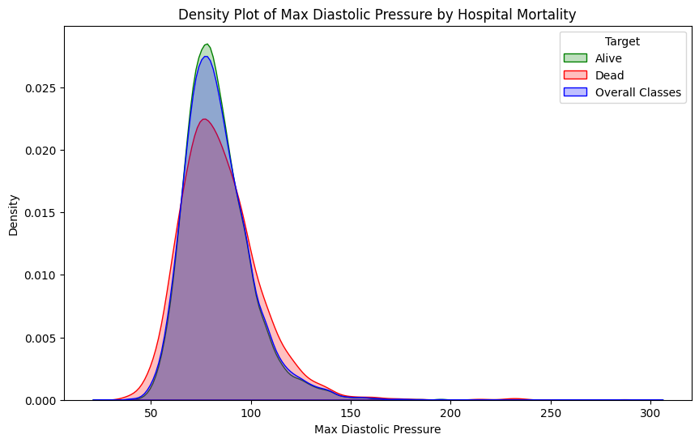

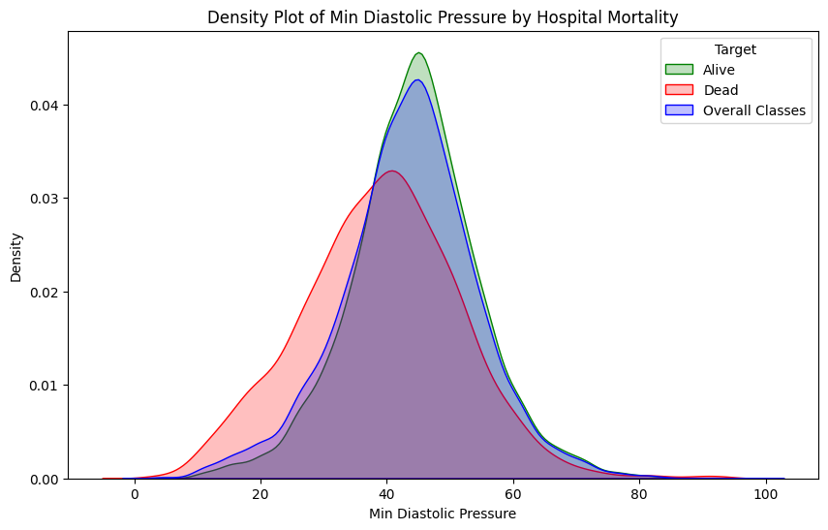

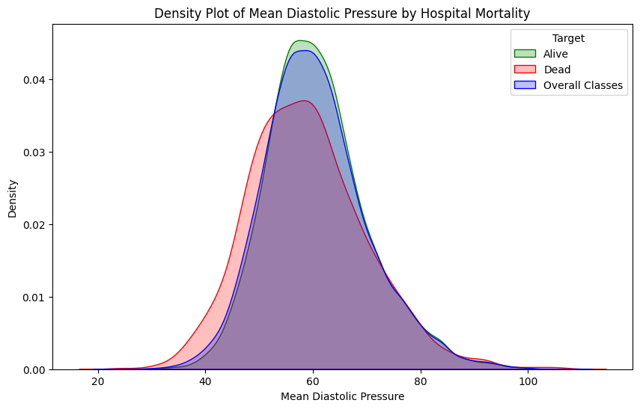

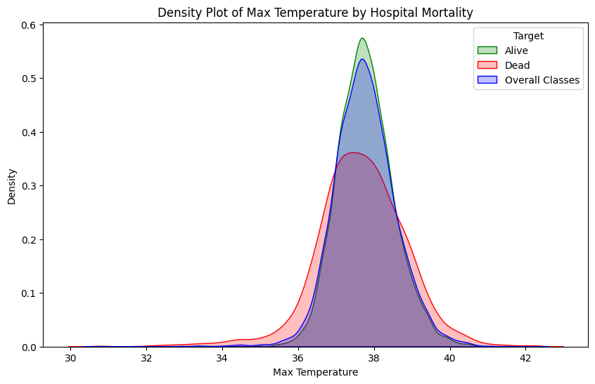

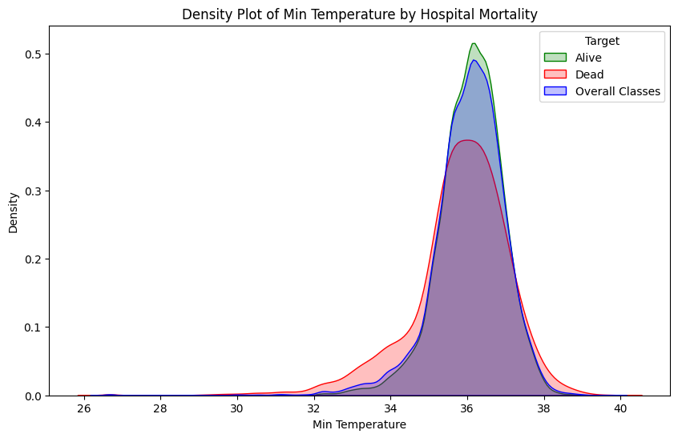

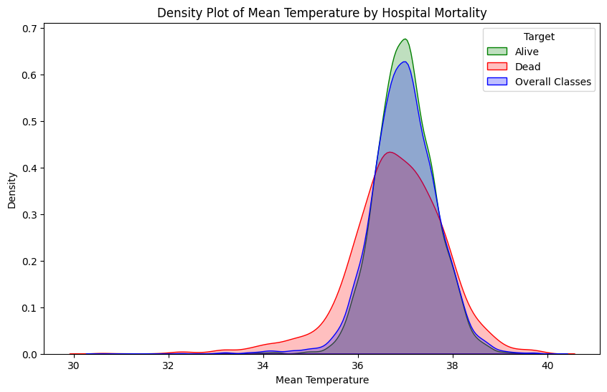

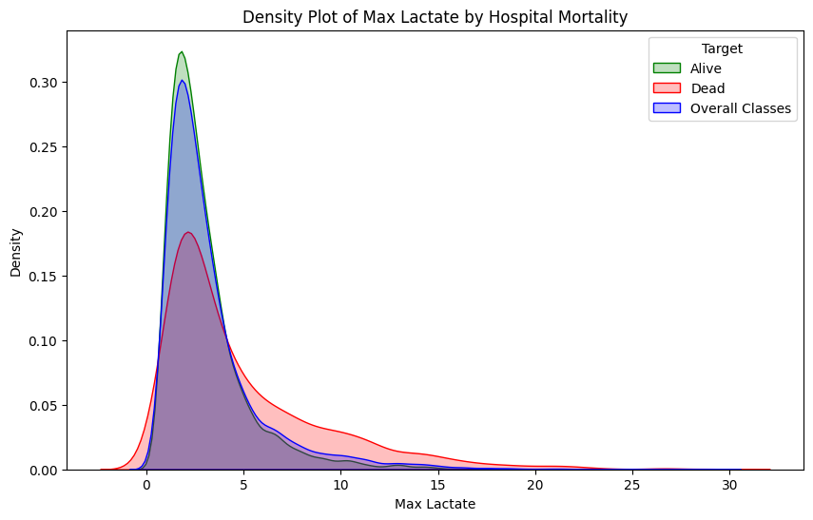

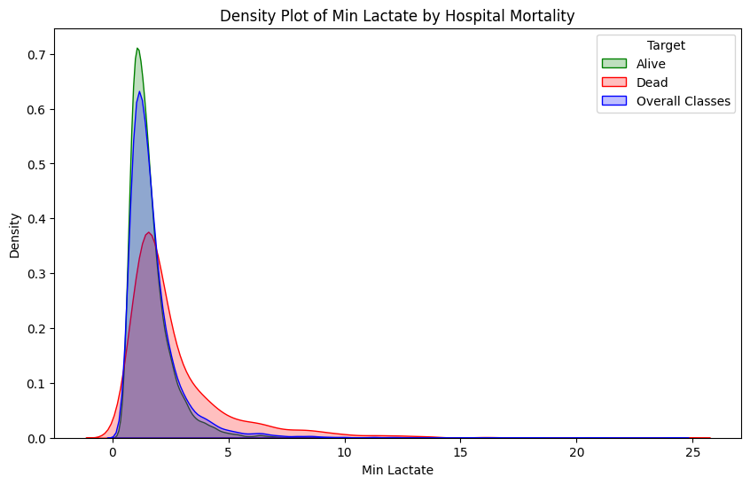

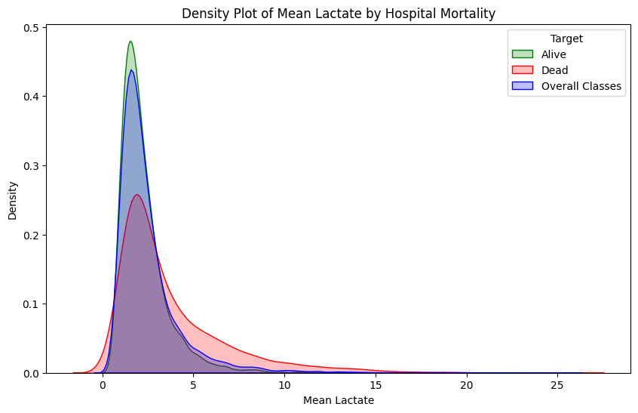

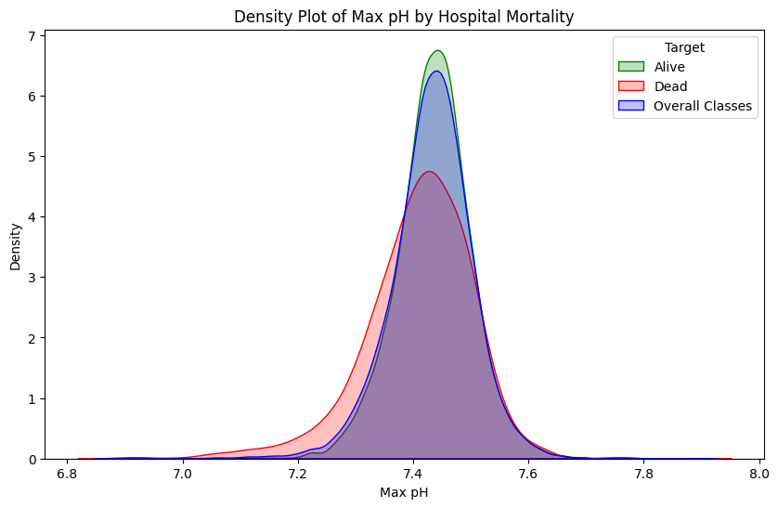

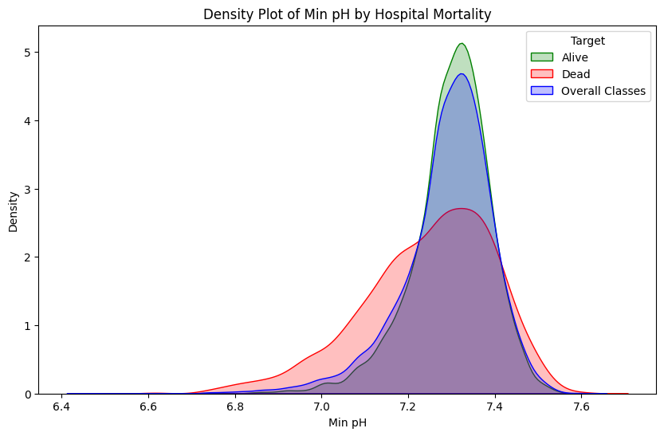

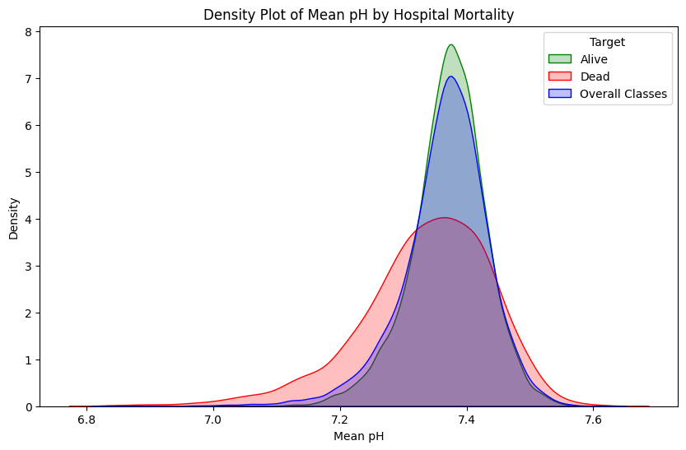

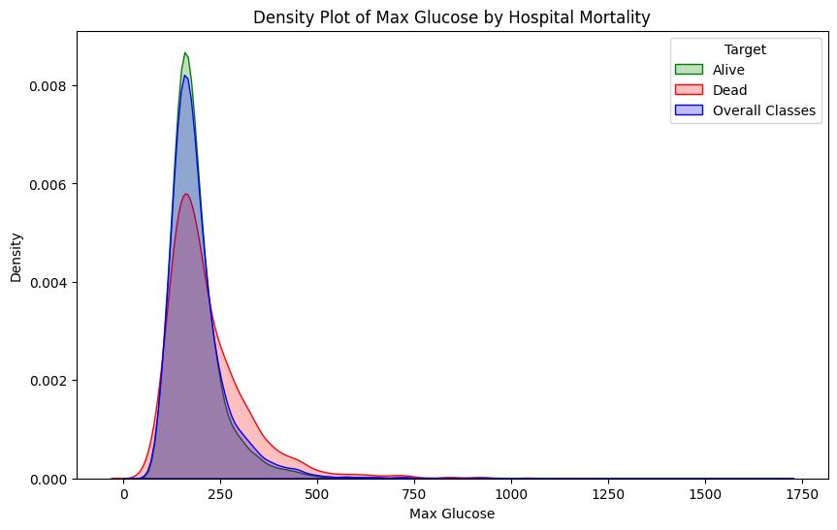

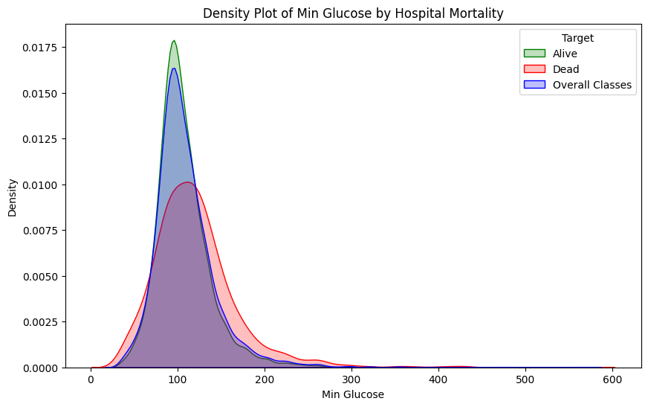

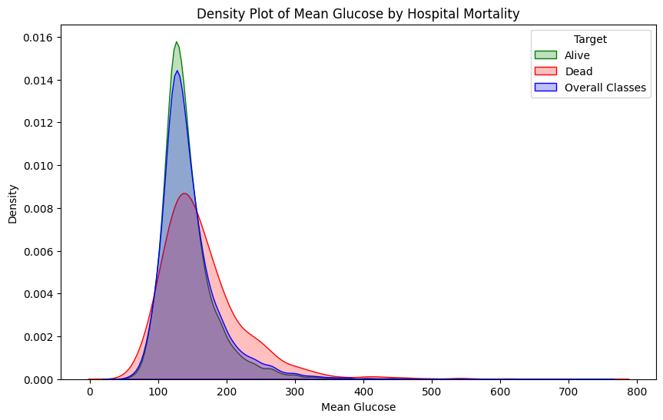

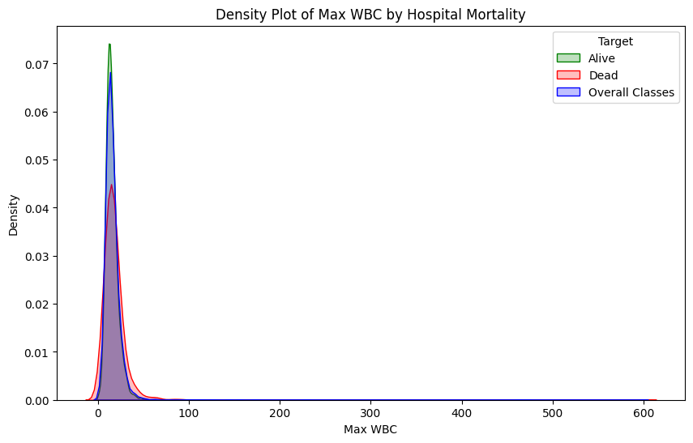

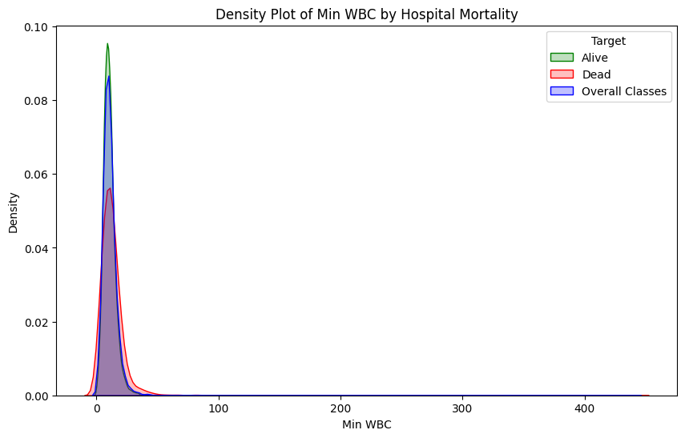

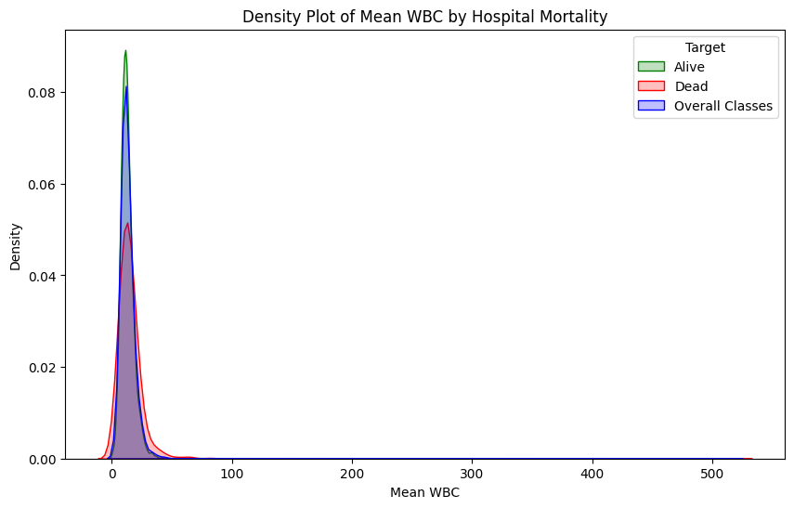

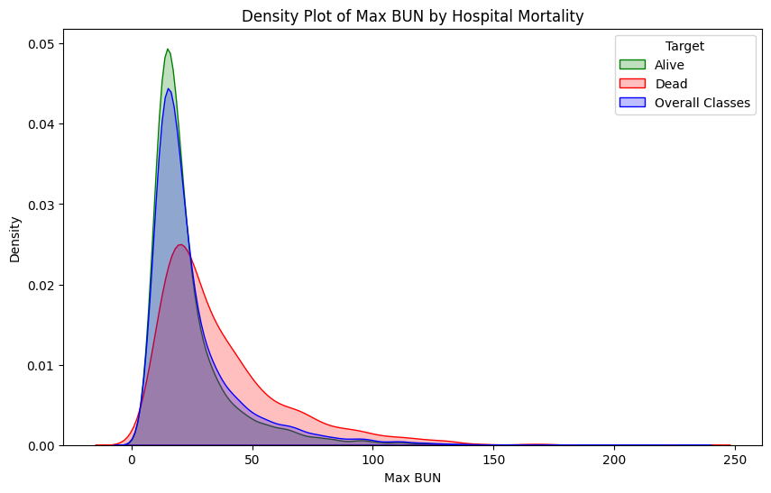

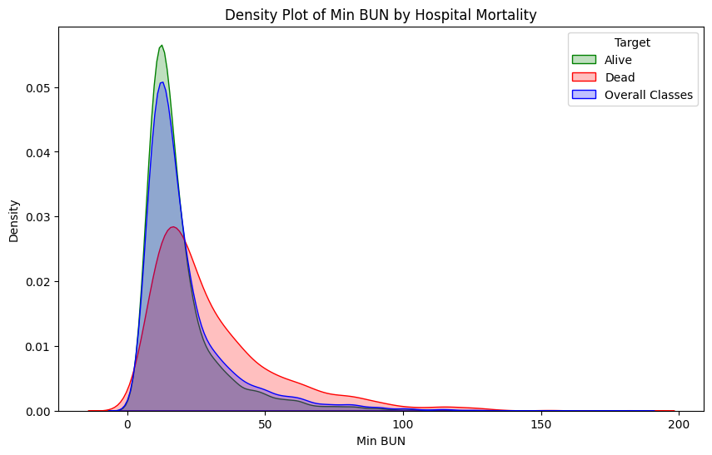

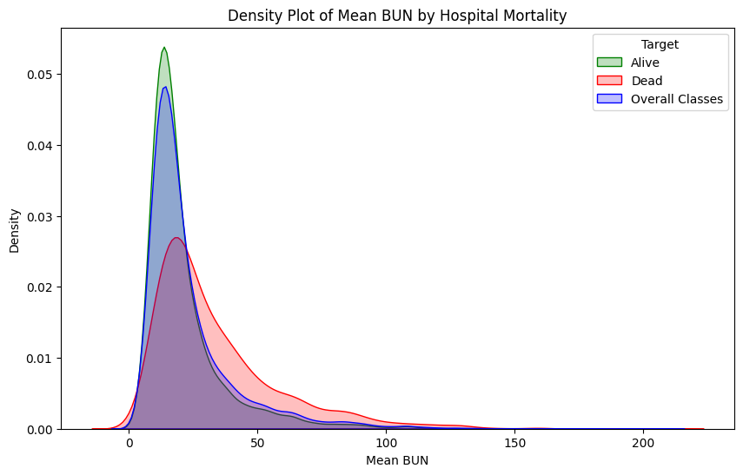

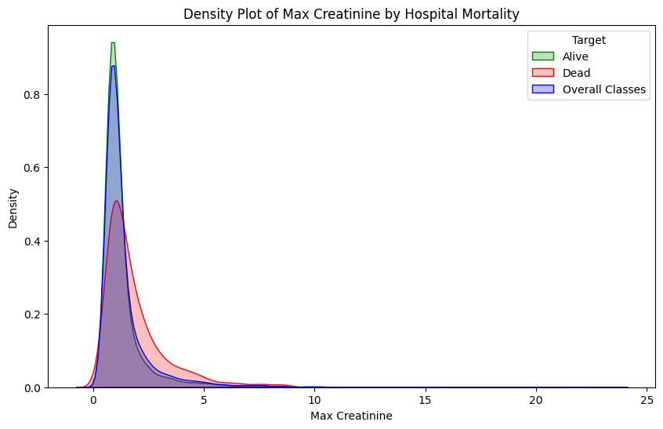

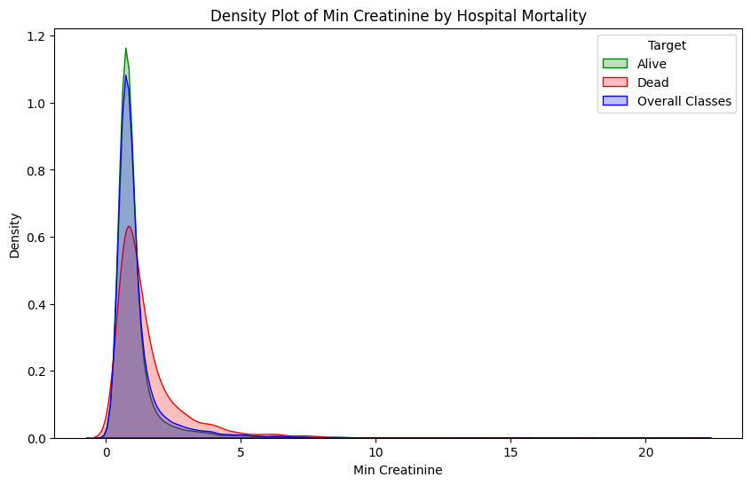

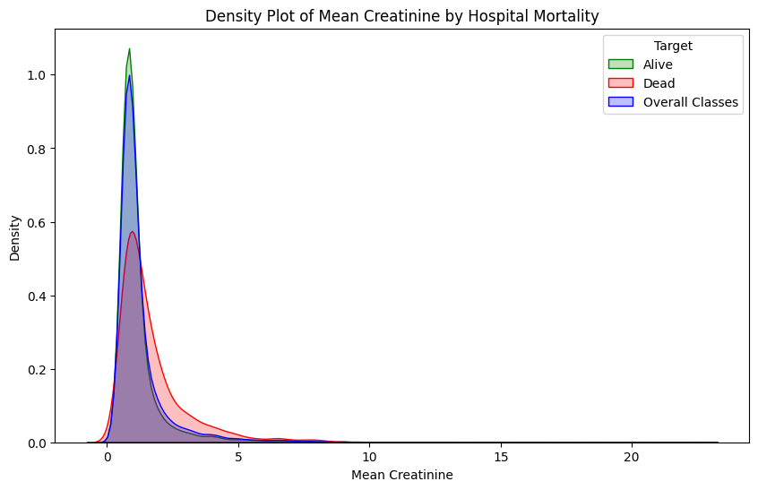

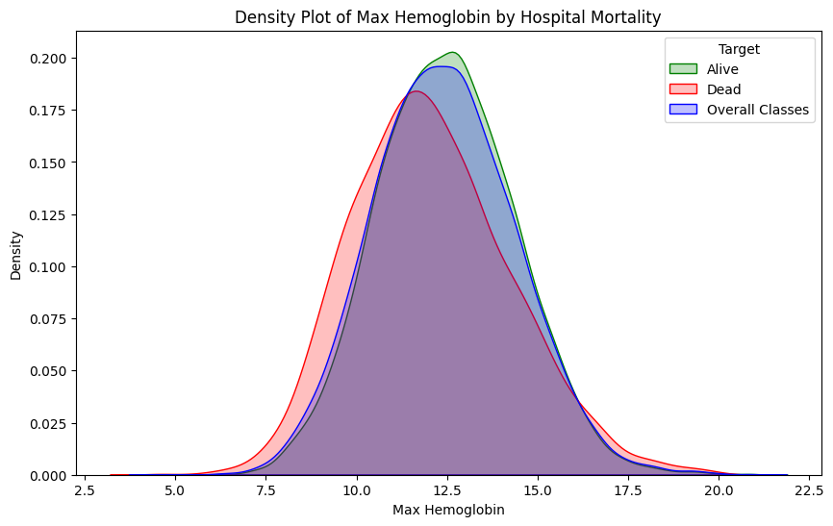

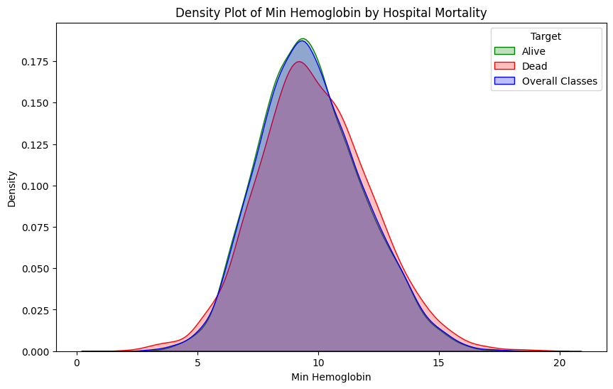

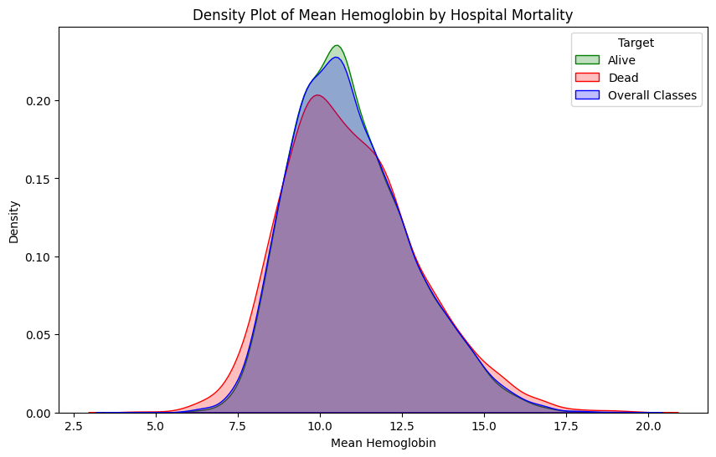

1. M A Papadakis et al., “Prognosis of Mechanically Ventilated Patients,” *The Western Journal of Medicine* 159, no. 6 (December 1993): 659–64, <https://www.ncbi.nlm.nih.gov/pmc/articles/PMC1022451/>.